Trader Workflow
Table of contents

https://github.com/seamusrobertmurphy/swing-trader
This is the single runtime document for the repository. It states what each stage does, why it is built that way, and how to run it, so a new reader can pick up the work and continue it. Three earlier notebooks were consolidated into this one on 6 September 2026 and archived under 02-runtime/archive/, kept out of version control so they cannot drift from what is actually run. The subject is spot crypto trading on Binance. The single question the pipeline exists to answer is whether there is a rule the model can trade that clears transaction fees on data it has never seen.

Contents
0. Overview - 0.1 After-Fee Objective - 0.2 Pipeline Overview - 0.3 Data Frames - 0.4 Hard Rules - 0.5 Running It
1. Trader Metrics - 1.1 Environment Setup - 1.2 Rank Universe - 1.3 Performance Metrics - 1.4 Entry Points - 1.5 Exit Points - 1.6 Decision Checklist
2. Trader Controls - 2.1 Key Variables - 2.2 Volatility Filter - 2.3 Four-Gate Screen - 2.4 Edge Sizing - 2.5 Hold Period - 2.6 Stacked Defences - 2.7 Signal Journal - 2.8 Frozen Harness
3. Trader Execution (drafted) - 3.1 Data Preparation - 3.2 Feature Variables - 3.3 Entries Exits - 3.4 Sharpening Entries - 3.5 Survivorship Pipeline - 3.6 Variable Selection - 3.7 Training Regime - 3.8 Model Tuning - 3.9 Model Assessment - 3.10 Stability - 3.11 Edge Diagnostics - 3.12 Regime Conditioning - 3.13 Edge Levers
4. Shared Method
5. Findings - 5.1 Current State - 5.2 The Lead - 5.3 Next Steps
Appendices - A. File Map - B. Glossary - C. Environment - D. Committee Layer

0. Overview

0.1 After-Fee Evaluation
The goal is one trading strategy that makes money after fees on data it has never seen. Every stage below serves that test, and nothing is accepted without passing it.
A candidate is scored on a blind final year that is held out from all training and tuning. It must clear three bars at once: beat a coin flip at the real base rate, beat buy and hold, and return more than zero per trade after the round-trip fee of about 0.20 percent. A rule that ranks trades well but still loses to the fee is a NO-GO. The fee is the adversary, not the market.
The search runs across three decision frames so intraday, interday, and longer holding each get a fair test. A frame is a whole system: its own bars, its own label, its own features, scored on its own out-of-sample. The frames are compared, never pooled, because a five-minute label and a four-hour label do not mean the same thing.

0.2 Pipeline Overview
The work splits into three parts that run in order. Each hands a clean input to the next.
Notebook | Role | The question it answers | Key outputs
Part 1, Metrics | Signal layer | What is worth measuring on a coin | indicators, entry and exit signals, a ranked shortlist, the decision checklist
Part 2, Controls | Risk and rules layer | What the account is allowed to do | position caps, stops, the daily loss circuit, the fee model, the four-gate screen, position sizing
Part 3, Execution | Modeling and search layer | Whether a tradeable edge survives fees | the datasets, the features, the model, and the after-fee scoreboard that returns GO or NO-GO
Metrics defines the vocabulary of signals. Controls sets the boundaries any strategy must live inside, above all the fee and the loss limits. Execution builds the datasets and the model and runs the honest test. The controls are not a step bolted on at the end. They are the filter the whole search is judged against.

0.3 Data Frames
Each frame is built from the same Binance Vision archives into its own dataset, dataset_5m_allmarket, dataset_1h_allmarket, dataset_4h_allmarket, and dataset_1d_allmarket, all stored as Parquet. One builder serves all three and retunes its feature windows, its label horizon, and its liquidity and volatility screens to the frame.
Frame | Bar | Trade style it targets | Default label
5m | 5 minutes | intraday scalps | a shorter ATR barrier, roughly two hours
1h | 1 hour | day-to-day swings | +2 / -1 ATR triple barrier, two wall-clock days
4h | 4 hours | multi-day holds | +2 / -1 ATR triple barrier, two wall-clock days
1d | 1 day | position swings, the fee-count lever | +2 / -1 ATR triple barrier, two daily bars
The higher-timeframe context shifts with the frame, so a five-minute model still sees the one-hour and four-hour trend, a one-hour model sees the four-hour and daily trend, and a four-hour model sees the daily and weekly trend. That is how each frame gets multi-resolution information without the datasets ever being merged. Every modelling section in Part 3 runs this same 1h, 4h, 5m loop and reports one block per frame. The 1d frame was added 2026-08-17 as the fee-count lever: the survivorship-complete daily archive (669 pairs) is on disk and its baseline dataset and edge matrix are section 3.13’s first read.

0.4 Hard Rules
Every candidate strategy lives inside a fixed set of controls, summarised here and detailed in Part 2. None is negotiable, and the after-fee test in the last row overrides any in-sample result. The rows marked revised carry the adjustments logged below; the rest are unchanged from the charter.
Control | Setting | Why
Position cap | 5 percent of equity at entry | one bad name cannot sink the book
Default size | half Kelly, a quarter on minimum signals | size to the edge, not the conviction
Fat-pitch exception | one position to 10 percent, with reward-to-risk at least 3:1, a named cause, and a written exit | rare, documented, reversible
Label geometry | longer-horizon, less fee-punishing triple barrier, replacing the +2 / -1 ATR default | the old label lost before any prediction; fewer round trips cut fee drag
Hard stop | ATR-scaled per frame, provisional, replacing the fixed 7 percent | trend protection sized to each coin’s volatility, not a flat percent
Trailing stop | ATR-scaled per frame, provisional, replacing the fixed 10 percent | lets winners run scaled to volatility; settled by the exit-geometry sweep
Regime gate | act only when BTC is trending up | deploys the real but drowned cross-sectional signal in the regime where it works
Narrow book | entries only in coins that carried the out-of-sample gated edge and pass the live liquidity screen | a minority of coins carry all the profit; the average hides it
Fee tier | maker entries, BNB-discounted fees, measured from the account each run | the achievable 0.15 percent round trip closes half the gap to zero
Daily circuit | halt new orders if rolling 24-hour drawdown passes 3 percent | stop the bleeding, existing stops stay live
Drawdown ramp | below a 5 percent rolling-week loss, cut new size with each further 1 percent | shrink the book, do not just block it
Cash floor | keep at least 10 percent in cash | always able to act
Position limit | at most 3 new positions per week | forces selectivity
Direction | spot only, never short, never margin, never leverage | the mandate; shorting is logged below as research, not policy
Averaging down | never | a loser is exited or held, not fed
Anchoring | cost basis never enters hold or sell logic | decide on forward value only
The bar | nothing ships unless it beats a coin flip, buy-and-hold, and the fee out of sample | the fee is the adversary
Adjustments logged. Six changes were made to release model potential without adding ruin risk. All are bounded and stay inside the no-short mandate. They are documented here as the intended design; the code-level work lands in Part 3 (the label, exit, and regime sections) and has not yet been rebuilt into the on-disk datasets.
- Exit geometry. The fixed 7 percent hard stop and 10 percent trailing stop become ATR-scaled per frame and stay provisional until the exit-geometry sweep, which fits per-coin trailing stops and a time-decaying take-profit and scores them after fees. The flat percent ignored each coin’s volatility and conflicted with the code’s existing 5 percent and roughly 8.5 percent ATR stops.
- Label. The default +2 / -1 ATR triple barrier is replaced by a longer-horizon, less fee-punishing geometry with fewer round trips. The old label had negative unconditional expectancy, a base rate near 0.313 against a breakeven near 0.333, so it lost before the model predicted anything.
- Regime gate Deploy the cross-sectional signal only when BTC is trending up. Relative strength is real and broad but drowned by a negative universe baseline, and a regime filter is the cheapest in-mandate way to test whether it turns positive.
- Longer-horizon frame. Extend the search toward the daily frame alongside 4h, because coarser frames cut the fee count per unit of return, which is the central obstacle. As of 2026-08-17 the daily archive is complete and the baseline build is in flight (3.13).
- Fee engineering (2026-08-17). The modelled cost gains a second, achievable scenario: post-only maker entries (no spread paid), BNB-discounted 0.075 percent per side, a 0.15 percent round trip (ACHIEVABLE_COST_PCT in 03-inputs/train_model.py). The live wrapper reads the account’s actual maker and taker rates and BNB-burn setting at the start of every run (fee_status) and warns when the measured round trip exceeds the scenario; the paper book charges the same engineered rate.
- Narrow book (2026-08-17). 03-inputs/narrow_book.py intersects the coins that carried the out-of-sample gated edge (positive contribution, at least three cohort appearances) with the live liquidity screen and writes 05-research/memory/narrow-book.json; 03-inputs/trade_binance.py refuses entries outside it. Rank broadly, trade narrowly.
Unchanged and kept tight. The 5 percent position cap, half-Kelly sizing, the 3 percent daily circuit, the drawdown ramp, the 10 percent cash floor, the three-new-per-week cap, no averaging down, no anchoring, and the after-fee bar. These bound survival, not the search. Loosening them would amplify a model that is still at the coin-flip floor, which is how no edge becomes ruin.
Open question on shorting. Going long the strong third and short the weak third would monetize the cross-sectional spread directly, even against a negative baseline. It is left out because it breaks the spot-only mandate and imports unbounded loss and liquidation risk. If ever tested, it should be small, market-neutral, unleveraged, and paper-first, still behind the after-fee bar.

0.5 Running It
The notebooks run on a MacPorts Python through a project .venv kernel. Secrets live in the run environment, never in the repository: the Binance and Alpaca keys, BINANCE_TESTNET, and the single money switch LIVE_TRADING, which stays false until a strategy has earned the right to trade. No real order is placed while it is false; the agent reads the market or runs against the Binance testnet.
One knob drives the modelling cells. LOAD_FRAME selects the active frame, 1h by default. Import Data loads that frame’s Parquet into df and feat, and every modelling cell consumes those two. The multi-frame sections in Part 3, model assessment, stability, edge diagnostics, selectivity, and regime conditioning, loop over 1h, 4h, and 5m on their own and restore the active frame when they finish, so the rest of the notebook is unaffected.
Run order is top to bottom. The code cells carried into this document have their outputs cleared, so run them on the Mac with the .venv kernel to regenerate every figure and table. One environment caveat: the repository sits on an exFAT volume that scatters ._ AppleDouble files, which can crash matplotlib; clear them if an import throws a 0xb0 decode error.

1. Trader Metrics
The signal layer, from Part 1 of this document. A read-only daily scan over public market data, no keys and no orders, sharing Part 3’s data spine: price from the survivorship-complete data.binance.vision 1h archives resampled to daily, and the universe from Part 3’s point-in-time Stage B screen.
The sections below present the signal families the model in Part 3 actually ranks and trades on, cross-sectional relative strength, the momentum family including MACD, the Supertrend and BTC-relative trend signals, the ATR-scaled exits, and the regime state, each tied to the feature it becomes and the evidence for it. The runnable daily indicator board is kept throughout as an illustrative within-coin read, a place to eyeball candidates, not a trade trigger. Any signal must clear the after-fee, out-of-sample bar in Part 3 before it means anything, and on the 1h frame the verdict so far is NO-GO.

1.1 Environment Setup
The scan runs on Python 3.11 with dependencies pinned in 03-inputs/requirements.txt and reinstalled on each fresh kernel: pandas-ta-classic for indicators, pykalman for smoothing, plotly and matplotlib for charts. No exchange login or API key is needed, because both the price history and the universe come from Part 3’s offline archives through build_dataset_1h. ccxt is kept only for an optional live top-up of the still-forming day.
Provenance is proven, not asserted. Price comes from the official data.binance.vision monthly per-symbol OHLCV zips, exchange-direct and checksummed, covering every USDT pair ever listed including delisted ones. That survivorship-complete source is what removes the universe-level bias the old live top-N-by-volume scan carried. The second cell pulls one month of BTCUSDT bars straight from the archive at 1h, 4h, and 5m to show the source and format.
UnicodeDecodeError: 'utf-8' codec can't decode byte 0xb0 in position 37: invalid start byte
[31m---------------------------------------------------------------------------[39m
[31mUnicodeDecodeError[39m Traceback (most recent call last)
[36mCell[39m[36m [39m[32mIn[1][39m[32m, line 29[39m
[32m 25[39m pd.set_option([33m"display.notebook_repr_html"[39m, [38;5;28;01mFalse[39;00m) [38;5;66;03m# IDE-safe: render DataFrames as text, not HTML[39;00m
[32m 26[39m [38;5;28;01mfrom[39;00m datetime [38;5;28;01mimport[39;00m datetime
[32m 27[39m [38;5;28;01mimport[39;00m ccxt
[32m 28[39m [38;5;28;01mimport[39;00m pandas_ta_classic [38;5;28;01mas[39;00m ta
[32m---> [39m[32m29[39m [38;5;28;01mfrom[39;00m pykalman [38;5;28;01mimport[39;00m KalmanFilter
[32m 30[39m [38;5;28;01mimport[39;00m plotly, plotly.graph_objects [38;5;28;01mas[39;00m go, plotly.io [38;5;28;01mas[39;00m pio
[32m 31[39m warnings.filterwarnings([33m"ignore"[39m)
[32m 32[39m pio.renderers.default = [33m"plotly_mimetype+notebook_connected"[39m
[36mFile [39m[32m/Volumes/PortableSSD/Github/day-trader/.venv/lib/python3.12/site-packages/pykalman/__init__.py:8[39m
[32m 1[39m [33;03m"""Python implementations of Kalman Filters and Kalman Smoothers.[39;00m
[32m 2[39m
[32m 3[39m [33;03mInference methods for state-space estimation in continuous spaces.[39;00m
[32m 4[39m [33;03m"""[39;00m
[32m 6[39m __version__ = [33m"[39m[33m0.11.2[39m[33m"[39m
[32m----> [39m[32m8[39m [38;5;28;01mfrom[39;00m[38;5;250m [39m[34;01m.[39;00m[34;01mstandard[39;00m[38;5;250m [39m[38;5;28;01mimport[39;00m KalmanFilter
[32m 9[39m [38;5;28;01mfrom[39;00m[38;5;250m [39m[34;01m.[39;00m[34;01munscented[39;00m[38;5;250m [39m[38;5;28;01mimport[39;00m AdditiveUnscentedKalmanFilter, UnscentedKalmanFilter
[32m 11[39m __all__ = [
[32m 12[39m [33m"[39m[33mKalmanFilter[39m[33m"[39m,
[32m 13[39m [33m"[39m[33mAdditiveUnscentedKalmanFilter[39m[33m"[39m,
[32m (...)[39m[32m 16[39m [33m"[39m[33msqrt[39m[33m"[39m,
[32m 17[39m ]
[36mFile [39m[32m/Volumes/PortableSSD/Github/day-trader/.venv/lib/python3.12/site-packages/pykalman/standard.py:24[39m
[32m 14[39m [38;5;28;01mfrom[39;00m[38;5;250m [39m[34;01mscipy[39;00m[38;5;250m [39m[38;5;28;01mimport[39;00m linalg
[32m 16[39m [38;5;28;01mfrom[39;00m[38;5;250m [39m[34;01m.[39;00m[34;01mutils[39;00m[38;5;250m [39m[38;5;28;01mimport[39;00m (
[32m 17[39m array1d,
[32m 18[39m array2d,
[32m (...)[39m[32m 22[39m preprocess_arguments,
[32m 23[39m )
[32m---> [39m[32m24[39m [38;5;28;01mfrom[39;00m[38;5;250m [39m[34;01m.[39;00m[34;01mutils_numpy[39;00m[38;5;250m [39m[38;5;28;01mimport[39;00m newbyteorder
[32m 26[39m [38;5;66;03m# Dimensionality of each Kalman Filter parameter for a single time step[39;00m
[32m 27[39m DIM = {
[32m 28[39m [33m"[39m[33mtransition_matrices[39m[33m"[39m: [32m2[39m,
[32m 29[39m [33m"[39m[33mtransition_offsets[39m[33m"[39m: [32m1[39m,
[32m (...)[39m[32m 35[39m [33m"[39m[33minitial_state_covariance[39m[33m"[39m: [32m2[39m,
[32m 36[39m }
[36mFile [39m[32m/Volumes/PortableSSD/Github/day-trader/.venv/lib/python3.12/site-packages/pykalman/utils_numpy.py:3[39m
[32m 1[39m [33;03m"""Utility functions to handle numpy 2."""[39;00m
[32m----> [39m[32m3[39m [38;5;28;01mfrom[39;00m[38;5;250m [39m[34;01mpykalman[39;00m[34;01m.[39;00m[34;01mutils[39;00m[34;01m.[39;00m[34;01m_numpy[39;00m[38;5;250m [39m[38;5;28;01mimport[39;00m newbyteorder
[32m 5[39m __all__ = [[33m"[39m[33mnewbyteorder[39m[33m"[39m]
[36mFile [39m[32m/Volumes/PortableSSD/Github/day-trader/.venv/lib/python3.12/site-packages/pykalman/utils/_numpy.py:5[39m
[32m 1[39m [33;03m"""Utility functions to handle numpy 2."""[39;00m
[32m 3[39m [38;5;28;01mfrom[39;00m[38;5;250m [39m[34;01mskbase[39;00m[34;01m.[39;00m[34;01mutils[39;00m[34;01m.[39;00m[34;01mdependencies[39;00m[38;5;250m [39m[38;5;28;01mimport[39;00m _check_soft_dependencies
[32m----> [39m[32m5[39m numpy2 = [30;43m_check_soft_dependencies[39;49m[30;43m([39;49m[30;43m"[39;49m[30;43mnumpy>=2[39;49m[30;43m"[39;49m[30;43m,[39;49m[30;43m [39;49m[30;43mseverity[39;49m[30;43m=[39;49m[30;43m"[39;49m[30;43mnone[39;49m[30;43m"[39;49m[30;43m)[39;49m
[32m 8[39m [38;5;28;01mdef[39;00m[38;5;250m [39m[34mnewbyteorder[39m(arr, new_order):
[32m 9[39m [38;5;250m [39m[33;03m"""Change the byte order of an array.[39;00m
[32m 10[39m
[32m 11[39m [33;03m Parameters[39;00m
[32m (...)[39m[32m 21[39m [33;03m Array with new byte order.[39;00m
[32m 22[39m [33;03m """[39;00m
[36mFile [39m[32m/Volumes/PortableSSD/Github/day-trader/.venv/lib/python3.12/site-packages/skbase/utils/dependencies/_dependencies.py:234[39m, in [36m_check_soft_dependencies[39m[34m(severity, obj, msg, normalize_reqs, case_sensitive, *packages)[39m
[32m 231[39m req_sat = []
[32m 233[39m [38;5;28;01mfor[39;00m package [38;5;129;01min[39;00m package_req:
[32m--> [39m[32m234[39m pkg_version_req, pkg_nm, pkg_env_version = [30;43m_get_pkg_version_and_req[39;49m[30;43m([39;49m
[32m 235[39m [30;43m [39;49m[30;43mpackage[39;49m[30;43m,[39;49m[30;43m [39;49m[30;43mcase_sensitive[39;49m[30;43m=[39;49m[30;43mcase_sensitive[39;49m
[32m 236[39m [30;43m [39;49m[30;43m)[39;49m
[32m 237[39m pkg_version_reqs.append(pkg_version_req)
[32m 238[39m pkg_env_versions.append(pkg_env_version)
[36mFile [39m[32m/Volumes/PortableSSD/Github/day-trader/.venv/lib/python3.12/site-packages/skbase/utils/dependencies/_dependencies.py:201[39m, in [36m_check_soft_dependencies.<locals>._get_pkg_version_and_req[39m[34m(package, case_sensitive)[39m
[32m 198[39m package_name = req.name
[32m 199[39m package_version_req = req.specifier
[32m--> [39m[32m201[39m pkg_env_version = [30;43m_get_pkg_version[39;49m[30;43m([39;49m[30;43mpackage_name[39;49m[30;43m,[39;49m[30;43m [39;49m[30;43mcase_sensitive[39;49m[30;43m=[39;49m[30;43mcase_sensitive[39;49m[30;43m)[39;49m
[32m 202[39m [38;5;28;01mif[39;00m normalize_reqs:
[32m 203[39m pkg_env_version = _normalize_version(pkg_env_version)
[36mFile [39m[32m/Volumes/PortableSSD/Github/day-trader/.venv/lib/python3.12/site-packages/skbase/utils/dependencies/_dependencies.py:380[39m, in [36m_get_pkg_version[39m[34m(package_name, case_sensitive)[39m
[32m 348[39m [38;5;129m@lru_cache[39m
[32m 349[39m [38;5;28;01mdef[39;00m[38;5;250m [39m[34m_get_pkg_version[39m(package_name, case_sensitive=[38;5;28;01mFalse[39;00m):
[32m 350[39m [38;5;250m [39m[33;03m"""Check whether package is available in environment, and return its version if yes.[39;00m
[32m 351[39m
[32m 352[39m [33;03m Returns ``Version`` object from ``lru_cache``, this should not be mutated.[39;00m
[32m (...)[39m[32m 378[39m [33;03m ``importlib`` ``Version`` of package, if present in environment.[39;00m
[32m 379[39m [33;03m """[39;00m
[32m--> [39m[32m380[39m pkgs = [30;43m_get_installed_packages[39;49m[30;43m([39;49m[30;43mlowercase[39;49m[30;43m=[39;49m[30;43;01mnot[39;49;00m[30;43m [39;49m[30;43mcase_sensitive[39;49m[30;43m)[39;49m
[32m 381[39m [38;5;28;01mif[39;00m [38;5;129;01mnot[39;00m case_sensitive:
[32m 382[39m package_name = package_name.lower()
[36mFile [39m[32m/Volumes/PortableSSD/Github/day-trader/.venv/lib/python3.12/site-packages/skbase/utils/dependencies/_dependencies.py:345[39m, in [36m_get_installed_packages[39m[34m(lowercase)[39m
[32m 331[39m [38;5;28;01mdef[39;00m[38;5;250m [39m[34m_get_installed_packages[39m(lowercase=[38;5;28;01mFalse[39;00m):
[32m 332[39m [38;5;250m [39m[33;03m"""Get a dictionary of installed packages and their versions.[39;00m
[32m 333[39m
[32m 334[39m [33;03m Parameters[39;00m
[32m (...)[39m[32m 343[39m [33;03m MAJOR.MINOR.PATCH version format is used for versions, e.g., "1.2.3"[39;00m
[32m 344[39m [33;03m """[39;00m
[32m--> [39m[32m345[39m [38;5;28;01mreturn[39;00m [30;43m_get_installed_packages_private[39;49m[30;43m([39;49m[30;43mlowercase[39;49m[30;43m=[39;49m[30;43mlowercase[39;49m[30;43m)[39;49m.copy()
[36mFile [39m[32m/Volumes/PortableSSD/Github/day-trader/.venv/lib/python3.12/site-packages/skbase/utils/dependencies/_dependencies.py:314[39m, in [36m_get_installed_packages_private[39m[34m(lowercase)[39m
[32m 311[39m [38;5;28;01mfrom[39;00m[38;5;250m [39m[34;01mimportlib[39;00m[34;01m.[39;00m[34;01mmetadata[39;00m[38;5;250m [39m[38;5;28;01mimport[39;00m distributions, version
[32m 313[39m dists = distributions()
[32m--> [39m[32m314[39m dists = {dist [38;5;28;01mfor[39;00m dist [38;5;129;01min[39;00m dists [38;5;28;01mif[39;00m [30;43mdist[39;49m[30;43m.[39;49m[30;43mmetadata[39;49m [38;5;129;01mis[39;00m [38;5;129;01mnot[39;00m [38;5;28;01mNone[39;00m}
[32m 315[39m package_names = {dist.metadata.get([33m"[39m[33mName[39m[33m"[39m) [38;5;28;01mfor[39;00m dist [38;5;129;01min[39;00m dists}
[32m 316[39m package_versions = {
[32m 317[39m pkg_name: version(pkg_name) [38;5;28;01mfor[39;00m pkg_name [38;5;129;01min[39;00m package_names [38;5;28;01mif[39;00m pkg_name
[32m 318[39m }
[36mFile [39m[32m/opt/local/Library/Frameworks/Python.framework/Versions/3.12/lib/python3.12/importlib/metadata/__init__.py:449[39m, in [36mDistribution.metadata[39m[34m(self)[39m
[32m 436[39m [38;5;129m@property[39m
[32m 437[39m [38;5;28;01mdef[39;00m[38;5;250m [39m[34mmetadata[39m([38;5;28mself[39m) -> _meta.PackageMetadata:
[32m 438[39m [38;5;250m [39m[33;03m"""Return the parsed metadata for this Distribution.[39;00m
[32m 439[39m
[32m 440[39m [33;03m The returned object will have keys that name the various bits of[39;00m
[32m 441[39m [33;03m metadata. See PEP 566 for details.[39;00m
[32m 442[39m [33;03m """[39;00m
[32m 443[39m opt_text = (
[32m 444[39m [38;5;28mself[39m.read_text([33m'[39m[33mMETADATA[39m[33m'[39m)
[32m 445[39m [38;5;129;01mor[39;00m [38;5;28mself[39m.read_text([33m'[39m[33mPKG-INFO[39m[33m'[39m)
[32m 446[39m [38;5;66;03m# This last clause is here to support old egg-info files. Its[39;00m
[32m 447[39m [38;5;66;03m# effect is to just end up using the PathDistribution's self._path[39;00m
[32m 448[39m [38;5;66;03m# (which points to the egg-info file) attribute unchanged.[39;00m
[32m--> [39m[32m449[39m [38;5;129;01mor[39;00m [30;43mself[39;49m[30;43m.[39;49m[30;43mread_text[39;49m[30;43m([39;49m[30;43m'[39;49m[30;43m'[39;49m[30;43m)[39;49m
[32m 450[39m )
[32m 451[39m text = cast([38;5;28mstr[39m, opt_text)
[32m 452[39m [38;5;28;01mreturn[39;00m _adapters.Message(email.message_from_string(text))
[36mFile [39m[32m/opt/local/Library/Frameworks/Python.framework/Versions/3.12/lib/python3.12/importlib/metadata/__init__.py:819[39m, in [36mPathDistribution.read_text[39m[34m(self, filename)[39m
[32m 811[39m [38;5;28;01mdef[39;00m[38;5;250m [39m[34mread_text[39m([38;5;28mself[39m, filename):
[32m 812[39m [38;5;28;01mwith[39;00m suppress(
[32m 813[39m [38;5;167;01mFileNotFoundError[39;00m,
[32m 814[39m [38;5;167;01mIsADirectoryError[39;00m,
[32m (...)[39m[32m 817[39m [38;5;167;01mPermissionError[39;00m,
[32m 818[39m ):
[32m--> [39m[32m819[39m [38;5;28;01mreturn[39;00m [30;43mself[39;49m[30;43m.[39;49m[30;43m_path[39;49m[30;43m.[39;49m[30;43mjoinpath[39;49m[30;43m([39;49m[30;43mfilename[39;49m[30;43m)[39;49m[30;43m.[39;49m[30;43mread_text[39;49m[30;43m([39;49m[30;43mencoding[39;49m[30;43m=[39;49m[30;43m'[39;49m[30;43mutf-8[39;49m[30;43m'[39;49m[30;43m)[39;49m
[36mFile [39m[32m/opt/local/Library/Frameworks/Python.framework/Versions/3.12/lib/python3.12/pathlib.py:1028[39m, in [36mPath.read_text[39m[34m(self, encoding, errors)[39m
[32m 1026[39m encoding = io.text_encoding(encoding)
[32m 1027[39m [38;5;28;01mwith[39;00m [38;5;28mself[39m.open(mode=[33m'[39m[33mr[39m[33m'[39m, encoding=encoding, errors=errors) [38;5;28;01mas[39;00m f:
[32m-> [39m[32m1028[39m [38;5;28;01mreturn[39;00m [30;43mf[39;49m[30;43m.[39;49m[30;43mread[39;49m[30;43m([39;49m[30;43m)[39;49m
[36mFile [39m[32m/opt/local/Library/Frameworks/Python.framework/Versions/3.12/lib/python3.12/codecs.py:322[39m, in [36mBufferedIncrementalDecoder.decode[39m[34m(self, input, final)[39m
[32m 319[39m [38;5;28;01mdef[39;00m[38;5;250m [39m[34mdecode[39m([38;5;28mself[39m, [38;5;28minput[39m, final=[38;5;28;01mFalse[39;00m):
[32m 320[39m [38;5;66;03m# decode input (taking the buffer into account)[39;00m
[32m 321[39m data = [38;5;28mself[39m.buffer + [38;5;28minput[39m
[32m--> [39m[32m322[39m (result, consumed) = [30;43mself[39;49m[30;43m.[39;49m[30;43m_buffer_decode[39;49m[30;43m([39;49m[30;43mdata[39;49m[30;43m,[39;49m[30;43m [39;49m[30;43mself[39;49m[30;43m.[39;49m[30;43merrors[39;49m[30;43m,[39;49m[30;43m [39;49m[30;43mfinal[39;49m[30;43m)[39;49m
[32m 323[39m [38;5;66;03m# keep undecoded input until the next call[39;00m
[32m 324[39m [38;5;28mself[39m.buffer = data[consumed:]
[31mUnicodeDecodeError[39m: 'utf-8' codec can't decode byte 0xb0 in position 37: invalid start byte
Survivorship-complete: acquire_vision.py crawl enumerates EVERY symbol ever listed (incl.
delisted), so dead coins are not silently dropped the way the exchangeInfo path is.
frame download command raw klines on disk built dataset
1h (old) acquire_vision.py download --interval 1h klines_1h/<SYM>/ dataset_1h_allmarket.parquet
1d (old) flow_data.py --interval 1d --all-market klines/<SYM>/ daily_flow.csv
4h (new) acquire_vision.py download --interval 4h klines_4h/<SYM>/ dataset_4h_allmarket.parquet
5m (new) acquire_vision.py download --interval 5m --symbols <scalp set> klines_5m/<SYM>/ dataset_5m_allmarket.parquet
LIVE proof of source + format (one month of BTCUSDT, straight from the archive):
1h : 744 bars, 42 KB <- https://data.binance.vision/data/spot/monthly/klines/BTCUSDT/1h/BTCUSDT-1h-2024-01.zip
4h : 186 bars, 11 KB <- https://data.binance.vision/data/spot/monthly/klines/BTCUSDT/4h/BTCUSDT-4h-2024-01.zip
5m : 8928 bars, 455 KB <- https://data.binance.vision/data/spot/monthly/klines/BTCUSDT/5m/BTCUSDT-5m-2024-01.zip

1.2 Rank Universe
The decision-grade ranking in Part 3 is cross-sectional, not within-coin. At each bar it ranks the screened universe by a strength signal and holds only the top third, reading that cohort’s after-fee return against the market and the bottom third (03-inputs/cross_sectional_4h.py). This is the classic momentum result: relative strength across coins often carries an edge where predicting each coin in isolation does not. The universe is thin, a median of five to seven coins per 4h bar, so it ranks into terciles at a five-coin floor rather than deciles.
The finding is real but drowned. Across the candidate signals most show the top third beating the market and a positive long-short spread that holds across train and test, the most robust being the adaptive-Supertrend direction and the daily Supertrend state. But the universe’s own after-fee baseline is about minus 0.38 percent per trade, so even the best top third beats the market while staying below zero. The edge exists; the negative baseline sinks it. The levers to lift it are the regime gate, a less fee-punishing label, and a coarser frame, all logged in 0.4.
The runnable board below is the illustrative within-coin read. It loads 400 daily bars per coin from the 1h archives, computes a Kalman smoother, Bollinger Bands, Ichimoku, the Archer trend flag, RSI, Choppiness, and the triple-Supertrend, and ranks Supertrend-first. Stablecoins are dropped as flat by construction. Treat a green cell as worth a look, checked against the Part 3 evaluation, not as a signal in its own right.
Data spine: survivorship-complete 1h archives -> 1d bars | 400 bars/coin | board top 20 | live top-up False
Engine ready.
2026-09-06: survivorship-COMPLETE universe from profile 2026-09-06T215959Z -- scanning 20 of 394 screened coins (600 on disk; stablecoins dropped).
['BTC/USDT',
'ETH/USDT',
'SOL/USDT',
'RE/USDT',
'XRP/USDT',
'BNB/USDT',
'PEPE/USDT',
'DOGE/USDT',
'SUI/USDT',
'WIF/USDT',
'AVAX/USDT',
'ENA/USDT',
'LINK/USDT',
'ADA/USDT',
'SHIB/USDT',
'TRX/USDT',
'ARB/USDT',
'WLD/USDT',
'DOT/USDT',
'LTC/USDT']
skip BTC/USDT: NameError
skip ETH/USDT: NameError
skip SOL/USDT: NameError
skip RE/USDT: NameError
skip XRP/USDT: NameError
skip BNB/USDT: NameError
skip PEPE/USDT: NameError
skip DOGE/USDT: NameError
skip SUI/USDT: NameError
skip WIF/USDT: NameError
skip AVAX/USDT: NameError
skip ENA/USDT: NameError
skip LINK/USDT: NameError
skip ADA/USDT: NameError
skip SHIB/USDT: NameError
skip TRX/USDT: NameError
skip ARB/USDT: NameError
skip WLD/USDT: NameError
skip DOT/USDT: NameError
skip LTC/USDT: NameError
AttributeError: 'DataFrame' object has no attribute 'Buy'
[31m---------------------------------------------------------------------------[39m
[31mAttributeError[39m Traceback (most recent call last)
[36mCell[39m[36m [39m[32mIn[6][39m[32m, line 6[39m
[32m 2[39m [38;5;28;01mfor[39;00m symbol [38;5;28;01min[39;00m universe:
[32m 3[39m [38;5;28;01mtry[39;00m: rows.append(calculate_indicator(symbol)[[32m1[39m])
[32m 4[39m [38;5;28;01mexcept[39;00m Exception [38;5;28;01mas[39;00m e: print(f"skip {symbol}: {type(e).__name__}")
[32m 5[39m results = pd.DataFrame(rows)
[32m----> [39m[32m6[39m print(f"\nscored {len(results)} pairs | {int(results.Buy.sum())} buys | {int(results.Sell.sum())} sells")
[32m 7[39m results.head()
[36mFile [39m[32m/Volumes/PortableSSD/Github/day-trader/.venv/lib/python3.12/site-packages/pandas/core/generic.py:6321[39m, in [36mNDFrame.__getattr__[39m[34m(self, name)[39m
[32m 6317[39m [38;5;28;01mand[39;00m name [38;5;28;01mnot[39;00m [38;5;28;01min[39;00m self._accessors
[32m 6318[39m [38;5;28;01mand[39;00m self._info_axis._can_hold_identifiers_and_holds_name(name)
[32m 6319[39m ):
[32m 6320[39m [38;5;28;01mreturn[39;00m self[name]
[32m-> [39m[32m6321[39m [38;5;28;01mreturn[39;00m object.__getattribute__(self, name)
[31mAttributeError[39m: 'DataFrame' object has no attribute 'Buy'

1.3 Performance Metrics
MACD is not retired; it feeds the model in three forms, each made scale-invariant so it fits a pipeline that compares hundreds of coins.
As a feature, the builder computes the PPO histogram (f_ta_pta_ppo_hist), which the code labels a scale-free MACD. PPO is MACD divided by price, so a sixty-thousand-dollar coin and a fraction-of-a-cent coin are comparable, which raw MACD is not. It sits in the optional pandas-ta momentum block beside TRIX, the Vortex indicator, CMO, the Fisher transform, and the Chande Kroll Stop, the wider momentum family the model carries.
As a cross-sectional signal, MACD and PPO are among the strength keys cross_sectional_4h ranks coins by, so momentum enters the relative-strength test in 1.2 directly.
As a standalone rule, 03-inputs/walkforward.py trades a daily MACD signal-line cross-up with ATR exits and an optional MACD cross-down exit. Scored after fees out of sample its verdict is NO-GO, one more confirmation that a single momentum trigger does not beat the fee on its own, which is why the model uses MACD as one ranked feature among many rather than as a trigger.
The methodology itself is unchanged: MACD reads momentum as the velocity of a trend, the 12-period EMA against the 26, with a crossover above the zero line bullish and below bearish and the histogram measuring how fast the lines converge or diverge. The board in 1.2 still reports a guarded crossover, MACD_Buy and MACD_Sell filtered by MACD_below_zero, as context beside the Supertrend baseline. The divergence taxonomy from the original chapter remains a design note, not implemented in the model.

1.4 Entry Points
The trend signals the model actually reads are the Supertrend family, not the illustrative board flags. The triple-Supertrend (f_st_) votes three ATR bands and the EMA-200 gate into an agreement score, signed distances, and a reversal flip. The Modern Adaptive Supertrend (f_mst_) adds a Kaufman efficiency-ratio regime gate and a commit filter that cuts false flips by around 80 percent. EMA-200 is the trend gate the live bot trails. The first signal not derived from the coin’s own price is BTC lead-lag relative strength (f_btc_): BTC’s own momentum, the coin’s momentum relative to BTC, and a rolling beta and correlation, the market beta of crypto.
The honest finding from Part 3 is that the entry rule alone, these trend signals fired as a long trigger, sits at the efficient-market floor on the 1h frame: the trend reverses back through the entry almost as often as it continues. That is why the search moved to cross-sectional ranking and a coarser frame rather than to more entry features. The board’s top candidates below illustrate an entry read on daily candles; they are not the decision-grade entry.
KeyError: 'ST_buy'
[31m---------------------------------------------------------------------------[39m
[31mKeyError[39m Traceback (most recent call last)
[36mCell[39m[36m [39m[32mIn[7][39m[32m, line 1[39m
[32m----> [39m[32m1[39m top = (results.sort_values([[33m'ST_buy'[39m,[33m'Buy'[39m,[33m'EMA_gt_Kalman'[39m,[33m'AMAT'[39m,[33m'RSI'[39m], ascending=[[38;5;28;01mFalse[39;00m,[38;5;28;01mFalse[39;00m,[38;5;28;01mFalse[39;00m,[38;5;28;01mFalse[39;00m,[38;5;28;01mTrue[39;00m]).reset_index(drop=[38;5;28;01mTrue[39;00m).head([32m10[39m))
[32m 2[39m bottom = (results.sort_values([[33m'Sell'[39m,[33m'AMAT'[39m,[33m'RSI'[39m],ascending=[[38;5;28;01mFalse[39;00m,[38;5;28;01mFalse[39;00m,[38;5;28;01mFalse[39;00m]).reset_index(drop=[38;5;28;01mTrue[39;00m).head([32m10[39m))
[32m 3[39m print([33m"ranked."[39m)
[32m 4[39m
[36mFile [39m[32m/Volumes/PortableSSD/Github/day-trader/.venv/lib/python3.12/site-packages/pandas/core/frame.py:7194[39m, in [36mDataFrame.sort_values[39m[34m(self, by, axis, ascending, inplace, kind, na_position, ignore_index, key)[39m
[32m 7190[39m f"Length of ascending ({len(ascending)})" [38;5;66;03m# type: ignore[arg-type][39;00m
[32m 7191[39m f" != length of by ({len(by)})"
[32m 7192[39m )
[32m 7193[39m [38;5;28;01mif[39;00m len(by) > [32m1[39m:
[32m-> [39m[32m7194[39m keys = [self._get_label_or_level_values(x, axis=axis) [38;5;28;01mfor[39;00m x [38;5;28;01min[39;00m by]
[32m 7195[39m
[32m 7196[39m [38;5;66;03m# need to rewrap columns in Series to apply key function[39;00m
[32m 7197[39m [38;5;28;01mif[39;00m key [38;5;28;01mis[39;00m [38;5;28;01mnot[39;00m [38;5;28;01mNone[39;00m:
[36mFile [39m[32m/Volumes/PortableSSD/Github/day-trader/.venv/lib/python3.12/site-packages/pandas/core/generic.py:1914[39m, in [36mNDFrame._get_label_or_level_values[39m[34m(self, key, axis)[39m
[32m 1910[39m values = self.xs(key, axis=other_axes[[32m0[39m])._values
[32m 1911[39m [38;5;28;01melif[39;00m self._is_level_reference(key, axis=axis):
[32m 1912[39m values = self.axes[axis].get_level_values(key)._values
[32m 1913[39m [38;5;28;01melse[39;00m:
[32m-> [39m[32m1914[39m [38;5;28;01mraise[39;00m KeyError(key)
[32m 1915[39m
[32m 1916[39m [38;5;66;03m# Check for duplicates[39;00m
[32m 1917[39m [38;5;28;01mif[39;00m values.ndim > [32m1[39m:
[31mKeyError[39m: 'ST_buy'
NameError: name 'top' is not defined
[31m---------------------------------------------------------------------------[39m
[31mNameError[39m Traceback (most recent call last)
[36mCell[39m[36m [39m[32mIn[8][39m[32m, line 2[39m
[32m 1[39m [38;5;28;01mfrom[39;00m IPython.display [38;5;28;01mimport[39;00m HTML
[32m----> [39m[32m2[39m HTML(plot(top[[33m'Symbol'[39m].iloc[[32m0[39m]).to_html(include_plotlyjs=[38;5;28;01mTrue[39;00m, full_html=[38;5;28;01mFalse[39;00m))
[31mNameError[39m: name 'top' is not defined
NameError: name 'top' is not defined
[31m---------------------------------------------------------------------------[39m
[31mNameError[39m Traceback (most recent call last)
[36mCell[39m[36m [39m[32mIn[9][39m[32m, line 3[39m
[32m 1[39m [38;5;66;03m# Save the chart as a standalone, self-contained HTML file you can open in any browser.[39;00m
[32m 2[39m [38;5;66;03m# include_plotlyjs=True embeds the library so it works offline. No nbformat / .show() needed.[39;00m
[32m----> [39m[32m3[39m fig = plot(top[[33m'Symbol'[39m].iloc[[32m0[39m])
[32m 4[39m fig.write_html([33m'../04-outputs/HTML/chart.html'[39m, include_plotlyjs=[38;5;28;01mTrue[39;00m, auto_open=[38;5;28;01mFalse[39;00m)
[32m 5[39m print([33m'saved 04-outputs/HTML/chart.html'[39m)
[31mNameError[39m: name 'top' is not defined

1.5 Exit Points
Exits are ATR-scaled, not signal-based. The stop and trailing stop are sized to each coin’s volatility per frame and settled by the exit-geometry sweep, which fits per-coin trailing stops and a time-decaying take-profit and scores them after fees, as logged in 0.4. A MACD cross-down was tried as an optional signal exit in walkforward.py and left off by default, so the exit design is volatility geometry, not a momentum trigger.
Read exits before entries. The board’s weakest-ranked names below are the illustrative exit read, flagged when none of the long conditions hold and price sits below the Kalman mean.
NameError: name 'bottom' is not defined
[31m---------------------------------------------------------------------------[39m
[31mNameError[39m Traceback (most recent call last)
[36mCell[39m[36m [39m[32mIn[10][39m[32m, line 1[39m
[32m----> [39m[32m1[39m [38;5;28;01mif[39;00m bottom[[33m'Sell'[39m].any():
[32m 2[39m print([33m"Exit candidates trending down showing prices below Kalman:"[39m)
[32m 3[39m [38;5;28;01mfor[39;00m s [38;5;28;01min[39;00m bottom.loc[bottom[[33m'Sell'[39m], [33m'Symbol'[39m]: print([33m" "[39m, s)
[32m 4[39m [38;5;28;01melse[39;00m: print([33m"No short signals today; showing weakest-ranked names."[39m)
[31mNameError[39m: name 'bottom' is not defined
The exit-geometry view is shared verbatim with Part 3 through 03-inputs/exit_geometry_viz.py, so the exit points and the trend around each entry sit beside the ranking tables and cannot drift from the model’s picture. It draws the three Supertrend trailing lines and EMA-200 over the survivorship 4h archive, shades the window before each entry, annotates the entry with its Supertrend agreement, EMA-200 side, and RSI, and tracks agreement, RSI, and volume beneath. These are the ATR-scaled exits of 1.5 seen on the candles; their after-fee scoring lives in Part 3. This view is fixed to one representative resolution, BTC/USDT on the 4h frame (frame=4, the working frame), to illustrate the exit mechanics; it does not loop over 5m, 1h, and 4h. The multi-frame sweep is only in the Part 3 modelling sections.
[single] BTC/USDT 4h: 282 trades exits: 63 TP / 214 stop / 5 time mean net +0.07%/trade
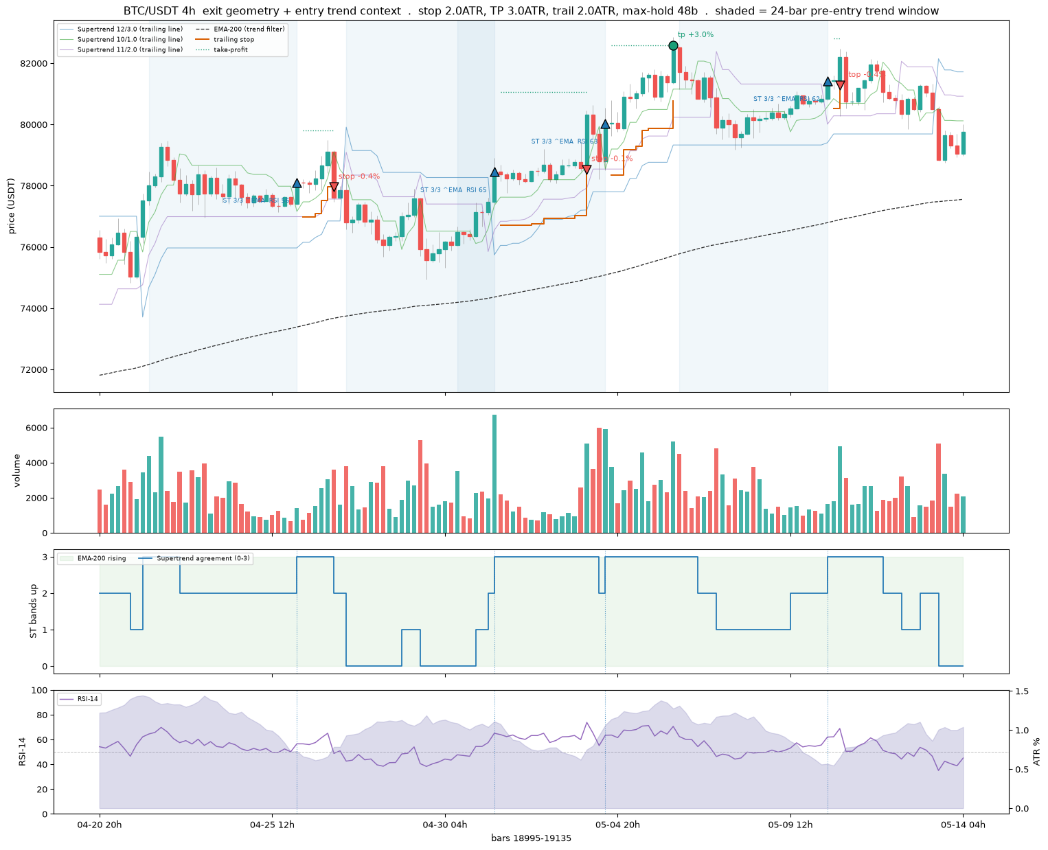
[compare] BTC/USDT 4h: anchored on entry at bar 19113
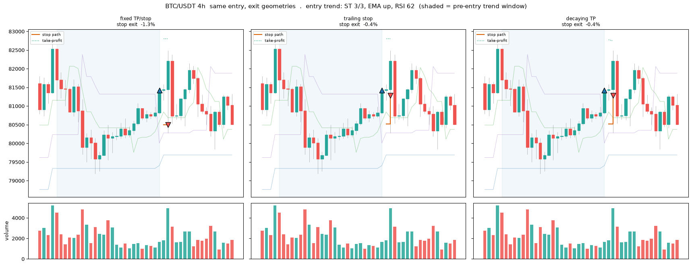

1.6 Decision Checklist
The decision is not a board reading; it is the after-fee scoreboard. A signal counts only if it beats a coin flip, buy-and-hold, and the fee on a blind final year, and Part 3 runs that test per frame across 1h, 4h, and 5m. On the 1h frame the verdict is NO-GO, at the efficient-market floor; 4h carries a little more signal; the cross-sectional relative strength of 1.2 is the one real but still-underwater lead.
Two controls shape where a signal is allowed to trade. The regime state (f_rg_) gives the model observable context: trailing realized volatility and its own-history percentile, a short and a long trend drift, a Kaufman trend efficiency, up-down breadth, and the BTC market regime. The regime gate in 0.4 then deploys the cross-sectional signal only when BTC is trending up, the cheapest in-mandate way to lift the underwater edge.
The daily board is demoted to what it is, an eyeball scan. Read exits before entries, treat a green cell as a candidate to check against the Part 3 evaluation, size and fence it in Part 2, and remember every snapshot is saved and dated under 04-outputs/. The signals table is written to CSV on each run.
saved ../04-outputs/CSV/DailySignals_20260906.csv

2. Trader Controls
The risk and rules layer, from Part 2 of this document. The boundaries every candidate strategy must live inside, above all the fee. This is a selective, high-conviction swing design, not a scalper: a trade held for a clean three to five percent move can absorb a 0.2 percent round trip, a trade chasing half a percent cannot, so the fee is the floor. Three guardrails enforce that, a cap on trades per day, a minimum net-edge floor on thin trades, and the after-fee validation protocol.
The control logic is demonstrated on synthetic OHLCV so it is legible without a data dependency; in production it consumes the same survivorship-complete archives as Parts 1 and 3. The 0.4 adjustments live here where they touch sizing and stops: the stop and trailing stop are ATR-scaled and provisional pending the exit-geometry sweep, and the regime gate is a new control layered on top and implemented in Part 3.

2.1 Key Variables
Every tunable parameter lives in one CONFIG block, never hard-coded, and the risk-bounding ones are operator-owned and held outside the model’s reach: reviewed weekly, and when the bot is built, lifted into a locked module the strategy file cannot write to. Secrets stay in the operator’s Keychain, never in the repo.
The block sets the venue fences (the round-trip fee and modelled slippage), the per-trade economics (the net-edge floor, the take-profit target, the ATR-based stop), the ATR band (floor and ceiling), and the hard selection gates. The stop and take-profit here are a starting point, provisional pending the exit-geometry sweep in Part 3 and superseded by the ATR-scaled exits logged in 0.4. A Supertrend band is itself an ATR-channel trailing stop, so it belongs to this controls vocabulary alongside the volatility filter and the sizing rule.
Environment ready · python 3.12.13
ccxt 4.5.59 · pandas 2.3.3 · numpy 2.2.6 · plotly 6.8.0
# -- CONFIG -- outside the model's reach.
CONFIG = dict(
# Venue fences — Binance crypto round trip (0.075%/side with BNB, 0.1% without)
round_trip_fee_pct = 0.15, # two sides, BNB-discounted; use 0.20 without BNB
expected_slippage_pct = 0.05, # modelled slippage per round trip
# Edge & exit (per-trade economics)
edge_floor_pct = 1.5, # minimum NET expected move to allow a trade
take_profit_pct = 10.0, # target gain; aligned to the Ch3 model label (+10%); must exceed edge_floor_pct
stop_atr_mult = 1.5, # ATR-based stop; the Ch3 label uses a fixed -5% stop, so the stop model (ATR vs fixed) is the open item for 3C exit tuning
# ATR band — selection filter AND live guardrail
atr_length = 14,
atr_floor_pct = 2.5, # below this a coin can't reach TP in the window
atr_ceiling_pct = 12.0, # above this it gaps through stop/TP unpredictably
# Hard gates (selection screen)
min_quote_volume_usdt = 30_000_000,# liquidity floor, 24h quote volume USDT
max_spread_pct = 0.05, # spread ceiling, well under the fee
min_history = 120, # candles required to span regimes
history_limit = 180, # candles pulled per coin (90–180)
# Frequency & position limits
max_trades_per_day = 3, # hard cap — defence one against volume-hiding
max_open_positions = 4, # concurrent positions (3–4 at this account size)
risk_per_trade_pct = 1.0, # % of account risked per trade (constant $ risk)
max_position_pct = 30.0, # cap any single position at this % of account
min_notional_usdt = 10.0, # venue minimum clip; below this a trade isn't worth it
# Hold window — a walk-forward RANGE, not a fixed number (swing band)
hold_window_days_min = 1,
hold_window_days_max = 20, # aligned to the Ch3 model horizon (20 days)
# Account & scan
account_usdt = 750.0, # proving-rig size (~$500–1000)
scan_top_n = 25, # scan wide (15–25), hold few (3–4)
)
Configured binance | account $750 | edge floor 1.5% | ATR band 2.5–12.0% | scan top 25

2.2 Volatility Filter
The control demos run on synthetic OHLCV so the logic is the point, not the bars; synthetic_ohlcv and fetch_daily provide deterministic per-coin data offline, and the live path falls back to it if the network is unavailable. In production the same functions read the survivorship archives proven in Part 1.
The ATR band is the average true range over 14 days as a percent of price, a read of a coin’s typical daily move, and it does two unrelated jobs. As a selection filter it admits or rejects a coin before the model sees it: below the floor, roughly two to three percent daily, a coin cannot reach the take-profit inside the hold window; above the ceiling it gaps through the stop and take-profit unpredictably and the indicators lose meaning. As a live guardrail it keeps the model from trading a coin that has drifted out of the tradable band.
universe (25): USDC/USDT, BTC/USDT, ETH/USDT, ZEC/USDT, SOL/USDT, USD1/USDT, BNB/USDT, PROM/USDT, XRP/USDT, NEAR/USDT, DOGE/USDT, UNI/USDT ...
def compute_atr_pct(df, length=None):
"""ATR(length) as a percent of price. TR = max(H−L, |H−Cprev|, |L−Cprev|);
ATR = simple moving average of TR (as written in §2); atr_pct = ATR/price×100."""
length = length or CONFIG["atr_length"]
h, l, c = df["high"], df["low"], df["close"]
pc = c.shift(1)
tr = pd.concat([(h - l).abs(), (h - pc).abs(), (l - pc).abs()], axis=1).max(axis=1)
atr = tr.rolling(length).mean()
return (atr / c) * 100.0
def atr_band_figure(symbol):
"""Live-guardrail view: ATR(14)% over time against the tradable band."""
df = fetch_daily(symbol)
atr_pct = compute_atr_pct(df)
lo, hi = CONFIG["atr_floor_pct"], CONFIG["atr_ceiling_pct"]
fig = go.Figure()
fig.add_trace(go.Scatter(x=atr_pct.index, y=atr_pct, name="ATR(14) %",
line=dict(color="#0B3D66", width=1.6)))
fig.add_hrect(y0=lo, y1=hi, fillcolor="#2E8B57", opacity=0.10, line_width=0,
annotation_text="tradable band", annotation_position="top left")
fig.add_hline(y=lo, line=dict(color="#2E8B57", dash="dash"),
annotation_text=f"floor {lo}%")
fig.add_hline(y=hi, line=dict(color="#B22222", dash="dash"),
annotation_text=f"ceiling {hi}%")
fig.update_layout(title=f"{symbol} — daily ATR% vs tradable band (selection + live guardrail)",
template="plotly_white", height=360,
yaxis_title="ATR(14) as % of price", xaxis_title=None,
margin=dict(l=40, r=20, t=50, b=30))
return fig
show(atr_band_figure(universe[0]))
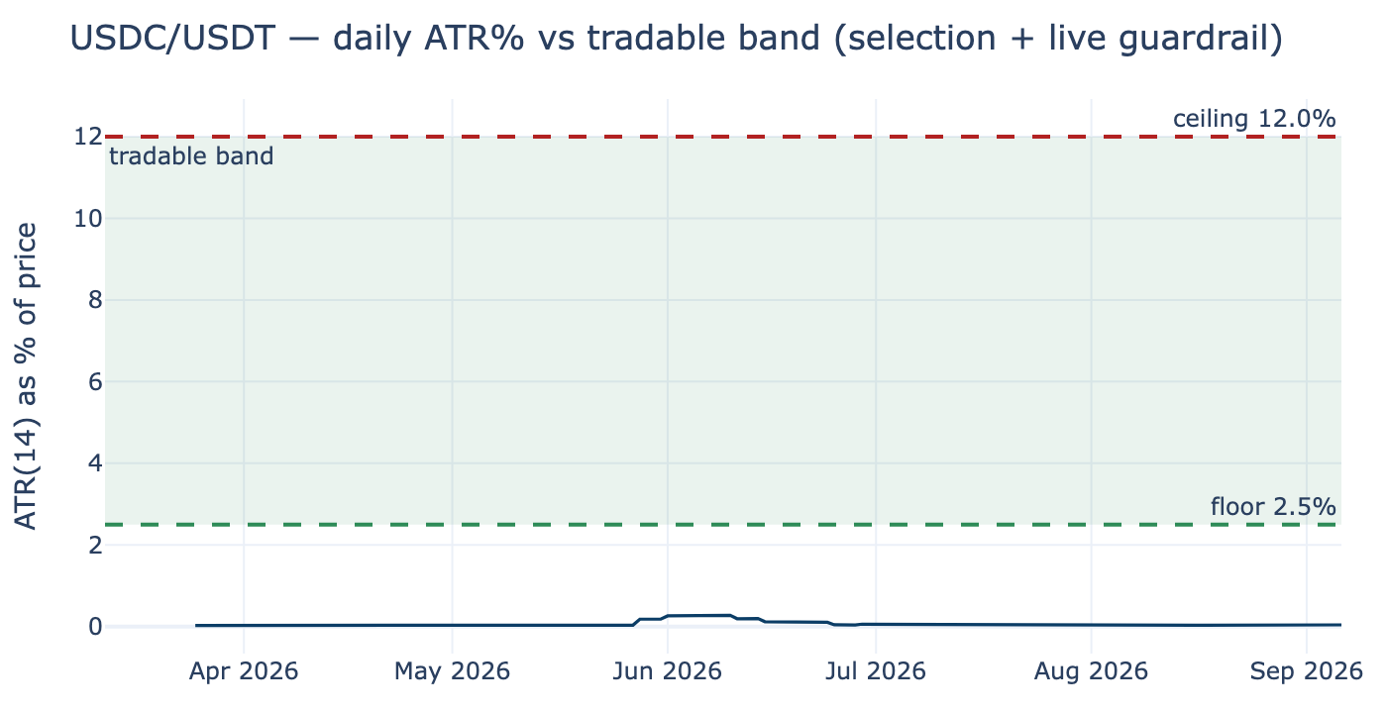

2.3 Four-Gate Screen
Coins are screened individually each week on daily OHLCV plus the order-book top, through four gates. Gate 1 liquidity rejects anything below a 24-hour quote-volume floor, evaluated first because it is the cheap hard gate. Gate 2 is the ATR band, floor to ceiling as above. Gate 3 spread rejects anything wider than a tight ceiling well under the fee floor. Gate 4 history rejects tokens too young to carry a full indicator history. A coin passes only if all four hold, and the screen targets a shortlist of fifteen to twenty-five coins to hold positions on three or four.
The same four-gate screen is replayed point-in-time over history in Part 3, so each training row is kept only if it would have passed as of that bar. Because the archives carry no top-of-book spread, the historical replay approximates it with a Corwin-Schultz high-low estimator while the live screen uses the real spread. The candidate scatter places every scanned coin on liquidity against volatility, with survivors inside the band.
def screen_coin(symbol, cfg=CONFIG):
"""Run the four gates on one coin. Liquidity is evaluated first (it is the cheap,
hard gate); all four numbers are recorded for the table either way."""
df = fetch_daily(symbol, cfg["history_limit"])
candle_count = int(len(df))
quote_vol = fetch_quote_volume(symbol)
spread = fetch_spread_pct(symbol)
atr_series = compute_atr_pct(df, cfg["atr_length"])
atr_pct = float(atr_series.iloc[-1]) if atr_series.notna().any() else float("nan")
g1 = quote_vol >= cfg["min_quote_volume_usdt"] # liquidity (hard)
g2 = (cfg["atr_floor_pct"] <= atr_pct <= cfg["atr_ceiling_pct"]) if atr_pct == atr_pct else False
g3 = spread <= cfg["max_spread_pct"] # spread (hard)
g4 = candle_count >= cfg["min_history"] # history (sufficiency)
gates = {"liquidity": bool(g1), "atr_band": bool(g2), "spread": bool(g3), "history": bool(g4)}
passed = all(gates.values())
fail = "" if passed else ",".join(k for k, v in gates.items() if not v)
return {"symbol": symbol,
"quote_volume_24h_usdt": round(quote_vol, 0),
"atr_pct": round(atr_pct, 3),
"spread_pct": round(spread, 4),
"candle_count": candle_count,
"pass": bool(passed), "fail_reason": fail, **gates}
def run_screen(universe, cfg=CONFIG, save=True):
rows = []
for s in universe:
try:
rows.append(screen_coin(s, cfg))
except Exception as e:
print("skip", s, type(e).__name__, str(e)[:60])
tab = pd.DataFrame(rows).sort_values(["pass", "quote_volume_24h_usdt"],
ascending=[False, False]).reset_index(drop=True)
if save and len(tab):
stamp = datetime.now(timezone.utc).strftime("%Y%m%d")
path = OUTPUTS / f"Candidates_{stamp}.csv"
tab.to_csv(path, index=False)
print(f"saved {path} ({int(tab['pass'].sum())} of {len(tab)} passed)")
return tab
saved /Volumes/PortableSSD/Github/day-trader/04-outputs/Candidates_20260907.csv (15 of 25 passed)
four-gate screen -- 15 of 25 coins passed:
symbol quote_volume_24h_usdt atr_pct spread_pct candle_count pass fail_reason
BTC/USDT 752925794.0 3.110 0.0000 179 True
ETH/USDT 538643028.0 3.842 0.0004 179 True
ZEC/USDT 440685570.0 7.205 0.0008 179 True
SOL/USDT 298140674.0 5.398 0.0094 179 True
BNB/USDT 124736298.0 3.311 0.0013 179 True
XRP/USDT 116177196.0 5.454 0.0071 179 True
NEAR/USDT 89730283.0 6.563 0.0415 179 True
DOGE/USDT 88172438.0 5.662 0.0111 179 True
UNI/USDT 79389414.0 7.667 0.0140 179 True
DASH/USDT 72792950.0 9.102 0.0280 179 True
TAO/USDT 68367539.0 6.535 0.0364 179 True
SUI/USDT 58510140.0 6.256 0.0124 179 True
LINK/USDT 55472368.0 5.003 0.0076 179 True
RAY/USDT 41820197.0 7.238 0.0487 179 True
ADA/USDT 31055399.0 5.985 0.0448 179 True
USDC/USDT 2388434323.0 0.041 0.0010 179 False atr_band
USD1/USDT 138131858.0 0.043 0.0010 179 False atr_band
PROM/USDT 124454447.0 21.537 0.0187 179 False atr_band
ARB/USDT 72299690.0 8.720 0.0541 179 False spread
MARSCOIN/USDT 58084851.0 NaN 0.0618 3 False atr_band,spread,history
SAHARA/USDT 50922215.0 6.011 0.1075 179 False spread
PUMP/USDT 41299991.0 12.797 0.0251 179 False atr_band
ENA/USDT 39825437.0 10.990 0.0572 179 False spread
WLD/USDT 25171531.0 7.126 0.0237 179 False liquidity
LTC/USDT 21526457.0 4.000 0.0184 179 False liquidity
symbol quote_volume_24h_usdt atr_pct spread_pct candle_count \
0 BTC/USDT 7.529258e+08 3.110 0.0000 179
1 ETH/USDT 5.386430e+08 3.842 0.0004 179
2 ZEC/USDT 4.406856e+08 7.205 0.0008 179
3 SOL/USDT 2.981407e+08 5.398 0.0094 179
4 BNB/USDT 1.247363e+08 3.311 0.0013 179
5 XRP/USDT 1.161772e+08 5.454 0.0071 179
6 NEAR/USDT 8.973028e+07 6.563 0.0415 179
7 DOGE/USDT 8.817244e+07 5.662 0.0111 179
8 UNI/USDT 7.938941e+07 7.667 0.0140 179
9 DASH/USDT 7.279295e+07 9.102 0.0280 179
10 TAO/USDT 6.836754e+07 6.535 0.0364 179
11 SUI/USDT 5.851014e+07 6.256 0.0124 179
12 LINK/USDT 5.547237e+07 5.003 0.0076 179
13 RAY/USDT 4.182020e+07 7.238 0.0487 179
14 ADA/USDT 3.105540e+07 5.985 0.0448 179
15 USDC/USDT 2.388434e+09 0.041 0.0010 179
16 USD1/USDT 1.381319e+08 0.043 0.0010 179
17 PROM/USDT 1.244544e+08 21.537 0.0187 179
18 ARB/USDT 7.229969e+07 8.720 0.0541 179
19 MARSCOIN/USDT 5.808485e+07 NaN 0.0618 3
20 SAHARA/USDT 5.092222e+07 6.011 0.1075 179
21 PUMP/USDT 4.129999e+07 12.797 0.0251 179
22 ENA/USDT 3.982544e+07 10.990 0.0572 179
23 WLD/USDT 2.517153e+07 7.126 0.0237 179
24 LTC/USDT 2.152646e+07 4.000 0.0184 179
pass fail_reason
0 True
1 True
2 True
3 True
4 True
5 True
6 True
7 True
8 True
9 True
10 True
11 True
12 True
13 True
14 True
15 False atr_band
16 False atr_band
17 False atr_band
18 False spread
19 False atr_band,spread,history
20 False spread
21 False atr_band
22 False spread
23 False liquidity
24 False liquidity
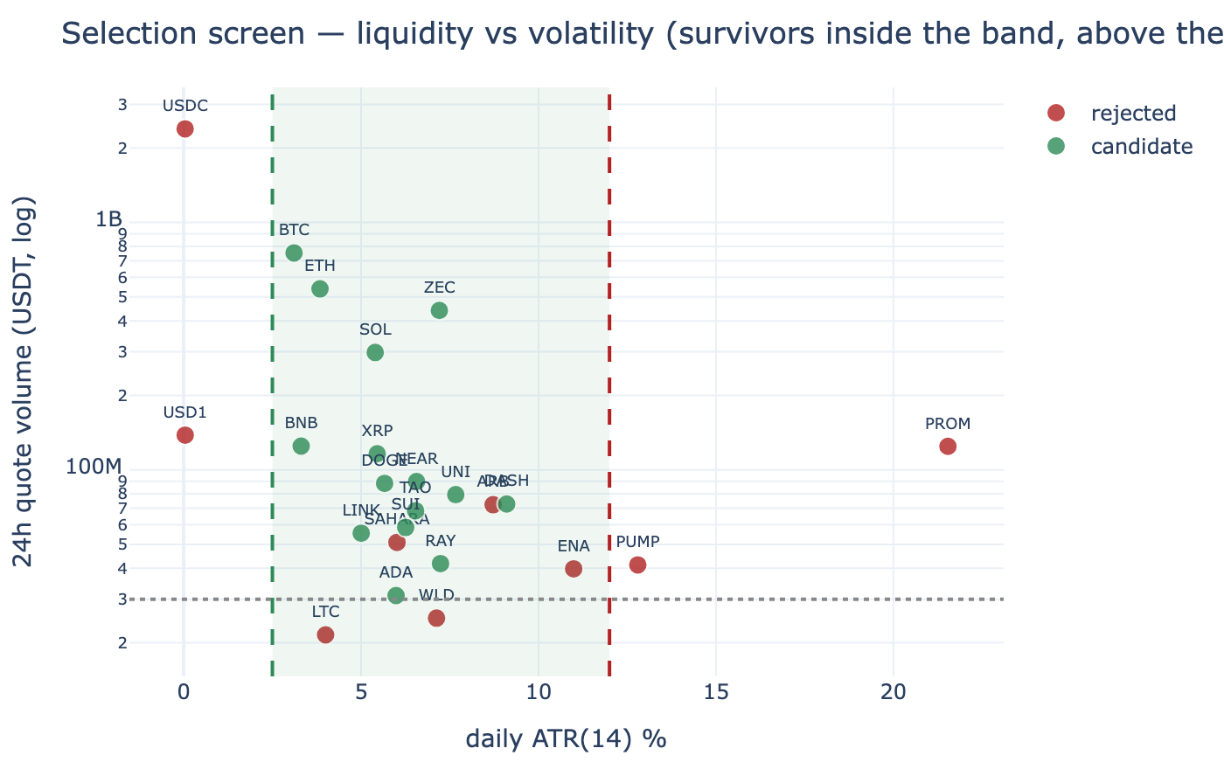
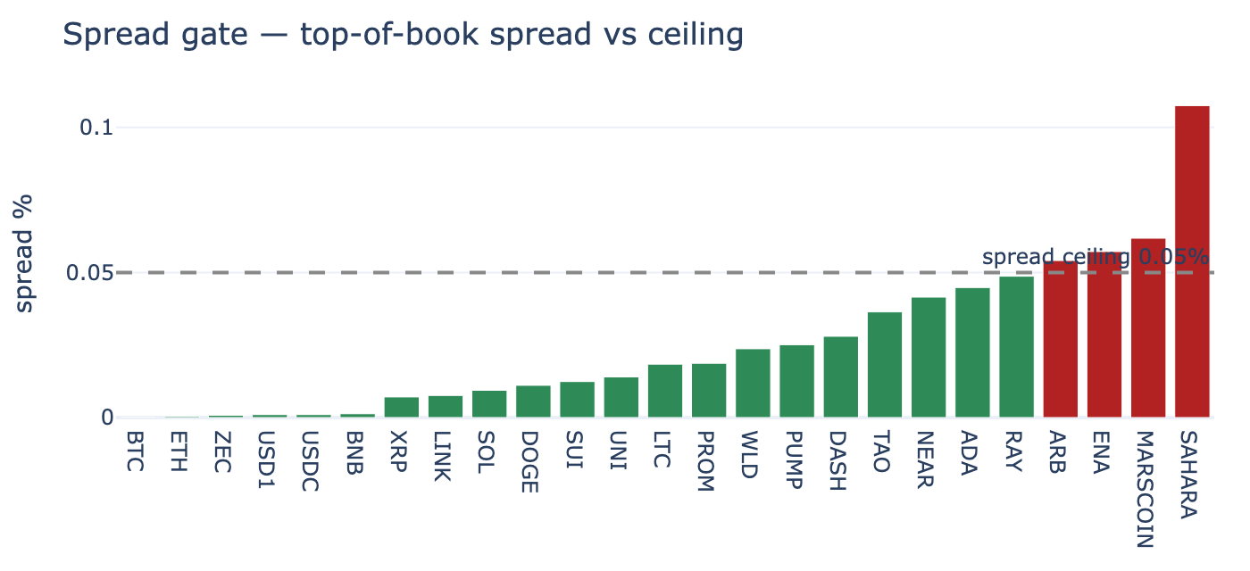

2.4 Edge Sizing
The net-edge fence is the entry gate: a trade is refused unless the estimated move minus the round-trip fee and slippage clears the edge floor. It is measured on net, not gross, and it refuses rather than warns. Exit coupling is enforced in code: the edge floor must sit below the take-profit, and the ATR floor must be high enough that a normal multi-day range reaches the take-profit inside the hold window.
Position sizing is volatility-scaled to keep dollar risk roughly constant across coins: the stop distance times the position value is held near a fixed risk budget, so a higher-ATR coin earns a smaller clip and a calmer coin a larger one, never past the per-position cap or below the venue minimum. At a small account this pushes toward a few larger positions rather than many tiny clips that waste edge on fees. The take-profit and stop in the CONFIG reference an older fixed label and are provisional pending the exit-geometry and label sweeps in 0.4 and Part 3.
# -- Net edge fence (entry gate) ---
def net_edge(est_move_pct, cfg=CONFIG):
"""NET expected move after round-trip fee and slippage (not gross)."""
return est_move_pct - cfg["round_trip_fee_pct"] - cfg["expected_slippage_pct"]
def net_edge_ok(est_move_pct, cfg=CONFIG):
"""The fence: refuse unless net move clears the floor. Refuses, does not warn."""
return net_edge(est_move_pct, cfg) >= cfg["edge_floor_pct"]
# -- Exit coupling (enforced ordering) ---
def validate_exit_coupling(cfg=CONFIG):
rt = cfg["round_trip_fee_pct"] + cfg["expected_slippage_pct"]
days_to_tp = cfg["take_profit_pct"] / cfg["atr_floor_pct"] # at the ATR floor
return {
"edge_floor < take_profit": cfg["edge_floor_pct"] < cfg["take_profit_pct"],
"round_trip < edge_floor": rt < cfg["edge_floor_pct"],
"take_profit > 2x round_trip (alive)": cfg["take_profit_pct"] > 2 * rt,
f"TP reachable at the ATR floor within the window (about {days_to_tp:.1f} days)":
days_to_tp <= cfg["hold_window_days_max"],
}
# -- ATR-scaled position sizing (constant dollar risk) ---
def position_plan(atr_pct, cfg=CONFIG, account=None):
"""Size so dollar risk is ~constant across coins: higher ATR -> smaller position.
stop% = stop_atr_mult × daily ATR%; size = risk_budget / stop%. Capped at
max_position_pct, floored at the venue minimum notional."""
account = account or cfg["account_usdt"]
stop_pct = cfg["stop_atr_mult"] * atr_pct
risk_budget = account * cfg["risk_per_trade_pct"] / 100.0
raw = risk_budget / (stop_pct / 100.0) if stop_pct > 0 else 0.0
capped = min(raw, account * cfg["max_position_pct"] / 100.0)
final = max(capped, cfg["min_notional_usdt"])
return {"atr_pct": round(atr_pct, 3), "stop_pct": round(stop_pct, 3),
"risk_budget_usdt": round(risk_budget, 2), "raw_size_usdt": round(raw, 2),
"position_usdt": round(final, 2),
"floored_at_min": bool(final == cfg["min_notional_usdt"] and capped < cfg["min_notional_usdt"])}
Net-edge fence (gross est. move -> net -> allowed?):
est 1.0% -> net 0.80% -> refuse
est 1.5% -> net 1.30% -> refuse
est 2.0% -> net 1.80% -> ALLOW
est 3.5% -> net 3.30% -> ALLOW
Exit-coupling checks (config must satisfy all):
[ok] edge_floor < take_profit
[ok] round_trip < edge_floor
[ok] take_profit > 2x round_trip (alive)
[ok] TP reachable at the ATR floor within the window (about 4.0 days)
symbol atr_pct stop_pct position_usdt floored_at_min
0 BTC/USDT 3.110 4.665 160.77 False
1 BNB/USDT 3.311 4.966 151.01 False
2 ETH/USDT 3.842 5.763 130.14 False
3 LINK/USDT 5.003 7.505 99.94 False
4 SOL/USDT 5.398 8.097 92.63 False
5 XRP/USDT 5.454 8.181 91.68 False
6 DOGE/USDT 5.662 8.493 88.31 False
7 ADA/USDT 5.985 8.978 83.54 False
8 SUI/USDT 6.256 9.384 79.92 False
9 TAO/USDT 6.535 9.803 76.51 False
10 NEAR/USDT 6.563 9.845 76.18 False
11 ZEC/USDT 7.205 10.808 69.40 False
12 RAY/USDT 7.238 10.857 69.08 False
13 UNI/USDT 7.667 11.500 65.21 False
14 DASH/USDT 9.102 13.653 54.93 False
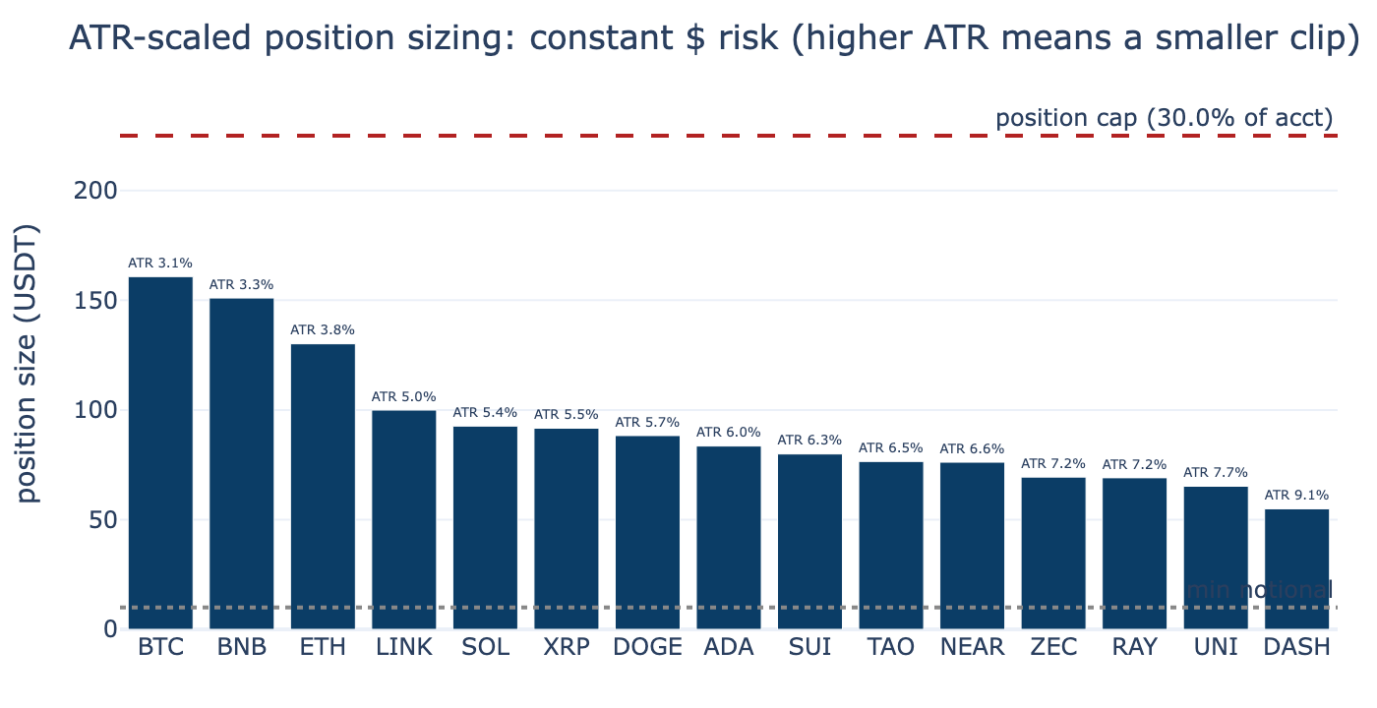

2.5 Hold Period
The hold period is the swing band, days to about two weeks. Scalping and day-trading are ruled out by fees and the pattern-day-trading rule, position-trading by underusing the signal stack. Within the swing band the hold window is a walk-forward parameter, searched roughly one to twenty days and picked by out-of-sample results, not by a gut figure. Shorter holds demand a higher ATR to reach the target in time; longer holds tolerate a lower one. This is the same coupling as the edge fence, seen on the time axis.

2.6 Stacked Defences
The defences are layered, not single. The selection screen keeps unsuitable coins out, the net-edge fence keeps thin trades out, the ATR band is both a selection filter and a live guardrail, the position cap and venue minimum bound each clip, and the per-day trade cap and the cash floor bound the book. Above them sit the 0.4 controls: the ATR-scaled stop and trailing stop, provisional pending the exit-geometry sweep, and the new regime gate that only lets the cross-sectional signal trade when BTC is trending up, implemented in Part 3.
The floor fence is the minimum net edge; the venue fences are the fee and slippage assumptions that define it. Each defence is cheap and independent, so a coin must clear all of them and any one can veto.

2.7 Signal Journal
A learning aid, not a trader. For each coin it finds every entry and exit the MACD logic produced, draws the candles with the moving averages and a volume histogram, marks each signal, and writes a table beside the chart recording what the model saw, trend, RSI, and volatility, and whether the fee fence would actually let the trade fire. Each study sheet is saved as a self-contained HTML page under 04-outputs/journal/, so a visual library builds up on every run. The net-edge column uses the take-profit as a stand-in for the expected move until the Part 3 model supplies a real per-trade estimate; the entries marked would-fire are the ones that clear both the fee floor and the ATR band.
saved /Volumes/PortableSSD/Github/day-trader/04-outputs/journal/journal_BTC-USDT_20260907.html - 21 entries/exits documented
saved /Volumes/PortableSSD/Github/day-trader/04-outputs/journal/journal_ETH-USDT_20260907.html - 15 entries/exits documented
saved /Volumes/PortableSSD/Github/day-trader/04-outputs/journal/journal_ZEC-USDT_20260907.html - 19 entries/exits documented
3 journal(s) saved under 04-outputs/journal/
--- BTC/USDT ---
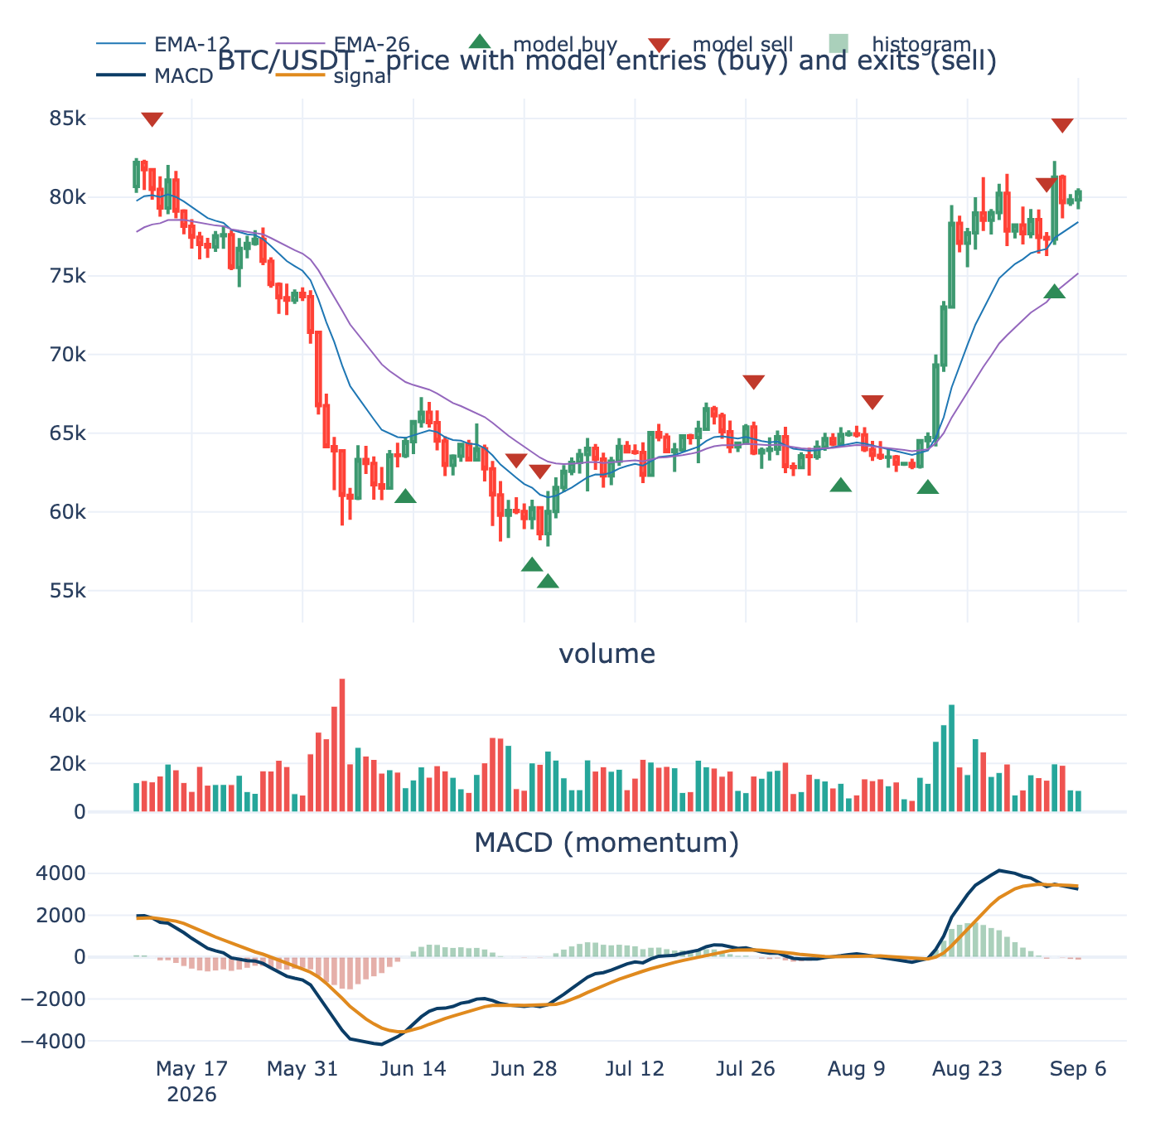
date action price trend rsi atr_pct net_edge_pct \
0 2026-02-01 exit / sell 76968.21 down NaN NaN 9.8
1 2026-02-20 enter / buy 68020.01 down 41.0 4.27 9.8
2 2026-02-24 exit / sell 64058.15 down 34.0 3.97 9.8
3 2026-02-25 enter / buy 67988.04 down 53.0 4.00 9.8
4 2026-03-21 exit / sell 68918.12 up 55.0 3.86 9.8
5 2026-04-06 enter / buy 68853.66 down 42.0 3.17 9.8
6 2026-04-28 exit / sell 76342.77 up 57.0 2.89 9.8
7 2026-05-04 enter / buy 79861.01 up 67.0 2.48 9.8
8 2026-05-12 exit / sell 80504.47 up 68.0 2.36 9.8
9 2026-06-13 enter / buy 64458.01 down 27.0 4.28 9.8
10 2026-06-27 exit / sell 60029.00 down 33.0 3.66 9.8
11 2026-06-29 enter / buy 60260.21 down 25.0 3.58 9.8
12 2026-06-30 exit / sell 58624.71 down 23.0 3.74 9.8
13 2026-07-01 enter / buy 60024.00 down 33.0 3.77 9.8
14 2026-07-27 exit / sell 63755.86 up 56.0 2.49 9.8
15 2026-08-07 enter / buy 64923.19 up 54.0 2.15 9.8
16 2026-08-11 exit / sell 63600.00 up 48.0 2.03 9.8
17 2026-08-18 enter / buy 64725.42 down 56.0 1.60 9.8
18 2026-09-02 exit / sell 77340.01 up 70.0 3.75 9.8
19 2026-09-03 enter / buy 81270.37 up 71.0 3.64 9.8
20 2026-09-04 exit / sell 79660.77 up 54.0 3.38 9.8
fence size_usdt \
0 exit NaN
1 would fire 117.03
2 exit NaN
3 would fire 124.88
4 exit NaN
5 would fire 157.60
6 exit NaN
7 blocked: out of band NaN
8 exit NaN
9 would fire 116.78
10 exit NaN
11 would fire 139.55
12 exit NaN
13 would fire 132.64
14 exit NaN
15 blocked: out of band NaN
16 exit NaN
17 blocked: out of band NaN
18 exit NaN
19 would fire 137.28
20 exit NaN
note
0 MACD crossed below signal -> momentum turning ...
1 MACD crossed above signal -> momentum turning up
2 MACD crossed below signal -> momentum turning ...
3 MACD crossed above signal -> momentum turning up
4 MACD crossed below signal -> momentum turning ...
5 MACD crossed above signal -> momentum turning up
6 MACD crossed below signal -> momentum turning ...
7 MACD crossed above signal -> momentum turning up
8 MACD crossed below signal -> momentum turning ...
9 MACD crossed above signal -> momentum turning up
10 MACD crossed below signal -> momentum turning ...
11 MACD crossed above signal -> momentum turning up
12 MACD crossed below signal -> momentum turning ...
13 MACD crossed above signal -> momentum turning up
14 MACD crossed below signal -> momentum turning ...
15 MACD crossed above signal -> momentum turning up
16 MACD crossed below signal -> momentum turning ...
17 MACD crossed above signal -> momentum turning up
18 MACD crossed below signal -> momentum turning ...
19 MACD crossed above signal -> momentum turning up
20 MACD crossed below signal -> momentum turning ...

2.8 Frozen Harness
The yardstick is frozen and operator-owned. Every walk-forward run appends one line to a log, the parameters tried, the out-of-sample after-fee result, and whether it was kept or discarded, and the operator reviews it weekly. The model never writes to the harness or the log, which keeps the evaluation surface human rather than automated away. The harness fixes the out-of-sample window, the train window, the embargo that straddles the cut, the regime set, the fee assumption, and the metric, identical across every comparison so results are commensurable.
The dated candidate table and the experiment log are written under 04-outputs/ each run, and nothing else: the notebook screens and sizes only, no orders, with LIVE_TRADING left false and never read here.
# Frozen evaluation harness — versioned, identical across every comparison. (locked)
HARNESS = dict(
version = "harness-v1",
oos_window_days = 90,
train_window_days = 365,
embargo_days = 20, # straddles the train/test cut
regime_set = ["bull", "bear", "sideways"],
fee_assumption_pct = CONFIG["round_trip_fee_pct"],
metric = "oos_after_fee_expectancy",
)
def log_experiment(params: dict, oos_result: dict, kept: bool, why: str,
path=OUTPUTS / "experiment_log.csv"):
"""Append one line per walk-forward run. The artefact the operator wakes to."""
row = {"ts_utc": datetime.now(timezone.utc).isoformat(timespec="seconds"),
"harness": HARNESS["version"], "kept": bool(kept), "why": why,
**{f"p_{k}": v for k, v in params.items()},
**{f"oos_{k}": v for k, v in oos_result.items()}}
df = pd.DataFrame([row])
header = not path.exists()
df.to_csv(path, mode="a", header=header, index=False)
return path
# Demonstration entry (replace with real walk-forward output once that loop exists).
p = log_experiment(
params=dict(edge_floor_pct=CONFIG["edge_floor_pct"], take_profit_pct=CONFIG["take_profit_pct"],
atr_floor_pct=CONFIG["atr_floor_pct"], threshold=2),
oos_result=dict(after_fee_expectancy_pct=-0.4, win_rate=0.41, n_trades=37, vs_buy_hold_pct=+1.2),
kept=False, why="no demonstrated OOS edge after fees (matches standing NO-GO)")
print("logged ->", p)
_log = pd.read_csv(p)
print(f'\nexperiment_log.csv ({len(_log)} rows; last 3):')
print(_log.tail(3).to_string(index=False)) # text fallback: renders in every IDE
display(_log.tail(3))
logged -> /Volumes/PortableSSD/Github/day-trader/04-outputs/experiment_log.csv
experiment_log.csv (9 rows; last 3):
ts_utc harness kept why p_edge_floor_pct p_take_profit_pct p_atr_floor_pct p_threshold oos_after_fee_expectancy_pct oos_win_rate oos_n_trades oos_vs_buy_hold_pct
2026-09-07T02:19:27+00:00 harness-v1 False no demonstrated OOS edge after fees (matches standing NO-GO) 1.5 10.0 2.5 2 -0.4 0.41 37 1.2
2026-09-07T02:33:21+00:00 harness-v1 False no demonstrated OOS edge after fees (matches standing NO-GO) 1.5 10.0 2.5 2 -0.4 0.41 37 1.2
2026-09-07T02:56:33+00:00 harness-v1 False no demonstrated OOS edge after fees (matches standing NO-GO) 1.5 10.0 2.5 2 -0.4 0.41 37 1.2
ts_utc harness kept \
6 2026-09-07T02:19:27+00:00 harness-v1 False
7 2026-09-07T02:33:21+00:00 harness-v1 False
8 2026-09-07T02:56:33+00:00 harness-v1 False
why p_edge_floor_pct \
6 no demonstrated OOS edge after fees (matches s... 1.5
7 no demonstrated OOS edge after fees (matches s... 1.5
8 no demonstrated OOS edge after fees (matches s... 1.5
p_take_profit_pct p_atr_floor_pct p_threshold \
6 10.0 2.5 2
7 10.0 2.5 2
8 10.0 2.5 2
oos_after_fee_expectancy_pct oos_win_rate oos_n_trades \
6 -0.4 0.41 37
7 -0.4 0.41 37
8 -0.4 0.41 37
oos_vs_buy_hold_pct
6 1.2
7 1.2
8 1.2
Artefacts written this run:
/Volumes/PortableSSD/Github/day-trader/04-outputs/Candidates_20260629.csv (1946 bytes)
/Volumes/PortableSSD/Github/day-trader/04-outputs/Candidates_20260701.csv (1956 bytes)
/Volumes/PortableSSD/Github/day-trader/04-outputs/Candidates_20260703.csv (1995 bytes)
/Volumes/PortableSSD/Github/day-trader/04-outputs/Candidates_20260906.csv (1858 bytes)
/Volumes/PortableSSD/Github/day-trader/04-outputs/Candidates_20260907.csv (1812 bytes)
/Volumes/PortableSSD/Github/day-trader/04-outputs/experiment_log.csv (1386 bytes)
Reminder: this notebook screens and sizes only. No orders are placed; LIVE_TRADING stays 'false' in 03-inputs/config.py and is never read here.

3. Trader Execution
The modeling and search layer, from Part 3 of this document. Where the datasets, features, and model meet the after-fee test, run per frame across 1h, 4h, and 5m. This is the decision-grade chapter: everything Parts 1 and 2 describe is built, screened point-in-time, labelled, trained, and scored on a blind final year here, and only what clears the fee out of sample counts.
The 0.4 adjustments are implemented across these sections: the label in 3.1 and 3.7, the ATR-scaled exits in 3.3, the regime gate in 3.12, and the longer-horizon frame across every per-frame loop. The cells run top to bottom on the project .venv. LOAD_FRAME selects the active frame the single-frame cells consume; the multi-frame sections from 3.9 on loop over all three frames on their own and restore the active frame afterward.

3.1 Data Preparation
The environment imports the shared loader build_dataset_1h, the split and cost machinery, and the model libraries. The three frames are built offline from the survivorship-complete data.binance.vision archives into dataset_5m_allmarket, dataset_1h_allmarket, and dataset_4h_allmarket, one builder retuned per frame. LOAD_FRAME picks the active frame, Import Data loads its Parquet into df and feat, and the train-test split holds out the final year with an embargo equal to the label horizon so no future leaks across the cut. The label is the ATR-scaled triple barrier; the 0.4 revision toward a longer, less fee-punishing geometry is the intended change tracked here.
outputs -> /Volumes/PortableSSD/Github/day-trader/04-outputs
env ready . kernel: /Volumes/PortableSSD/Github/day-trader/.venv/bin/python
python 3.12.13 . lightgbm yes . pandas-ta yes . TA-Lib yes
# Knobs live in the scripts so the notebook cannot drift. Read-only here.
CONFIG = dict(
oos_days = t1.OOS_DAYS, # final year held out of sample
embargo_days = t1.EMBARGO_DAYS, # = label horizon in days
conf_hi = tm.CONF_HI, # confidence filter act-long (Keller Metric 1)
conf_lo = tm.CONF_LO, # act-short / stand-aside
cost_pct = tm.COST_PCT, # round-trip drag (fee + slippage), Metric 2
)
lab = bd.LABEL
print(f"label: +{lab['tgt_atr']} ATR before -{lab['stp_atr']} ATR within {lab['horizon_bars']} bars "
f"({lab['horizon_bars']//bd.BARS_PER_DAY}d) . hold out final {CONFIG['oos_days']}d, "
f"embargo +/-{CONFIG['embargo_days']}d . confidence {CONFIG['conf_lo']}-{CONFIG['conf_hi']} . "
f"cost {CONFIG['cost_pct']:.2f}% round trip")
label: +2.0 ATR before -1.0 ATR within 12 bars (2d) . hold out final 365d, embargo +/-2d . confidence 0.4-0.6 . cost 0.20% round trip
SOURCE / LOCATION (Binance spot, data.binance.vision archives; one dataset per frame)
[ 1h] dataset_1h_allmarket.parquet 2026-06-21 11:15, 684 MB <- active
klines: /Volumes/PortableSSD/Github/day-trader/03-inputs/binance-data/klines_1h
[ 4h] dataset_4h_allmarket.parquet 2026-06-23 20:30, 2008 MB
klines: /Volumes/PortableSSD/Github/day-trader/03-inputs/binance-data/klines_4h
[ 5m] dataset_5m_allmarket.parquet 2026-06-24 23:02, 2990 MB
klines: /Volumes/PortableSSD/Github/day-trader/03-inputs/binance-data/klines_5m
storage : Parquet (columnar, compressed, dtype-preserving); CSV is the fallback
ACTIVE FRAME = 1h (the cells below model this frame)
flow table : flow_1h.parquet 2026-06-21 10:36, 458 MB
dataset : dataset_1h_allmarket.parquet 2026-06-21 11:15, 684 MB
TIME WINDOWS (counts of bars; 1 bar = the active frame)
wall-clock (daily x bars/day): {'ema_fast': 336, 'ema_mid': 2184, 'ema_slow': 3000, 'rsi': 336, 'bb': 336, 'bb_std': 2.0, 'atr': 336, 'rv_short': 168, 'rv_long': 720, 'vol': 480, 'mom': [120, 240, 480, 1440]}
intraday : {'ema_fast': 12, 'ema_mid': 26, 'ema_slow': 50, 'rsi': 14, 'bb': 20, 'bb_std': 2.0, 'atr': 14, 'rv_short': 24, 'rv_long': 168, 'vol': 24, 'mom': [6, 12, 24, 72, 168]}
LABEL (ATR-scaled triple barrier): {'tgt_atr': 2.0, 'stp_atr': 1.0, 'horizon_bars': 48, 'atr_len': 14}
SCREEN gates : {'min_quote_volume_usdt': 30000000, 'qv_window': 24, 'atr_floor_pct': 0.5, 'atr_ceiling_pct': 2.5, 'atr_len': 14, 'min_history_bars': 2880, 'spread_proxy_ceiling_pct': 0.5, 'spread_window': 24}
DATA-QUALITY gate : {'max_gap_ratio': 0.02, 'max_single_gap_hours': 72}
To (re)build offline from the .venv (reference - not run here):
.venv/bin/python 03-inputs/binance-data/flow_data.py --interval 1h --all-market
.venv/bin/python 03-inputs/build_dataset_1h.py --interval 1h
LOADED 1,640,660 rows from Parquet (1h frame)
in-sample rows : 458,539 (27.9% of total)
coins : 47
features : 61
date range : 2017-10-16 11:00:00 -> 2026-06-18 23:00:00
base rate all / in-sample : 0.322 / 0.313
feature families : wall-clock 13, intraday 14, in-house TA 8, pandas-ta 7, TA-Lib 15, flow 4
in-sample rows with any NaN feature: 0
rows per coin:
 | rows
symbol
BTC/USDT | 75229
ETH/USDT | 75229
BNB/USDT | 73293
LTC/USDT | 72405
ADA/USDT | 69437
LINK/USDT | 62715
FET/USDT | 61837
DASH/USDT | 61177
DOGE/USDT | 58971
HBAR/USDT | 56858
CHZ/USDT | 56837
BCH/USDT | 55495
SOL/USDT | 49343
JST/USDT | 49290
SAND/USDT | 49264
PAXG/USDT | 48754
BEL/USDT | 48437
AVAX/USDT | 48335
NEAR/USDT | 47808
AAVE/USDT | 47772
INJ/USDT | 47613
AXS/USDT | 47352
ALICE/USDT | 44456
RIF/USDT | 44034
BICO/USDT | 37805
PEPE/USDT | 25926
ORDI/USDT | 21468
JTO/USDT | 20730
ALT/USDT | 19574
PORTAL/USDT | 18734
ENA/USDT | 17944
RENDER/USDT | 15184
EIGEN/USDT | 13565
ACT/USDT | 12538
PENGU/USDT | 11722
BIO/USDT | 11304
HEI/USDT | 10322
EPIC/USDT | 9650
ONDO/USDT | 8962
HOME/USDT | 7473
PUMP/USDT | 5292
EDEN/USDT | 4823
ASTER/USDT | 4692
ALLO/USDT | 3826
MET/USDT | 3778
SOLV/USDT | 2462
NIGHT/USDT | 945

3.2 Feature Variables
Every feature is causal and scale-invariant, computed from past bars only and normalized so hundreds of coins compare. The families span an in-house wall-clock and intraday baseline, extra oscillators, an optional pandas-ta momentum block including the scale-free PPO, an optional TA-Lib block, the trade-flow imbalance, the triple-Supertrend (f_st_), the Modern Adaptive Supertrend (f_mst_), BTC lead-lag relative strength (f_btc_), multi-timeframe context (f_4h_, f_d1_, f_w1_), and the regime state (f_rg_). Feature integration verifies the higher-timeframe joins are causal with no lookahead.
wall-clock (wc) : 13
intraday (hr) : 14
in-house TA : 8
pandas-ta : 7
TA-Lib : 15
flow : 4
TOTAL : 61
 | mean | std | min | max
f_wc_ema_fast_mid | -0.018 | 0.194 | -1.729 | 0.655
f_wc_ema_mid_slow | -0.006 | 0.064 | -0.566 | 0.153
f_wc_rsi | 0.502 | 0.026 | 0.372 | 0.647
f_wc_bb_pos | 0.531 | 0.358 | -1.825 | 2.594
f_wc_atr_pct | 0.014 | 0.006 | 0.002 | 0.076
f_wc_rv_short | 0.009 | 0.004 | 0.002 | 0.049
f_wc_rv_long | 0.010 | 0.004 | 0.002 | 0.055
f_wc_rv_ratio | 0.957 | 0.247 | 0.257 | 2.037
f_wc_vol_ratio | 1.032 | 1.123 | 0.001 | 129.313
f_wc_mom_120 | 0.011 | 0.097 | -0.716 | 0.801
f_wc_mom_240 | 0.019 | 0.144 | -0.724 | 2.531
f_wc_mom_480 | 0.038 | 0.241 | -0.722 | 11.377
f_wc_mom_1440 | 0.189 | 0.949 | -0.823 | 28.396
f_hr_ema_fast_mid | 0.000 | 0.010 | -0.063 | 0.050
f_hr_ema_mid_slow | 0.000 | 0.012 | -0.077 | 0.059
f_hr_rsi | 0.503 | 0.122 | 0.054 | 0.965
f_hr_bb_pos | 0.503 | 0.337 | -0.576 | 1.582
f_hr_atr_pct | 0.013 | 0.005 | 0.005 | 0.025
f_hr_rv_short | 0.008 | 0.004 | 0.002 | 0.062
f_hr_rv_long | 0.009 | 0.004 | 0.002 | 0.049
f_hr_rv_ratio | 0.961 | 0.320 | 0.159 | 2.606
f_hr_vol_ratio | 1.024 | 0.789 | 0.002 | 19.739
f_hr_mom_6 | 0.001 | 0.022 | -0.137 | 0.244
f_hr_mom_12 | 0.001 | 0.031 | -0.150 | 0.277
f_hr_mom_24 | 0.003 | 0.044 | -0.260 | 0.312
f_hr_mom_72 | 0.007 | 0.074 | -0.387 | 0.588
f_hr_mom_168 | 0.014 | 0.117 | -0.721 | 1.089
f_ta_willr | -0.487 | 0.274 | -1.000 | -0.000
f_ta_stochk | 0.513 | 0.274 | 0.000 | 1.000
f_ta_cci | 0.006 | 0.923 | -6.722 | 6.836
f_ta_cmf | 0.020 | 0.162 | -0.705 | 0.750
f_ta_mfi | 0.501 | 0.182 | 0.000 | 1.000
f_ta_adx | 0.273 | 0.111 | 0.056 | 0.834
f_ta_dmi_diff | -0.007 | 0.148 | -0.721 | 0.754
f_ta_aroon_osc | 0.020 | 0.606 | -1.000 | 1.000
f_ta_pta_ppo_hist | -0.000 | 0.005 | -0.039 | 0.043
f_ta_pta_trix | 0.006 | 0.095 | -0.568 | 0.678
f_ta_pta_vortex_diff | 0.009 | 0.318 | -1.141 | 1.285
f_ta_pta_cmo | 0.007 | 0.244 | -0.892 | 0.931
f_ta_pta_fisher | -0.126 | 2.023 | -7.600 | 7.598
f_ta_pta_cksp_long_dist | 0.001 | 0.028 | -0.669 | 0.085
f_ta_pta_cksp_short_dist | -0.000 | 0.029 | -0.622 | 0.087
f_tl_sar_dist | 0.000 | 0.033 | -0.274 | 0.508
f_tl_ultosc | 0.512 | 0.085 | 0.127 | 0.864
f_tl_ht_trendmode | 0.617 | 0.486 | 0.000 | 1.000
f_tl_ht_dcphase | 0.679 | 0.561 | -0.250 | 1.750
f_tl_mama_dist | 0.000 | 0.013 | -0.110 | 0.167
f_tl_cdl_engulfing | -0.006 | 0.369 | -1.000 | 1.000
f_tl_cdl_hammer | 0.027 | 0.162 | 0.000 | 1.000
f_tl_cdl_shootingstar | -0.005 | 0.072 | -1.000 | 0.000
f_tl_cdl_doji | 0.150 | 0.357 | 0.000 | 1.000
f_tl_cdl_morningstar | 0.003 | 0.051 | 0.000 | 1.000
f_tl_cdl_eveningstar | -0.003 | 0.054 | -1.000 | 0.000
f_tl_cdl_three_white | 0.001 | 0.024 | 0.000 | 1.000
f_tl_cdl_three_black | -0.000 | 0.009 | -1.000 | 0.000
f_tl_cdl_harami | 0.001 | 0.267 | -1.000 | 1.000
f_tl_cdl_marubozu | 0.004 | 0.189 | -1.000 | 1.000
f_flow_imb | -0.009 | 0.132 | -0.905 | 0.896
f_flow_imb_24 | -0.009 | 0.044 | -0.713 | 0.544
f_flow_imb_168 | -0.009 | 0.028 | -0.292 | 0.286
f_flow_taker_ratio | 0.496 | 0.066 | 0.047 | 0.948
f_st_ triple-Supertrend : 0 cols []
f_btc_ BTC lead-lag / rel-str : 0 cols []
f_4h_/f_d1_ multi-timeframe : 0 cols []
integration point -> build_coin(df, symbol_slash, flow, btc):
feats.update(supertrend_block(df)) # f_st_ : 3 ATR bands voting + EMA-200 gate
feats.update(btc_block(df, btc)) # f_btc_ : BTC momentum, relative strength, beta/corr
feats.update(multitf_block(df)) # f_4h_/f_d1_ : 4h + daily trend, causally aligned
# btc = load_btc_series(klines_root) is loaded ONCE in build() and threaded through each coin
--- key code: btc_block (new information) and multitf_block (causal higher-timeframe context) ---
def btc_block(df: pd.DataFrame, btc) -> dict:
"""f_btc_* : BTC momentum (market state), the coin's momentum relative to BTC, and the coin's
rolling beta and correlation to BTC. Empty dict if BTC is unavailable (e.g. building BTC itself
against a missing series). For BTC vs itself the relatives are ~0 and beta/corr ~1, which is
correct and harmless."""
out = {}
if btc is None:
return out
idx = pd.to_datetime(df["datetime"]).astype("datetime64[ns]").to_numpy()
bc = btc.reindex(idx)
if bc.isna().all():
return out
bc = pd.Series(bc.to_numpy(float), index=df.index)
close = df["close"]
bret, cret = bc.pct_change(), close.pct_change()
for k in (6, 24, 168): # BTC market-state momentum
out[f"f_btc_mom_{k}"] = bc / bc.shift(k) - 1.0
for k in (24, 168): # relative strength vs BTC
out[f"f_btc_rel_mom_{k}"] = (close / close.shift(k) - 1.0) - (bc / bc.shift(k) - 1.0)
win = 168 # rolling beta + correlation to BTC
out["f_btc_beta_168"] = cret.rolling(win).cov(bret) / (bret.rolling(win).var() + EPS)
out["f_btc_corr_168"] = cret.rolling(win).corr(bret)
return out
def multitf_block(df: pd.DataFrame, rules=None) -> dict:
"""Higher-timeframe CONTEXT (e.g. f_4h_*, f_d1_*): a compact causal, scale-invariant set on
resampled higher-timeframe candles (RSI, fast-slow EMA spread, momentum, ATR%, Supertrend
direction), aligned onto the decision frame so bar t only sees higher-tf bars closed by t.
`rules` defaults to the module MTF_RULES, which configure() retunes per interval."""
if rules is None:
rules = MTF_RULES
out = {}
base = df[["datetime"]].copy()
base["datetime"] = pd.to_datetime(base["datetime"]).astype("datetime64[ns]")
for rule, pre in rules:
r = _resample_ohlcv(df, rule)
if len(r) < 30:
continue
c = r["close"]
feat = pd.DataFrame({"datetime": r["datetime"].astype("datetime64[ns]")})
feat[f"{pre}_rsi"] = (_rsi(c, 14) / 100.0).values
ef, es = c.ewm(span=12, adjust=False).mean(), c.ewm(span=26, adjust=False).mean()
feat[f"{pre}_ema_fast_slow"] = ((ef - es) / c).values
feat[f"{pre}_mom_10"] = (c / c.shift(10) - 1.0).values
feat[f"{pre}_atr_pct"] = (_atr_pct(r, 14) / 100.0).values
up, _ = _supertrend_band(r, 10, 3.0)
feat[f"{pre}_st_up"] = up.astype(float)
m = pd.merge_asof(base, feat.sort_values("datetime"), on="datetime", direction="backward")
for col in feat.columns:
if col != "datetime":
out[col] = m[col].values
return out
DATASET DIMENSIONS & CHARACTERISTICS
 | value
in-sample rows | 458,539
coins | 38
features | 61
date span | 2017-12-15 to 2026-06-18
base rate (P win) | 0.313
label 1 / 0 | 143,615 / 314,924
rows with any NaN feature | 0
in-memory size | 262 MB
label base rate by year:
 | rows | base_rate
year
2017 | 114 | 0.307
2018 | 13390 | 0.293
2019 | 19570 | 0.306
2020 | 32475 | 0.334
2021 | 68261 | 0.318
2022 | 70764 | 0.308
2023 | 51624 | 0.321
2024 | 85228 | 0.312
2025 | 91006 | 0.314
2026 | 26107 | 0.290
top 10 coins carry 81% of rows (panel tilts to long-history coins):
 | rows | row_share | base_rate | first | last
symbol
ETH/USDT | 59543 | 0.130 | 0.324 | 2017-12-18 | 2026-06-18
BTC/USDT | 54154 | 0.118 | 0.313 | 2017-12-15 | 2026-06-18
BNB/USDT | 47723 | 0.104 | 0.320 | 2018-03-19 | 2026-06-18
SOL/USDT | 35692 | 0.078 | 0.318 | 2021-02-04 | 2026-06-18
DOGE/USDT | 35421 | 0.077 | 0.316 | 2021-02-27 | 2026-06-18
ADA/USDT | 33338 | 0.073 | 0.305 | 2018-09-23 | 2026-06-18
LTC/USDT | 32527 | 0.071 | 0.307 | 2018-05-03 | 2026-06-06
LINK/USDT | 29987 | 0.065 | 0.312 | 2019-10-09 | 2026-06-07
AVAX/USDT | 23799 | 0.052 | 0.316 | 2021-02-21 | 2026-06-06
BCH/USDT | 17200 | 0.038 | 0.315 | 2020-03-27 | 2026-06-04
most correlated feature pairs (redundancy):
 | feature_a | feature_b | abs_corr
0 | f_hr_rsi | f_ta_pta_cmo | 1.000
1 | f_flow_taker_ratio | f_flow_imb | 1.000
2 | f_wc_rv_short | f_hr_rv_long | 1.000
3 | f_ta_willr | f_ta_stochk | 1.000
4 | f_ta_cci | f_hr_bb_pos | 0.940
5 | f_hr_ema_mid_slow | f_ta_pta_trix | 0.935
6 | f_ta_dmi_diff | f_ta_pta_cmo | 0.933
7 | f_ta_dmi_diff | f_hr_rsi | 0.933
8 | f_hr_ema_fast_mid | f_hr_mom_24 | 0.914
9 | f_ta_pta_trix | f_hr_mom_72 | 0.894
top 12 features by class separation |mean(1) - mean(0)| / sd:
 | separation
f_ta_pta_vortex_diff | 0.059
f_ta_dmi_diff | 0.059
f_ta_mfi | 0.054
f_ta_pta_ppo_hist | 0.054
f_ta_pta_cmo | 0.050
f_hr_rsi | 0.050
f_hr_mom_12 | 0.050
f_ta_pta_cksp_long_dist | 0.044
f_ta_cci | 0.044
f_hr_bb_pos | 0.041
f_hr_ema_fast_mid | 0.040
f_wc_bb_pos | 0.038

3.3 Entries Exits
The entry and exit mechanics are drawn on real candles so the picture and the after-fee scoreboard cannot drift, all through the shared exit_geometry_viz. The panels show OHLCV with the three Supertrend trailing bands and EMA-200, the entry and exit points across regimes and multiple timelines, the entry design on candles, the exit geometry with its ratcheting trailing stop and decaying take-profit, and a side-by-side comparison of exit configurations. The exits are the ATR-scaled, per-frame geometry of 0.4, seen here before they are scored.
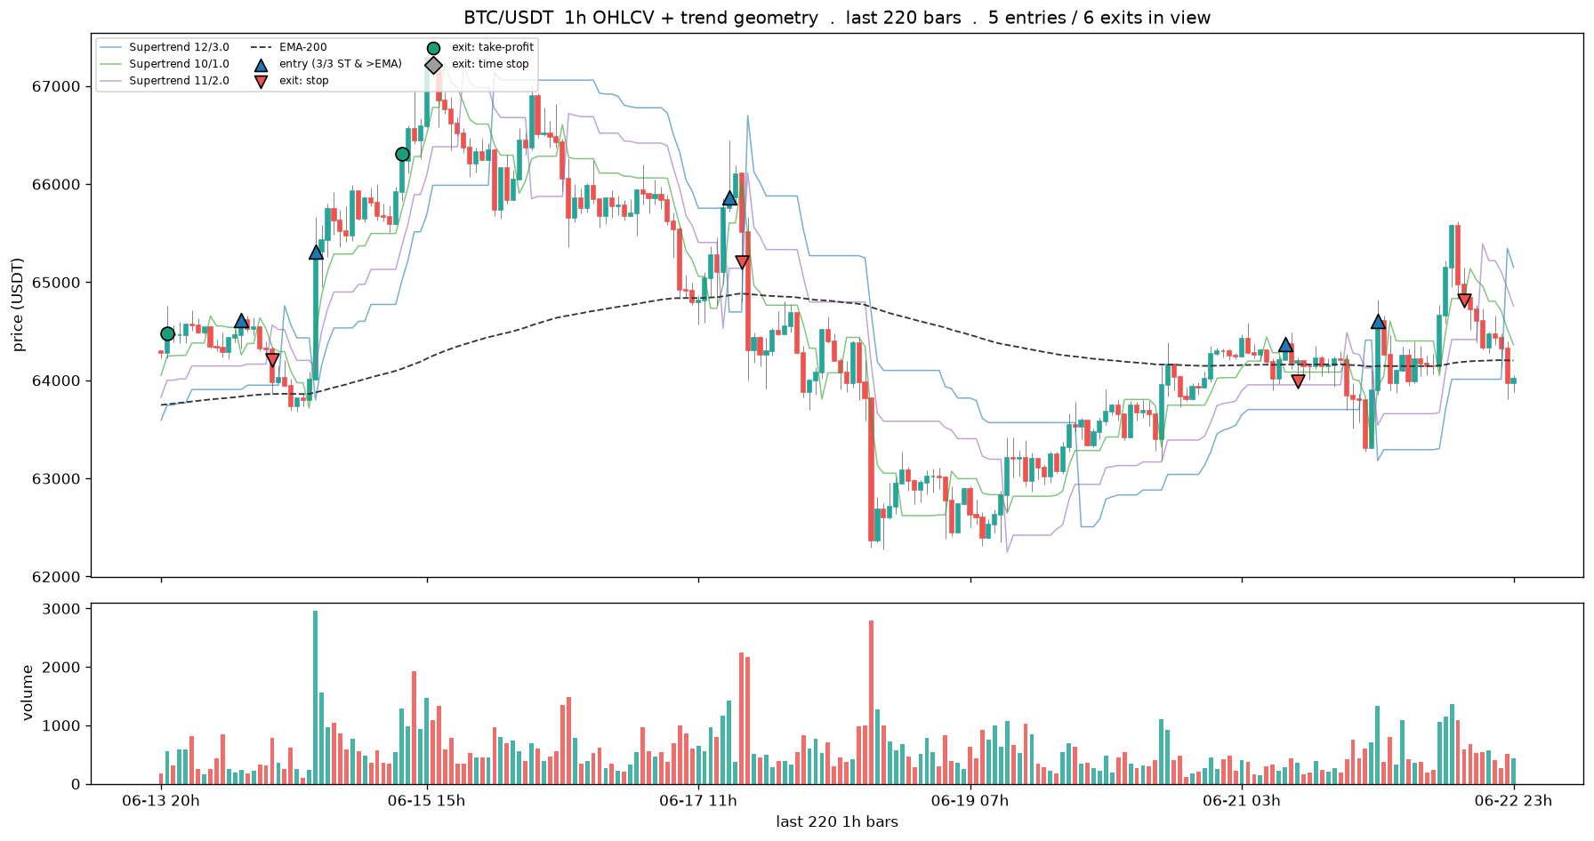
BTC/USDT: 1145 trades total . 5 entries / 6 exits in the 220-bar window
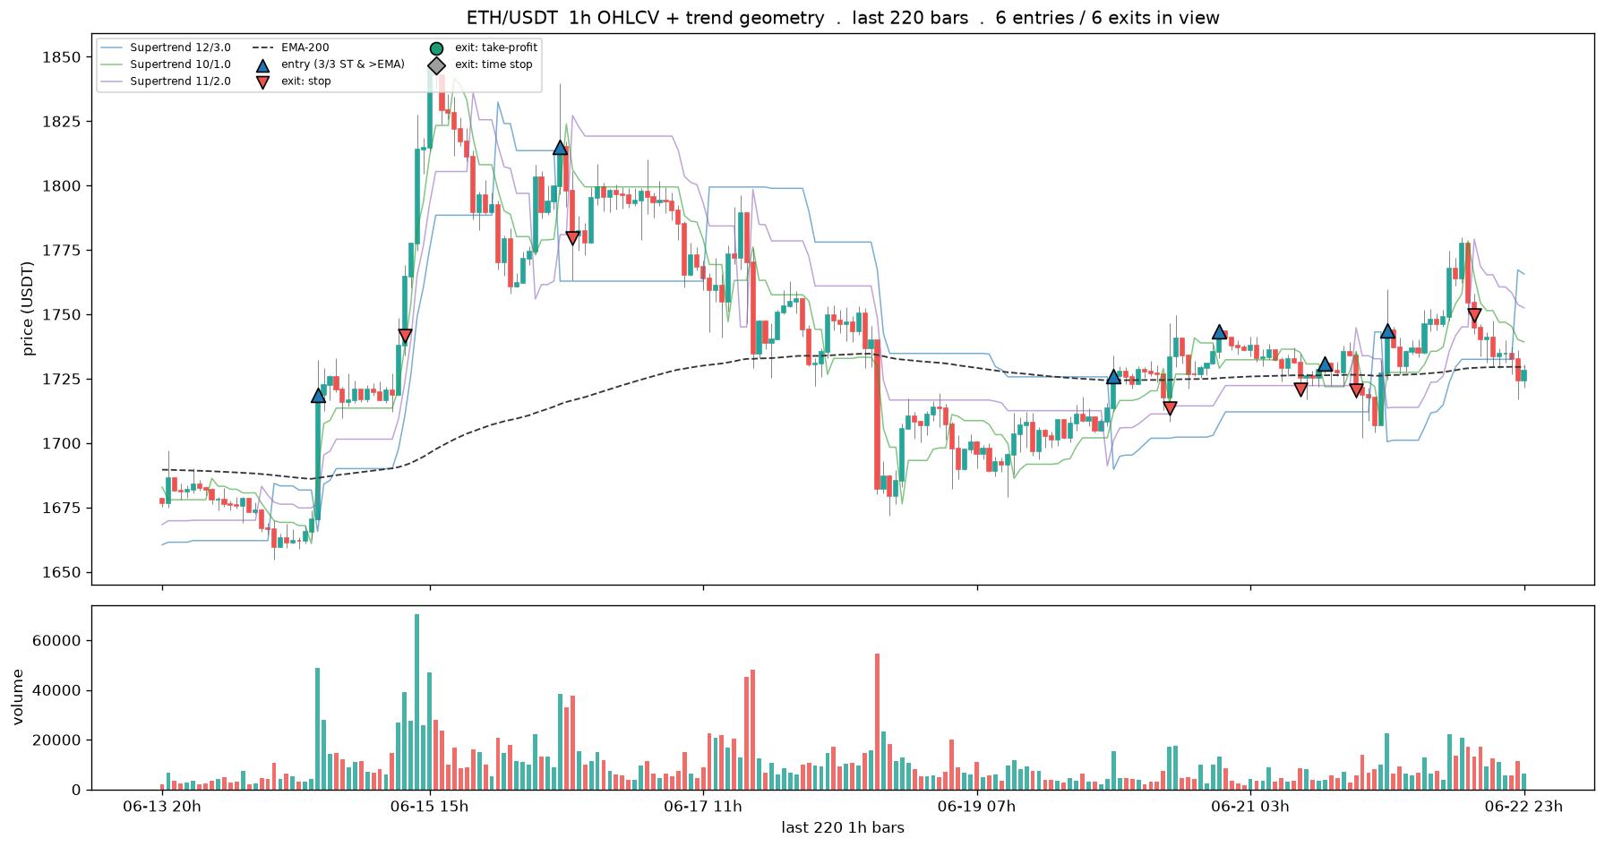
ETH/USDT: 1166 trades total . 6 entries / 6 exits in the 220-bar window
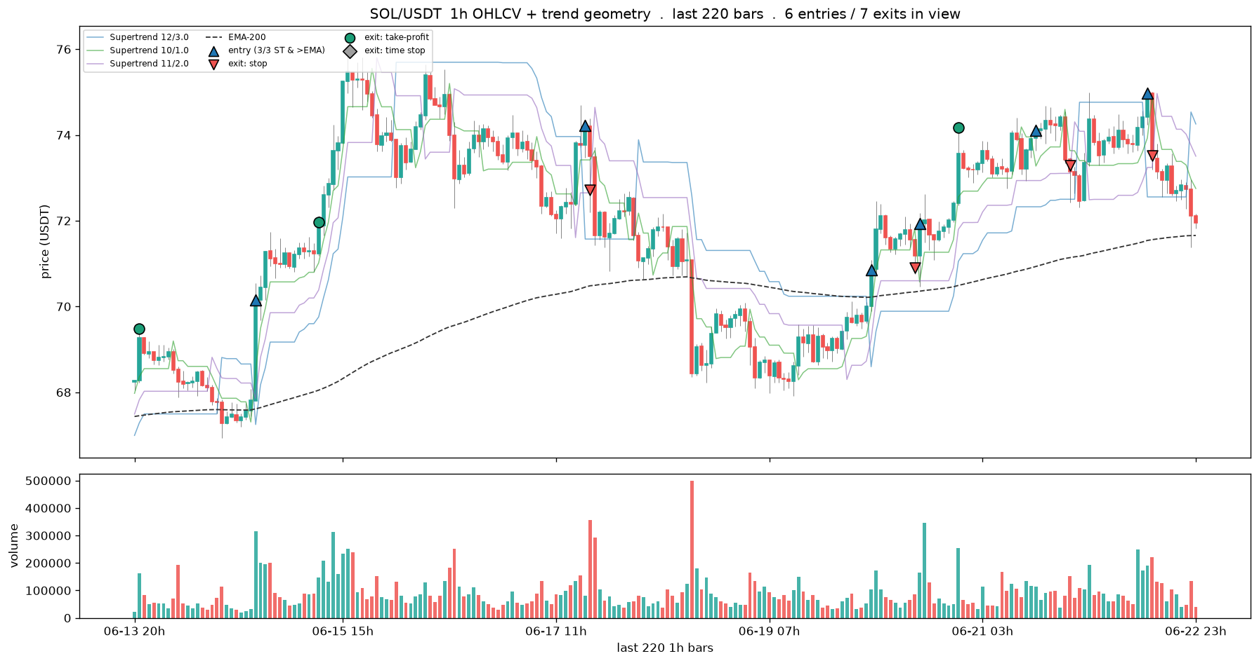
SOL/USDT: 820 trades total . 6 entries / 7 exits in the 220-bar window
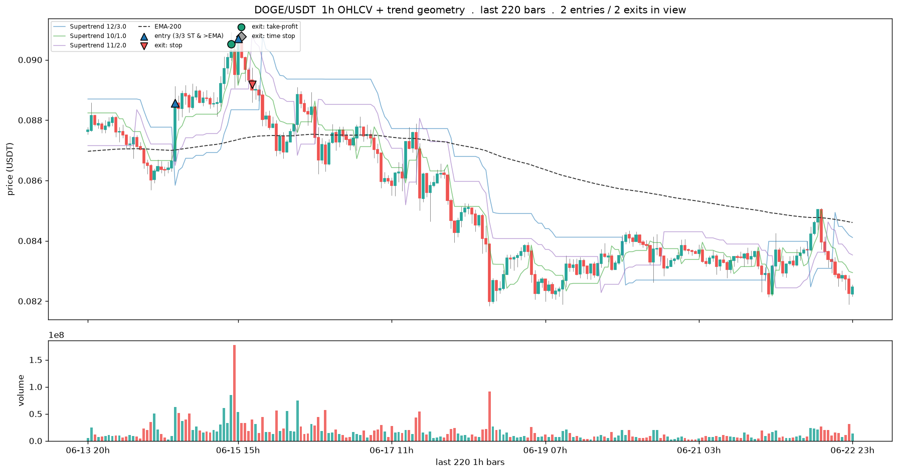
DOGE/USDT: 804 trades total . 2 entries / 2 exits in the 220-bar window
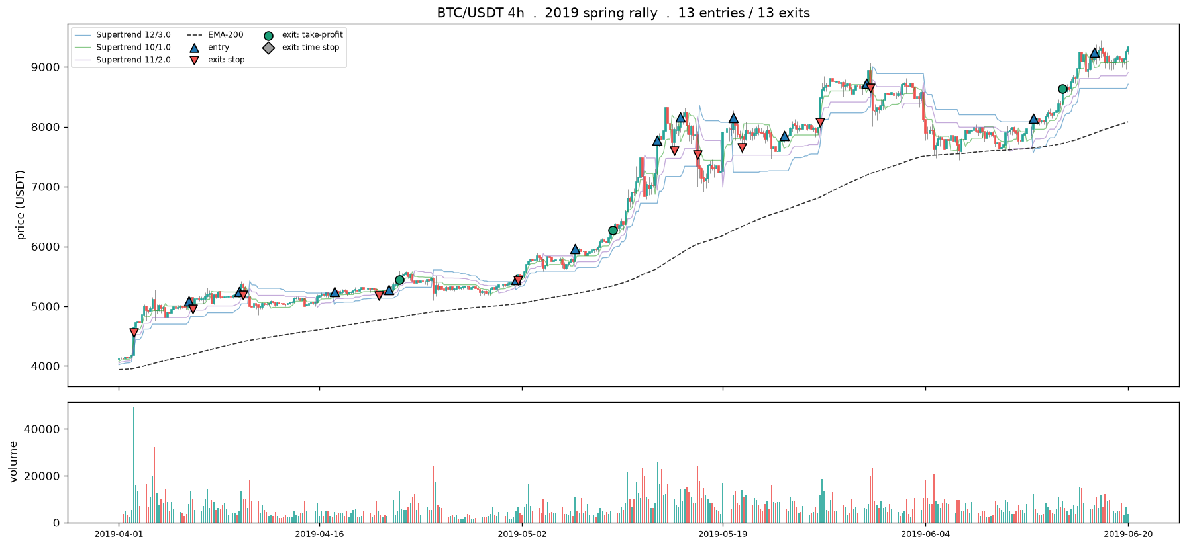
2019 spring rally 2019-04-01 -> 2019-06-20 13 entries / 13 exits
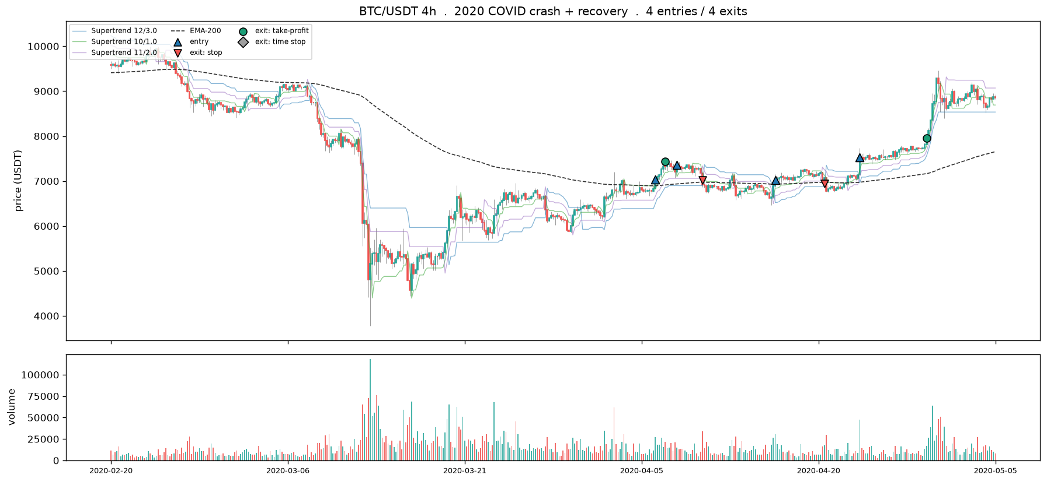
2020 COVID crash + recovery 2020-02-20 -> 2020-05-05 4 entries / 4 exits
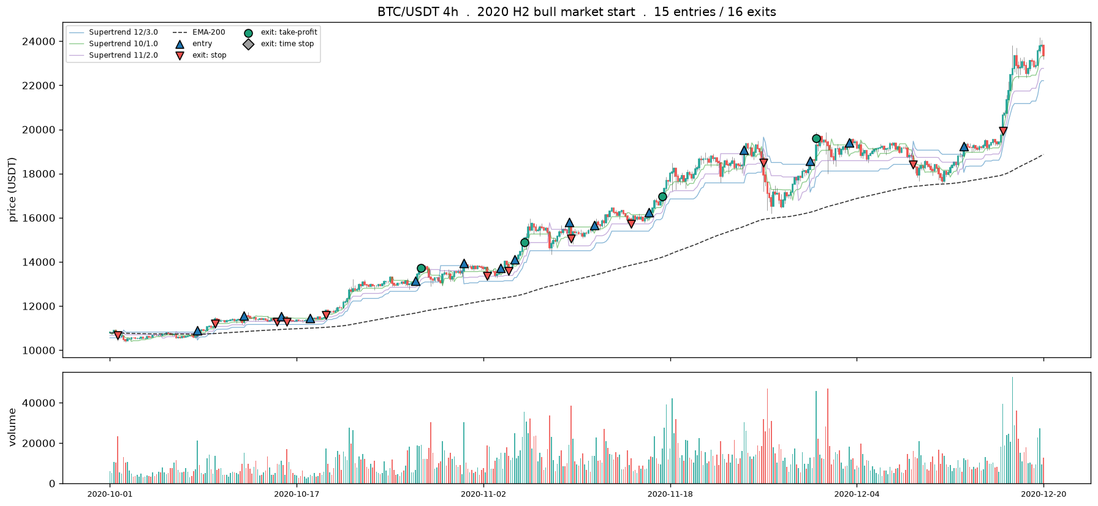
2020 H2 bull market start 2020-10-01 -> 2020-12-20 15 entries / 16 exits
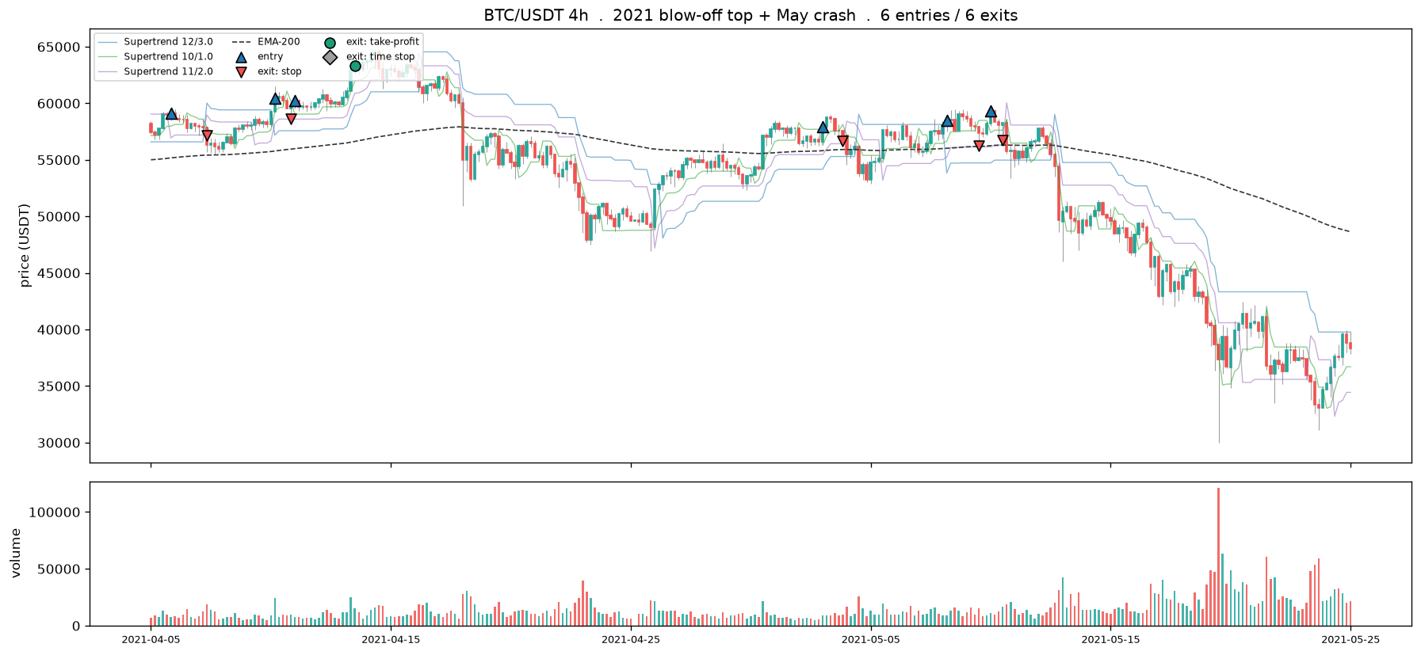
2021 blow-off top + May crash 2021-04-05 -> 2021-05-25 6 entries / 6 exits
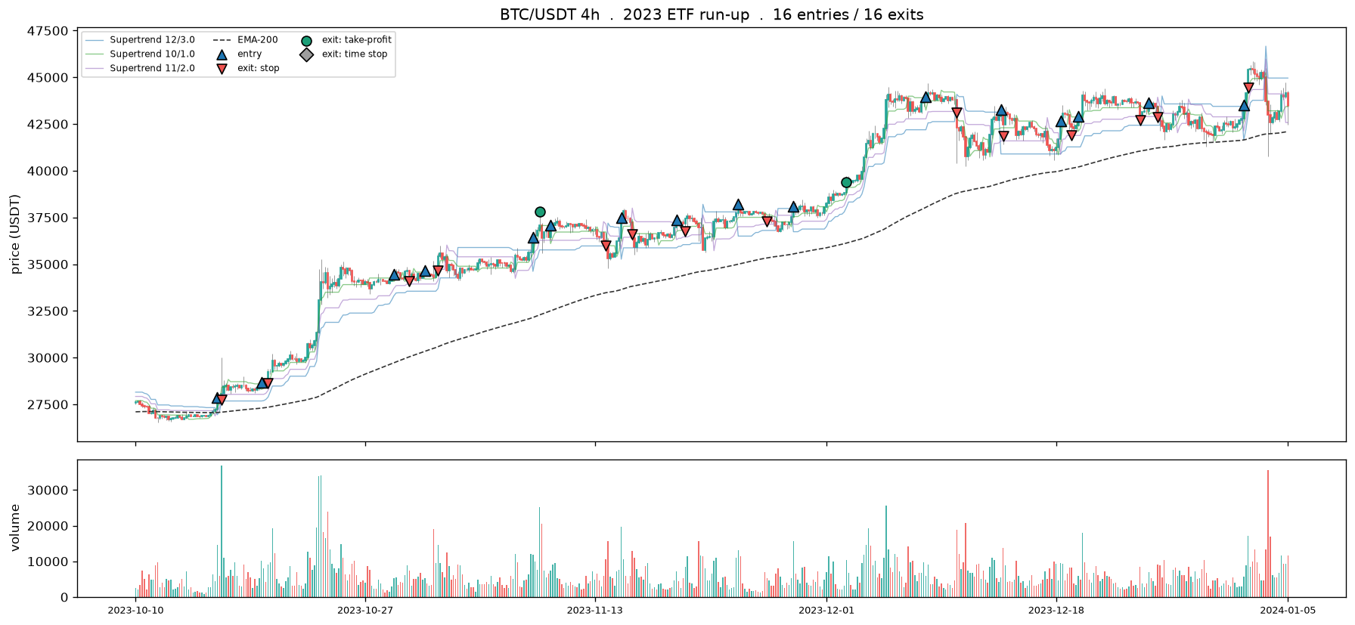
2023 ETF run-up 2023-10-10 -> 2024-01-05 16 entries / 16 exits
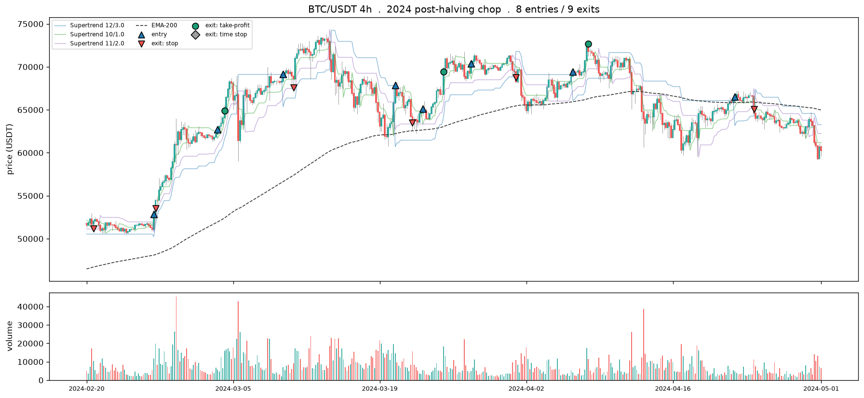
2024 post-halving chop 2024-02-20 -> 2024-05-01 8 entries / 9 exits
note: the 2022 LUNA/bear leg is omitted because the rule fires ZERO entries there -- it stands aside
when no uptrend exists, which is itself the correct (and only safe) behaviour.
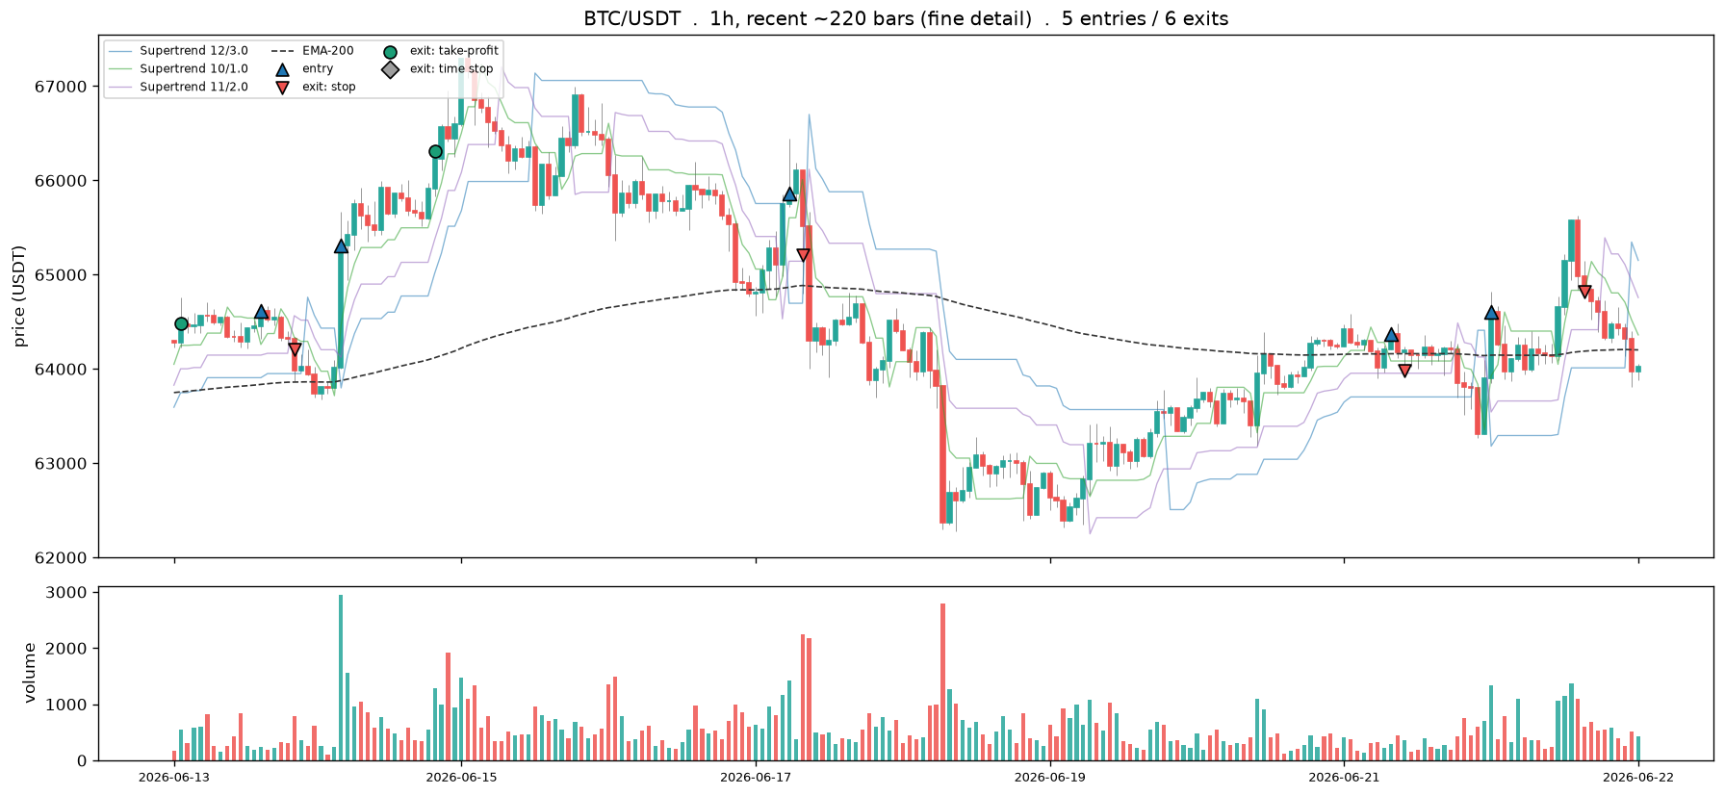
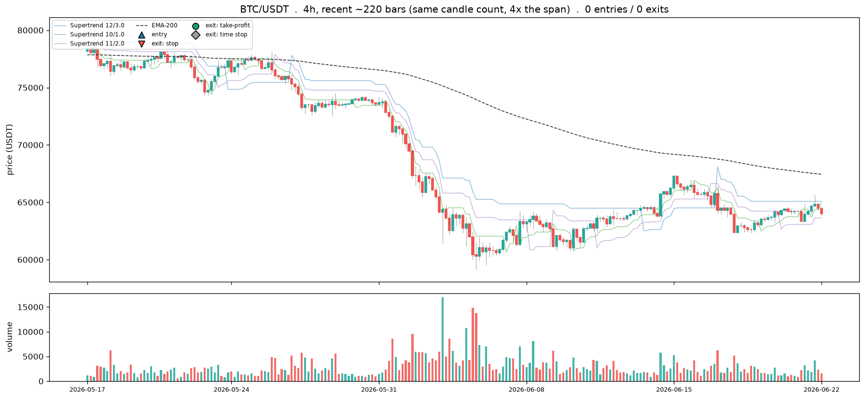
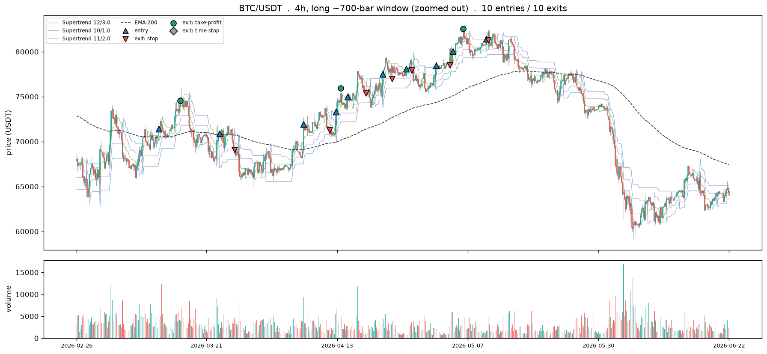
1h vs 4h at equal candle count is lever 1 (frame); 220 vs 700 on 4h is lever 2 (window). Past ~900 candles, step to a coarser frame rather than zoom further.
from 282 BTC 4h trades . best +15.5% / worst -8.7%
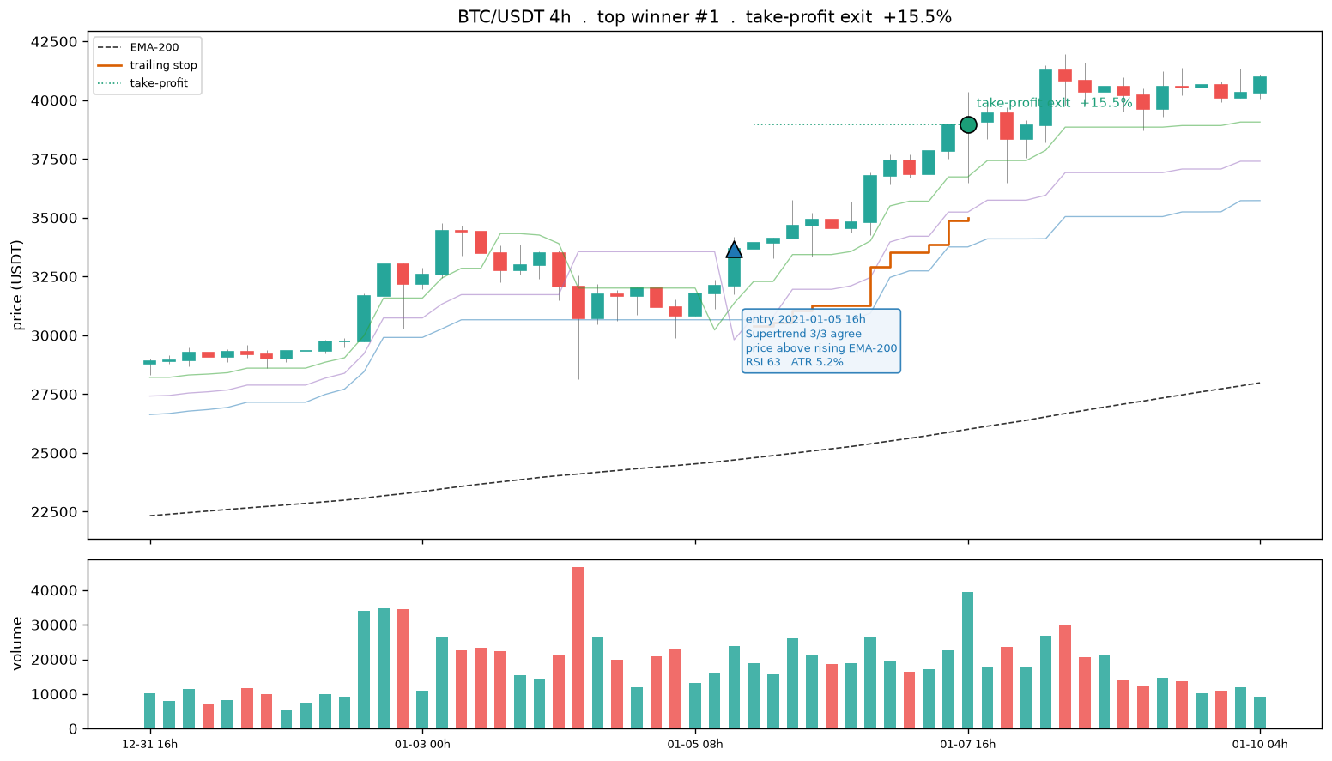
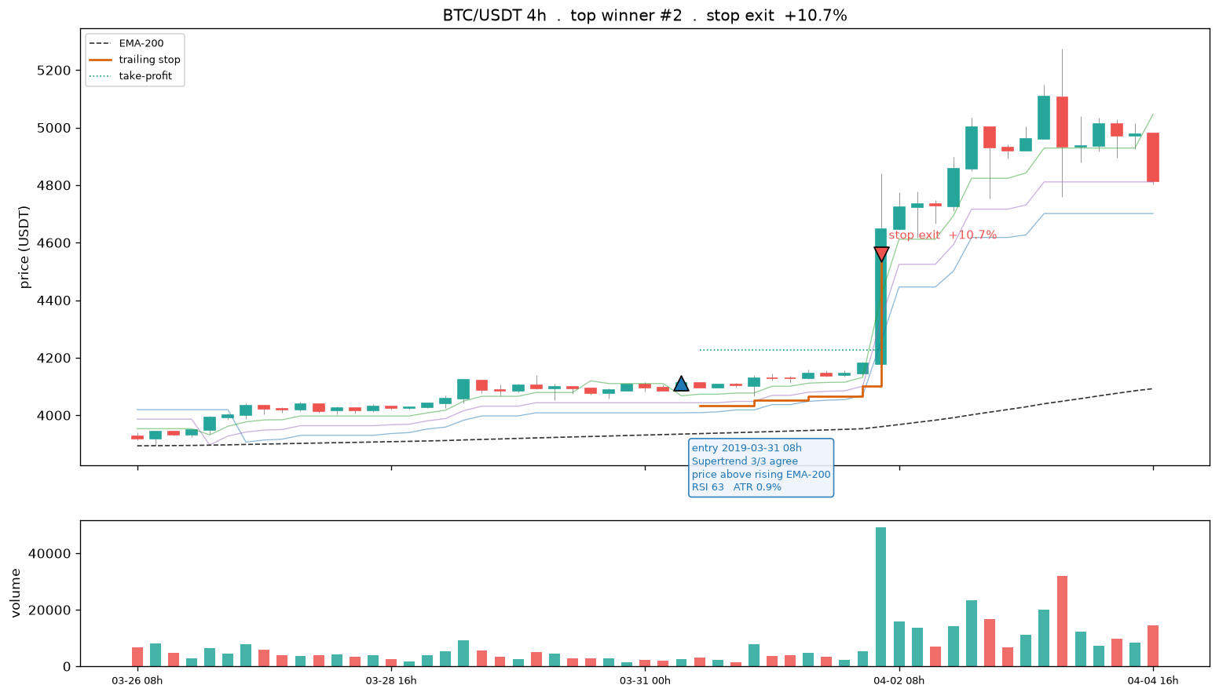
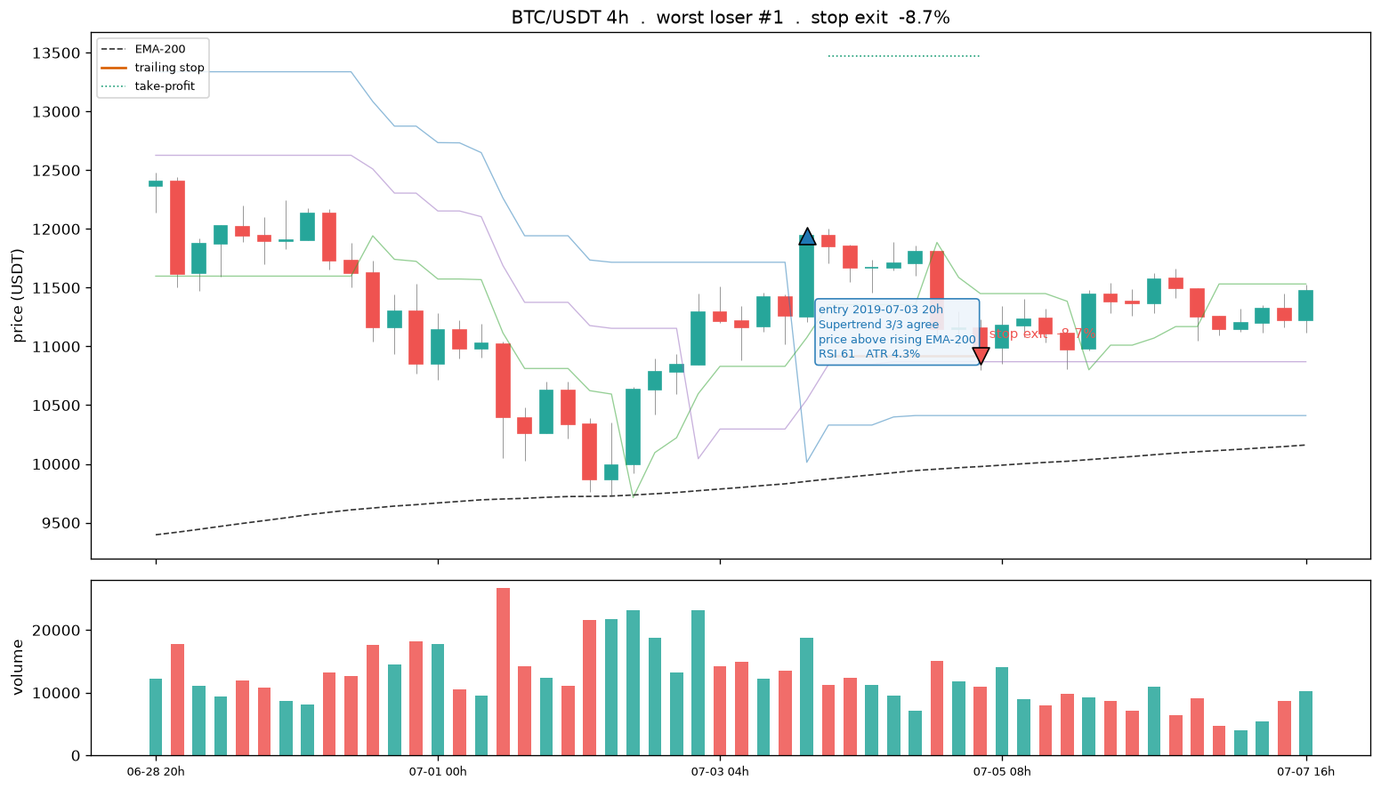
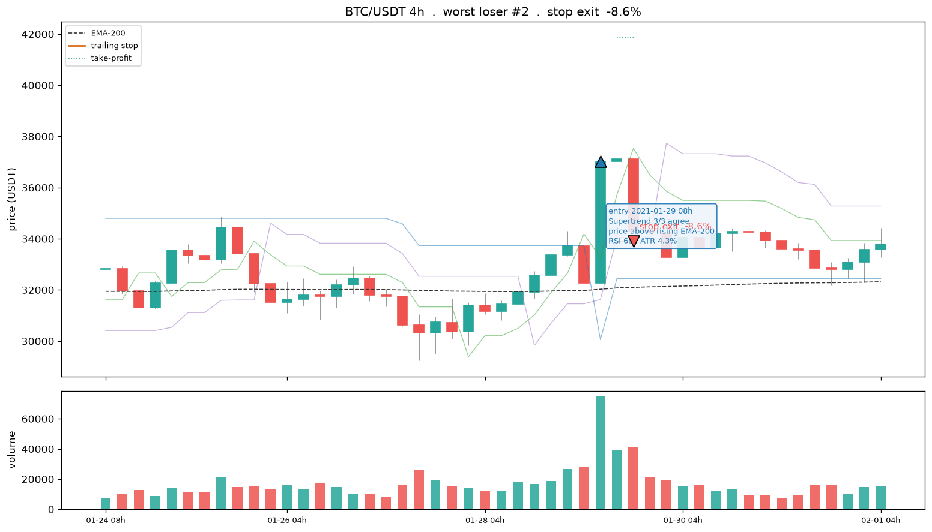
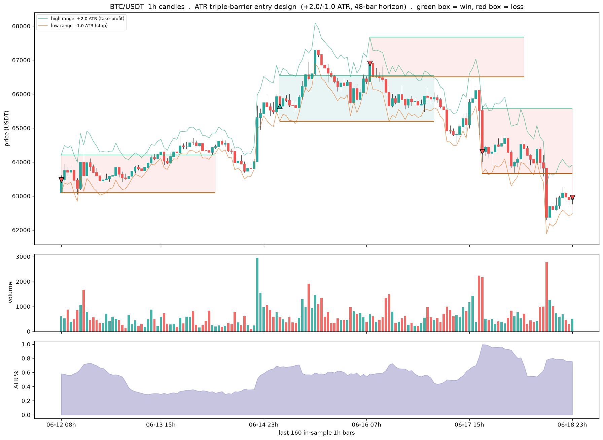
window 2026-06-12 08h -> 2026-06-18 23h | 111 labelled entries, 35 wins (32%), base rate 31%
[single] BTC/USDT 1h: 1145 trades exits: 181 TP / 963 stop / 1 time mean net -0.35%/trade -> /Volumes/PortableSSD/Github/day-trader/04-outputs/PNG/3-exit-geometry-candles.png
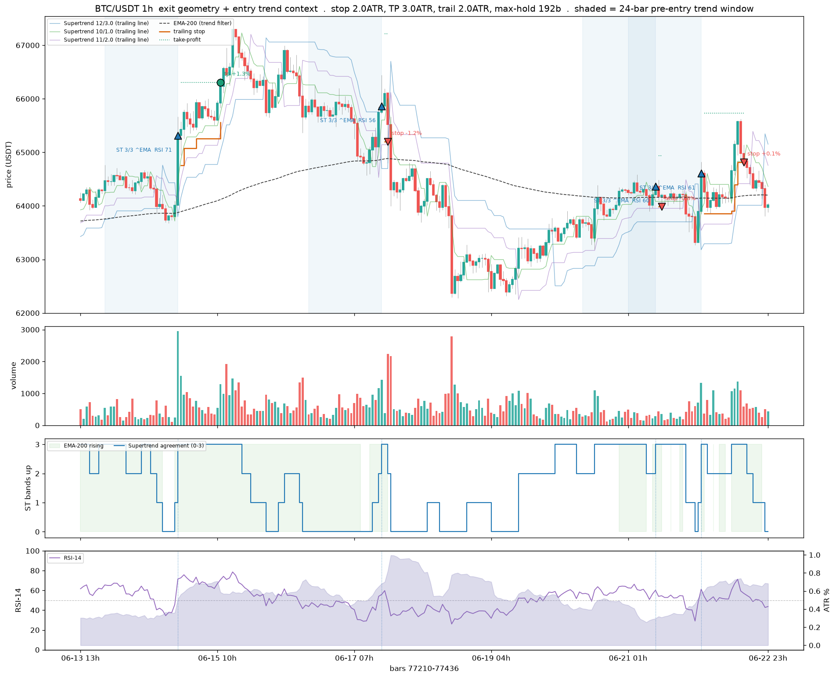
# --- Same entry, several exit geometries: how the shape changes where a trade exits ------
# Reuses ohlc / lines / ema / ups / entries from the Exit Geometry cell above.
COMPARE_CFGS = [("fixed TP/stop", dict(stop_mult=2.0, tp_atr=3.0, trail=0.0, tp_decay=False)),
("trailing stop", dict(stop_mult=2.0, tp_atr=3.0, trail=2.0, tp_decay=False)),
("decaying TP", dict(stop_mult=2.0, tp_atr=3.0, trail=2.0, tp_decay=True))]
fig = egv.plot_compare(ohlc, lines, ema, ups, entries, COMPARE_CFGS, MAX_HOLD, FEE,
f"{EXIT_SYMBOL} {bd.INTERVAL}",
OUTPUTS / "PNG" / "3-exit-geometry-compare.png", show=False)
show_fig(fig) # embed inline (Positron-safe)
[compare] BTC/USDT 1h: anchored on entry at bar 77414 -> /Volumes/PortableSSD/Github/day-trader/04-outputs/PNG/3-exit-geometry-compare.png
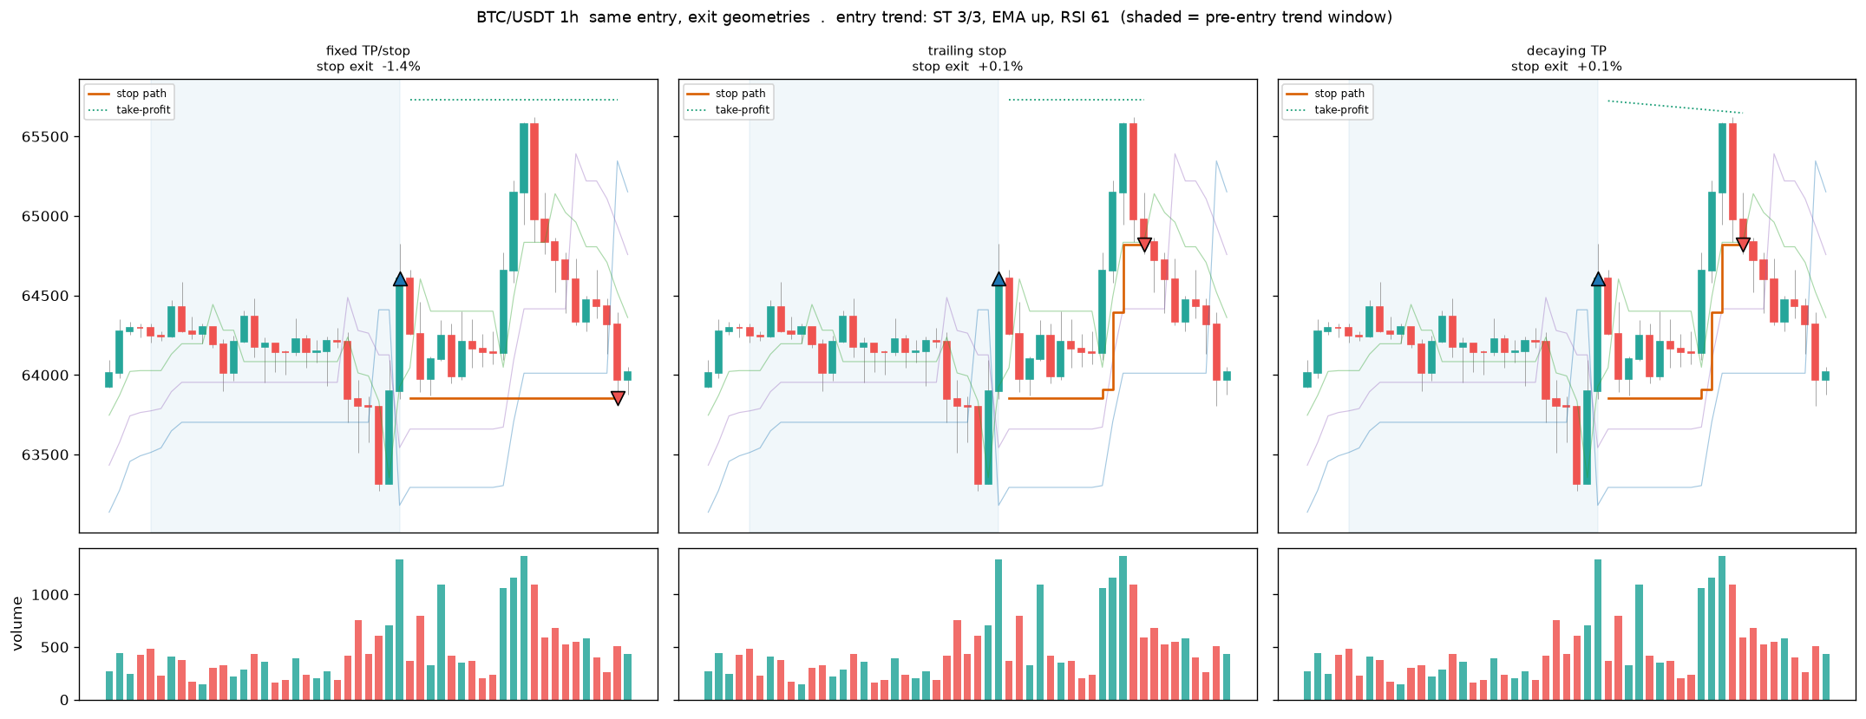

3.4 Sharpening Entries
An honest test of whether a sharper entry helps. Range and volatility entry conditions never pay, trend and momentum pay only marginally, and an early BTC-trend-gated entry that fires a few bars before the Supertrend flip lifts a single year to breakeven but does not survive walk-forward, positive in only a minority of folds. The conclusion carried through the rest of the chapter is that more price-derived entry features will not cross the fee line, which is why the search turns to cross-sectional framing and a coarser frame.
Best single-feature entry filters (in-sample, GROSS of cost):
 | feature | best_decile_winrate | lift_over_breakeven
0 | f_ta_pta_vortex_diff | 0.342 | 0.009
1 | f_hr_mom_12 | 0.335 | 0.001
2 | f_ta_dmi_diff | 0.333 | -0.000
3 | f_ta_mfi | 0.333 | -0.000
4 | f_ta_pta_cmo | 0.331 | -0.003
5 | f_hr_rsi | 0.331 | -0.003
6 | f_ta_pta_ppo_hist | 0.327 | -0.006
7 | f_ta_pta_cksp_long_dist | 0.323 | -0.010
cost drag is ~0.20% round trip; on a +2.0 ATR target a win must clear breakeven by more than that to pay.

3.5 Survivorship Pipeline
The three-stage pipeline that makes the panel survivorship-complete and point-in-time honest. Stage A crawls the data.binance.vision listing to enumerate every USDT pair ever listed, delisted coins included, and downloads them checksum-verified. Stage B profiles coverage, gaps, listing timelines, and liquidity to derive the usable start, the minimum history, and the purge and embargo. Stage C is the forward-chained walk-forward splitter with per-fold point-in-time universes and train-only transforms. This is the spine Parts 1 and 2 borrow their universe from.
historical USDT universe (incl. dead coins): 671 pairs (+52 leveraged excluded)
dead-coin audit: 10/10 known-delisted present in universe
snapshot: 487 active USDT pairs as of 2026-09-07 -> /Volumes/PortableSSD/Github/day-trader/03-inputs/binance-data/exchange_info_snapshot_2026-09-07.json
survivorship: 671 universe / 468 active / 203 delisted = 30.3% dead coins
profile run : /Volumes/PortableSSD/Github/day-trader/04-outputs/3A-training-test-data/panel-profile/2026-09-06T215959Z
symbols : 600 | delisted share: 33.3%
usable start : 2019-04-01
min history : 157 days
purge/embargo: 125 days (3000 bars)
point-of-entry: coin enters at its first valid bar (realistic; mirrors when trading would actually begin) ...
symbol metadata (first 10 of 600 rows):
symbol first_bar last_bar n_bars coverage max_gap_hours halt_flag active
ETHUSDT 2017-08-17 04:00:00+00:00 2026-06-22 23:00:00+00:00 77437 0.9984 75 True True
BTCUSDT 2017-08-17 04:00:00+00:00 2026-06-22 23:00:00+00:00 77437 0.9984 75 True True
BNBUSDT 2017-11-06 03:00:00+00:00 2026-06-22 23:00:00+00:00 75501 0.9984 75 True True
BCCUSDT 2017-11-11 08:00:00+00:00 2018-11-20 02:00:00+00:00 8805 0.9815 105 True False
NEOUSDT 2017-11-20 03:00:00+00:00 2026-06-22 23:00:00+00:00 75165 0.9984 75 True True
LTCUSDT 2017-12-13 03:00:00+00:00 2026-06-22 23:00:00+00:00 74613 0.9984 75 True True
QTUMUSDT 2018-03-19 08:00:00+00:00 2026-06-22 23:00:00+00:00 72337 0.9988 10 False True
ADAUSDT 2018-04-17 04:00:00+00:00 2026-06-22 23:00:00+00:00 71645 0.9988 10 False True
XRPUSDT 2018-05-04 08:00:00+00:00 2024-06-30 23:00:00+00:00 53905 0.9984 10 False True
EOSUSDT 2018-05-28 05:00:00+00:00 2025-05-26 02:00:00+00:00 61231 0.9986 10 False False
symbol first_bar last_bar n_bars \
0 ETHUSDT 2017-08-17 04:00:00+00:00 2026-06-22 23:00:00+00:00 77437
1 BTCUSDT 2017-08-17 04:00:00+00:00 2026-06-22 23:00:00+00:00 77437
2 BNBUSDT 2017-11-06 03:00:00+00:00 2026-06-22 23:00:00+00:00 75501
3 BCCUSDT 2017-11-11 08:00:00+00:00 2018-11-20 02:00:00+00:00 8805
4 NEOUSDT 2017-11-20 03:00:00+00:00 2026-06-22 23:00:00+00:00 75165
5 LTCUSDT 2017-12-13 03:00:00+00:00 2026-06-22 23:00:00+00:00 74613
6 QTUMUSDT 2018-03-19 08:00:00+00:00 2026-06-22 23:00:00+00:00 72337
7 ADAUSDT 2018-04-17 04:00:00+00:00 2026-06-22 23:00:00+00:00 71645
8 XRPUSDT 2018-05-04 08:00:00+00:00 2024-06-30 23:00:00+00:00 53905
9 EOSUSDT 2018-05-28 05:00:00+00:00 2025-05-26 02:00:00+00:00 61231
coverage max_gap_hours halt_flag active
0 0.9984 75 True True
1 0.9984 75 True True
2 0.9984 75 True True
3 0.9815 105 True False
4 0.9984 75 True True
5 0.9984 75 True True
6 0.9988 10 False True
7 0.9988 10 False True
8 0.9984 10 False True
9 0.9986 10 False False
# Stage C: the splitter draws usable_start + per-fold universes from the Stage B run above.
# Reuses `bd` (build_dataset_1h) from the Environment cell.
import wf_splitter as wf
print(wf.METHODOLOGY)
pb, lf, lh = wf.purge_embargo_bars()
print(f'purge/embargo = max(feature lookback {lf}, label horizon {lh}) = {pb} bars '
f'= {wf.purge_embargo_days()} days')
df_wf = bd.read_frame(bd.DATASET_PATH)
if df_wf is not None:
if 'in_sample' in df_wf.columns:
df_wf = df_wf[df_wf['in_sample']].copy()
sp = wf.WalkForwardSplitter(n_folds=5, test_days=120, scheme='expanding',
usable_start=wf.load_usable_start(),
universes=wf.load_universes())
_folds = sp.fold_table(df_wf) # per-fold spans + coin counts (C.5 composition audit)
print(f'\nwalk-forward folds ({len(_folds)}):')
print(_folds.to_string(index=False)) # text fallback: renders in every IDE
display(_folds)
# Regime-stability metrics (fits a model per fold; run on the .venv):
# wf.evaluate_walkforward(df_wf, bd.feature_columns(df_wf), sp)
else:
print('No dataset yet at', bd.DATASET_PATH)
## Splitting methodology: forward-chained, not stratified
Objective: estimate out-of-sample performance under REGIME DRIFT, not interpolation within a
known distribution. The data-generating process drifts across time -- the 2017-18 ICO mania,
the 2021 bull run, the 2022 deleveraging, and the current regime are different processes. A
split that interleaves test bars among training bars borrows the future to predict the past
and yields an error estimate that will not survive live trading.
Stratified sampling is rejected. Stratifying on variance forces similar class proportions
across splits by drawing observations regardless of position in time, which destroys the
temporal ordering that is the whole object of interest. It answers "can the model interpolate
within a known distribution"; the question that matters is "can it extrapolate forward into an
unknown regime." Only a forward-chained split measures that.
Design: expanding/rolling walk-forward on shared calendar boundaries; purge/embargo =
max(feature lookback, label horizon) at every cut; split on time not on coins; per-fold
universe drawn point-in-time from the Stage B profile; transforms fit on train only;
per-fold metrics weighted by coin count.
purge/embargo = max(feature lookback 3000, label horizon 48) = 3000 bars = 125 days
walk-forward folds (5):
fold train_start train_end test_start test_end n_train n_test n_coins embargo_days
0 2019-04-01 2024-06-23 2024-10-26 2025-02-23 279036 28742 21 125
1 2019-04-01 2024-10-21 2025-02-23 2025-06-23 302694 25482 19 125
2 2019-04-01 2025-02-18 2025-06-23 2025-10-21 337209 31086 23 125
3 2019-04-01 2025-06-18 2025-10-21 2026-02-18 364391 24993 21 125
4 2019-04-01 2025-10-16 2026-02-18 2026-06-18 395181 16801 20 125
fold train_start train_end test_start test_end n_train n_test \
0 0 2019-04-01 2024-06-23 2024-10-26 2025-02-23 279036 28742
1 1 2019-04-01 2024-10-21 2025-02-23 2025-06-23 302694 25482
2 2 2019-04-01 2025-02-18 2025-06-23 2025-10-21 337209 31086
3 3 2019-04-01 2025-06-18 2025-10-21 2026-02-18 364391 24993
4 4 2019-04-01 2025-10-16 2026-02-18 2026-06-18 395181 16801
n_coins embargo_days
0 21 125
1 19 125
2 23 125
3 21 125
4 20 125

3.6 Variable Selection
Feature selection on the training window only, so the choice never sees the blind year. It ranks the candidate features and prunes the redundant and the near-zero-signal, keeping the causal, scale-invariant set the model trains on, with the after-fee out-of-sample scoreboard as the final arbiter of whether a family earns its place.
lasso path on 25,000 TRAIN rows x 61 features.
lambda.min=0.0004569 (nonzero 45), lambda.1se=0.01121 (nonzero 0)
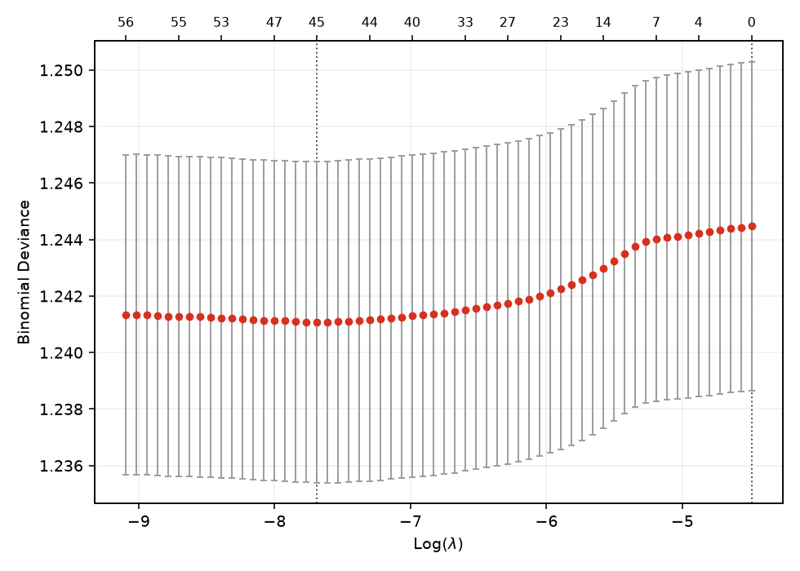
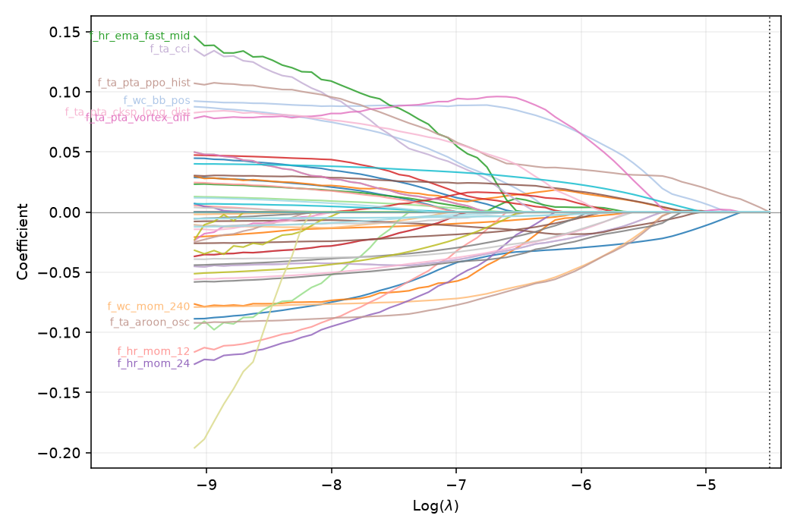
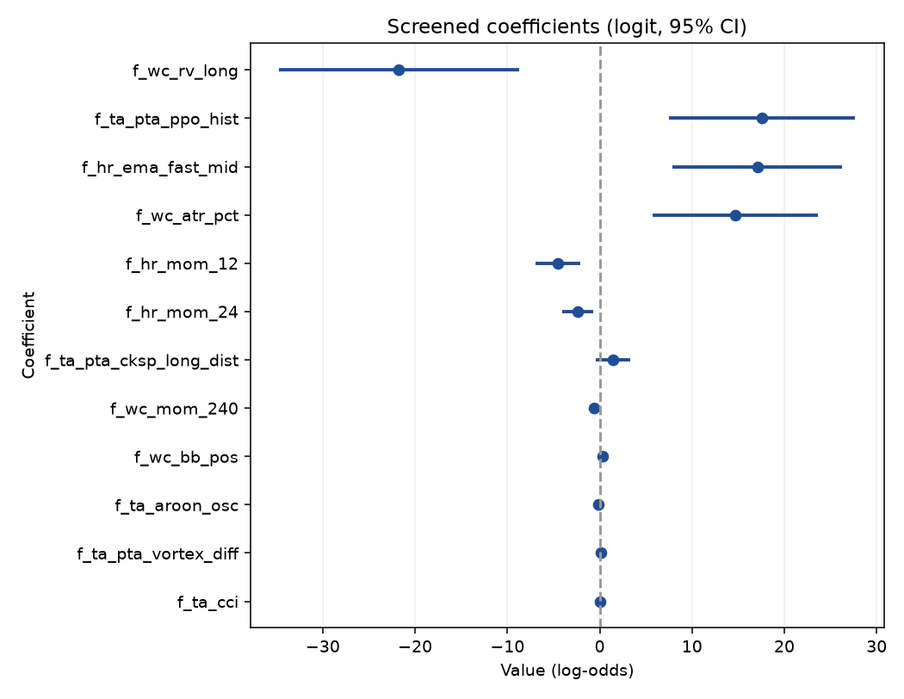
elastic-net kept 45 of 61 features at lambda.1se.
top kept: f_hr_ema_fast_mid(+0.096), f_wc_bb_pos(+0.088), f_ta_aroon_osc(-0.087), f_ta_pta_ppo_hist(+0.086), f_ta_pta_vortex_diff(+0.086), f_hr_mom_24(-0.085), f_ta_cci(+0.077), f_wc_mom_240(-0.076), f_hr_mom_12(-0.075), f_ta_pta_cksp_long_dist(+0.072), f_wc_rv_long(-0.070), f_wc_atr_pct(+0.068), f_wc_ema_fast_mid(-0.068), f_tl_sar_dist(-0.049), f_ta_pta_fisher(-0.047)
interactive coefficient path (open in browser): /Volumes/PortableSSD/Github/day-trader/04-outputs/AA-evals/varselect/coefpath.html
To train the head-to-head on this subset: set feat = SELECTED_FEATURES then re-run training.

3.7 Training Regime
The model trains on all history before the final-year cut and is scored once on the blind year. A capped sample keeps the in-notebook fit quick; the full fit runs from the .venv. The section reports the held-out margin of the model’s confident picks over the base rate, the feature importances, and a look at one tree, so the training is legible rather than a black box. The label and horizon are the 0.4 geometry.
# Split and scoring come from the scripts: t1.split for the 1h final-year hold-out; tm.evaluate,
# tm.build_models, tm.confidence_filtered shared with 03-inputs/train_model.py. Nothing reimplemented.
train, test, cut = t1.split(df)
Xtr, ytr, Xte, yte = train[feat], train["label"], test[feat], test["label"]
base_te = yte.mean()
span = lambda d: f"{d['datetime'].min().date()} to {d['datetime'].max().date()}"
print(f"train {len(train):,} ({span(train)}) . test {len(test):,} ({span(test)}) . "
f"cut {pd.Timestamp(cut).date()} embargo +/-{t1.EMBARGO_DAYS}d . base rate {base_te:.3f}")
train 381,207 (2017-12-15 to 2025-06-16) . test 76,789 (2025-06-19 to 2026-06-18) . cut 2025-06-18 embargo +/-2d . base rate 0.303
# Fast interactive pass. The full-fidelity 3-model run on ALL history is 03-inputs/train_model_1h.py
# (script / auto-eval). The heavy part here is evaluate()'s 5-fold TimeSeriesSplit CV on each model
# (3 models x (5 CV fits + 1 final fit) on ~381k rows = minutes). For the notebook we fit a bounded
# sample taken across the whole period and re-sorted by time, so the time-series CV stays
# chronological. Raise TRAIN_CAP or set it to None for the full run (slow).
TRAIN_CAP = 80_000
if TRAIN_CAP is None or len(train) <= TRAIN_CAP:
tr_fit = train
else:
tr_fit = train.sample(TRAIN_CAP, random_state=0).sort_values("datetime")
Xtr_f, ytr_f = tr_fit[feat], tr_fit["label"]
print(f"fitting on {len(tr_fit):,} of {len(train):,} train rows "
f"({tr_fit['datetime'].min().date()} to {tr_fit['datetime'].max().date()})"
+ (" [sampled for the notebook; full run is 03-inputs/train_model_1h.py]"
if (TRAIN_CAP and len(train) > TRAIN_CAP) else ""))
lines, scored = [], []
for name, mdl in tm.build_models(HAVE_LGBM):
prec, m = tm.evaluate(name, mdl, Xtr_f, ytr_f, Xte, yte, base_te, lines)
scored.append((prec, name, mdl, m))
print("\n".join(lines))
_, best_name, best_model, best = max(scored, key=lambda t: t[0])
print(f"\nchosen: {best_name} (precision {best['prec']:.3f} vs base {base_te:.3f}, AUC {best['auc']:.3f})")
fitting on 80,000 of 381,207 train rows (2017-12-16 to 2025-06-16) [sampled for the notebook; full run is 03-inputs/train_model_1h.py]
--- LogisticRegression ---
train CV ROC-AUC (5-fold TimeSeriesSplit): 0.528
test accuracy : 0.484
test precision(buy): 0.307 (base rate 0.303)
test recall(buy) : 0.560
test ROC-AUC : 0.504
confusion matrix [rows=true 0/1, cols=pred 0/1]:
[[24164, 29352], [10241, 13032]]
precision lift over base rate: +0.004
confidence filter (act if p>=0.60 or p<=0.40): keeps 2.7% of test rows (n=2075)
precision(buy) 0.285 recall 0.663 F1 0.398 (base rate 0.303)
--- RandomForest ---
train CV ROC-AUC (5-fold TimeSeriesSplit): 0.526
test accuracy : 0.489
test precision(buy): 0.310 (base rate 0.303)
test recall(buy) : 0.557
test ROC-AUC : 0.509
confusion matrix [rows=true 0/1, cols=pred 0/1]:
[[24627, 28889], [10319, 12954]]
precision lift over base rate: +0.007
confidence filter (act if p>=0.60 or p<=0.40): keeps 1.2% of test rows (n=931)
precision(buy) 0.000 recall 0.000 F1 0.000 (base rate 0.303)
--- LightGBM ---
train CV ROC-AUC (5-fold TimeSeriesSplit): 0.520
test accuracy : 0.534
test precision(buy): 0.311 (base rate 0.303)
test recall(buy) : 0.440
test ROC-AUC : 0.510
confusion matrix [rows=true 0/1, cols=pred 0/1]:
[[30769, 22747], [13024, 10249]]
precision lift over base rate: +0.008
confidence filter (act if p>=0.60 or p<=0.40): keeps 27.8% of test rows (n=21316)
precision(buy) 0.292 recall 0.349 F1 0.318 (base rate 0.303)
chosen: LightGBM (precision 0.311 vs base 0.303, AUC 0.510)
HONESTY GATE: NO-GO (no demonstrable edge - do not trade)
saved /Volumes/PortableSSD/Github/day-trader/04-outputs/3B-model-training/model_1h.joblib and model_metrics_1h.txt
evaluation record: /Volumes/PortableSSD/Github/day-trader/04-outputs/AA-evals/2026-09-07/eval-head-to-head-20260907.md

3.8 Model Tuning
Two sweeps, both scored on the after-fee out-of-sample scoreboard and logged to the consolidated scoreboard: the label-geometry sweep over the ATR barrier and horizon, and the model hyperparameter sweep over expanding time-series folds. These run full-market as scripts from the .venv; the cell shows the commands and renders the persisted result.
import model_metrics as mm # heading demotion for embedded records
# The sweeps are full-market and run as scripts from the project .venv:
# .venv/bin/python 03-inputs/sweep_label_1h.py # Priority 1b: label geometry (target, stop, horizon)
# .venv/bin/python 03-inputs/walkforward.py # Priority 1a: exit geometry (stop, take-profit, trail)
# Both append to the consolidated scoreboard; here we render that one table so tuning reads off it.
#from IPython.display import Markdown, display
#scoreboard = OUTPUTS / "AA-evals" / "evaluation-scores.md"
#if scoreboard.exists():
# display(Markdown(mm.demote_headings(scoreboard.read_text())))
#else:
# print("no evaluation-scores.md yet - run a model (cells above) or a sweep script first.")
# Quick inline 1b probe (small grid; the full grid is the script above):
# import sweep_label_1h as sw
# coins, scols = sw.precompute(bd.DEFAULT_KLINES_ROOT, bd.DEFAULT_FLOW_CSV, None)
# sw.score_cell(coins, scols, 3.0, 1.0, 48, tm.COST_PCT/100.0, tm.CONF_HI)

3.9 Model Assessment
The caret-style scorecard, across every built frame. For each of 1h, 4h, and 5m it fits a bounded zoo on a sampled slice and scores a blind final year, reporting Full and cross-validated RMSE on predicted probabilities, the RMSEratio overfit flag, and the after-fee blind read, one block per frame. Frames are scored independently and stacked, never pooled.
RECOMPUTE off -- showing latest persisted full-zoo record: model-assessment-20260906.md

Model assessment (2026-09-06) – caret-style, 1h frame
RMSE/MAE are on predicted probabilities (RMSE = sqrt(Brier), the caret-style classification RMSE). Full = in-sample on the training window; CV = time-series out-of-fold on the training window; RMSEratio = CV RMSE / Full RMSE (near 1 = stable, above 1.1 = rejected as overfit). The final year is held out as a single blind test (below). Ranked by CV RMSE, best first.
model | hyperparameters | Full MAE | Full RMSE | CV MAE | CV RMSE | RMSEratio
HistGBM | leaves=31 lr=0.05 iter=600 | 0.2181 | 0.2619 | 0.3861 | 0.4818 | 1.840
LightGBM | leaves=31 lr=0.05 n=600 | 0.2387 | 0.2806 | 0.4036 | 0.4826 | 1.720
RF | mtry=auto ntree=400 depth=8 | 0.4445 | 0.4526 | 0.4761 | 0.4840 | 1.069
LogReg.glm | C=1.0 | 0.4718 | 0.4855 | 0.4463 | 0.4909 | 1.011
Best by CV RMSE: HistGBM (CV RMSE 0.4818, RMSEratio 1.840).
Blind final-year test of the best model (scored once): AUC 0.509, precision(buy|p>=0.60) 0.249 vs base rate 0.254, net P&L/trade -0.454% on 3,012 trades.
Classification view (blind test, 0.5 threshold) – diagnostics for whether the minority (barrier-hit) class is learned; the after-fee Metric 2 above remains the GO/NO-GO. Cohen’s Kappa 0.006; OOB nan (RandomForest only).
class | precision | recall | F1
0 (no-hit) | 0.748 | 0.706 | 0.726
1 (barrier-hit) | 0.258 | 0.301 | 0.278
Confusion matrix [true x pred]: TN 9,942, FP 4,142, FN 3,348, TP 1,440.

3.10 Stability
The Monte Carlo robustness gate, per frame. It resamples the model’s held-out confident trades ten thousand times to ask whether the result is robust or luck and what the realistic worst case is, reporting total return, drawdown, and Sharpe with their worst-case percentiles, the probability of a loss, and a sign-flip p-value. A frame is ROBUST only if the fifth-percentile total is positive, the loss probability is low, and the p-value small. On the current label every frame reads FRAGILE, the honest reading of a negative-mean series compounded.
=== [1h] Stability Monte Carlo (reusing loaded frame, 150,000 rows) ===
 | actual | P5 (worst) | median | P95
total return | -99.8% | -99.9% | -99.8% | -99.2%
max drawdown | -99.8% | -99.9% | -99.8% | -
Sharpe | -7.71 | -9.56 | -7.72 | -
1h trained model (held-out OOS, confident picks): trades 1476 prob(loss) 100.0% sign-flip p-value 1.0000 -> FRAGILE
monte carlo record: /Volumes/PortableSSD/Github/day-trader/04-outputs/AA-evals/2026-09-07/monte-carlo-20260907-1h.md
=== [4h] Stability Monte Carlo (loaded from disk, 150,000 rows) ===
 | actual | P5 (worst) | median | P95
total return | -90.3% | -99.2% | -90.3% | +32.9%
max drawdown | -99.6% | -99.6% | -95.8% | -
Sharpe | -0.65 | -2.30 | -0.65 | -
4h trained model (held-out OOS, confident picks): trades 2010 prob(loss) 92.7% sign-flip p-value 0.7403 -> FRAGILE
monte carlo record: /Volumes/PortableSSD/Github/day-trader/04-outputs/AA-evals/2026-09-07/monte-carlo-20260907-4h.md
=== [5m] Stability Monte Carlo (loaded from disk, 150,000 rows) ===
 | actual | P5 (worst) | median | P95
total return | -41.8% | -51.2% | -41.8% | -30.3%
max drawdown | -43.4% | -51.8% | -42.7% | -
Sharpe | -4.84 | -6.85 | -4.86 | -
5m trained model (held-out OOS, confident picks): trades 398 prob(loss) 100.0% sign-flip p-value 1.0000 -> FRAGILE
monte carlo record: /Volumes/PortableSSD/Github/day-trader/04-outputs/AA-evals/2026-09-07/monte-carlo-20260907-5m.md

3.11 Edge Diagnostics
Why the scoreboard says NO-GO, in three questions plus the honest selectivity test, run per frame. Q1 asks whether a pre-cost edge exists at all against a base-rate coin flip and a one-bar persistence rule. Q5 asks whether any edge is stable across eras or an artifact of one regime. Q6 sweeps the confidence threshold to see whether selectivity pays. The out-of-sample selectivity test then chooses the threshold on train and scores it once on the blind year, so a thin in-sample peak cannot pass. The verdict is a genuine floor, not a leakage artifact; the leakage audit is clean.
RECOMPUTE off -- showing the latest persisted records (3 of 9):

Edge diagnostics (2026-07-03) – 5m (60,000-row sample)

Q1. Pre-cost edge (held-out, fees stripped)
- base rate 0.393 (majority-class accuracy 0.607, informational only)
- model: AUC 0.519 (vs 0.50), accuracy 0.515
- model picks: precision 0.448 vs base 0.393 -> beats the real balance: True
- 1-bar persistence baseline: precision 0.390, pre-cost -0.006%/trade
- model pre-cost mean return per acted trade +0.024% on 473 trades; after-cost -0.176% (cost 0.20% round trip)
- gate: PASS - a pre-cost edge exists to chase (beats base True, beats persistence True)

Q5. Edge stability across eras (after-cost, time-series out-of-fold)
era | trades | after-cost / trade | win rate
2017 launch run-up | 0 | - | -
2018 bear | 0 | - | -
2019-20 base | 31 | -0.185% | 0.39
2020-21 bull | 440 | -0.198% | 0.36
2021 top + chop | 572 | -0.121% | 0.45
2022 collapse | 961 | -0.186% | 0.37
2023-24 recovery | 1,065 | -0.200% | 0.26
2025-26 recent | 1,106 | -0.209% | 0.34

Q6. Selectivity (after-cost return per trade vs confidence threshold)
selectivity
selectivity
threshold | trades | after-cost / trade | total after-cost | win rate
0.450 | 33,449 | -0.198% | -6621.6% | 0.35
0.491 | 24,131 | -0.195% | -4717.5% | 0.35
0.532 | 14,232 | -0.191% | -2715.3% | 0.35
0.573 | 6,978 | -0.189% | -1315.4% | 0.35
0.614 | 3,189 | -0.187% | -594.9% | 0.34
0.655 | 1,293 | -0.176% | -228.2% | 0.34
0.695 | 487 | -0.159% | -77.2% | 0.36
0.736 | 173 | -0.187% | -32.4% | 0.35
0.777 | 53 | -0.072% | -3.8% | 0.38
0.818 | 6 | +0.977% | +5.9% | 0.67
0.859 | 1 | +4.012% | +4.0% | 1.00
0.900 | 0 | - | - | -
Selectivity reading: after-cost return per trade rises but stays NEGATIVE at every threshold (-0.198% -> best -0.072% on 53 trades), and the trade count collapses toward the top. The model RANKS well but the frame still loses to fees at every operating point – selectivity does not rescue it. The lever is a coarser decision frame, new information, or cross-sectional framing, NOT a higher threshold and NOT a model retrain on selectivity.

Edge diagnostics (2026-09-07) – 1d all-market

Q1. Pre-cost edge (held-out, fees stripped)
- base rate 0.147 (majority-class accuracy 0.853, informational only)
- model: AUC 0.530 (vs 0.50), accuracy 0.657
- model picks: precision 0.167 vs base 0.147 -> beats the real balance: True
- 1-bar persistence baseline: precision 0.159, pre-cost -2.299%/trade
- model pre-cost mean return per acted trade -1.150% on 418 trades; after-cost -1.350% (cost 0.20% round trip)
- gate: FAIL - no pre-cost edge; the problem is features/architecture, not costs (beats base False, beats persistence True)

Q5. Edge stability across eras (after-cost, time-series out-of-fold)
era | trades | after-cost / trade | win rate
2017 launch run-up | 0 | - | -
2018 bear | 0 | - | -
2019-20 base | 0 | - | -
2020-21 bull | 0 | - | -
2021 top + chop | 0 | - | -
2022 collapse | 1,142 | -1.849% | 0.22
2023-24 recovery | 306 | -0.043% | 0.34
2025-26 recent | 606 | -0.473% | 0.27

Q6. Selectivity (after-cost return per trade vs confidence threshold)
selectivity
selectivity
threshold | trades | after-cost / trade | total after-cost | win rate
0.450 | 4,204 | -1.151% | -4838.3% | 0.26
0.491 | 3,513 | -1.005% | -3528.9% | 0.27
0.532 | 2,879 | -1.021% | -2939.6% | 0.26
0.573 | 2,360 | -1.060% | -2502.0% | 0.26
0.614 | 1,926 | -1.132% | -2180.1% | 0.26
0.655 | 1,568 | -1.291% | -2023.6% | 0.25
0.695 | 1,232 | -1.241% | -1528.6% | 0.25
0.736 | 931 | -1.293% | -1203.6% | 0.25
0.777 | 691 | -1.650% | -1139.9% | 0.24
0.818 | 500 | -1.687% | -843.3% | 0.24
0.859 | 327 | -2.559% | -836.8% | 0.20
0.900 | 179 | -4.240% | -759.0% | 0.14
Selectivity reading: after-cost return per trade is flat or falls with the threshold – the confidence ranking carries no usable selectivity; neither a higher threshold nor a retrain on it helps.

Edge diagnostics (2026-09-07) – 4h all-market

Q1. Pre-cost edge (held-out, fees stripped)
- base rate 0.254 (majority-class accuracy 0.746, informational only)
- model: AUC 0.549 (vs 0.50), accuracy 0.598
- model picks: precision 0.273 vs base 0.254 -> beats the real balance: True
- 1-bar persistence baseline: precision 0.265, pre-cost -0.118%/trade
- model pre-cost mean return per acted trade -0.182% on 1,748 trades; after-cost -0.382% (cost 0.20% round trip)
- gate: FAIL - no pre-cost edge; the problem is features/architecture, not costs (beats base False, beats persistence False)

Q5. Edge stability across eras (after-cost, time-series out-of-fold)
era | trades | after-cost / trade | win rate
2017 launch run-up | 0 | - | -
2018 bear | 0 | - | -
2019-20 base | 0 | - | -
2020-21 bull | 0 | - | -
2021 top + chop | 0 | - | -
2022 collapse | 1,722 | -0.262% | 0.35
2023-24 recovery | 3,493 | -0.028% | 0.38
2025-26 recent | 3,650 | -0.316% | 0.34

Q6. Selectivity (after-cost return per trade vs confidence threshold)
selectivity
selectivity
threshold | trades | after-cost / trade | total after-cost | win rate
0.450 | 41,690 | -0.242% | -10096.9% | 0.35
0.491 | 30,545 | -0.207% | -6316.9% | 0.35
0.532 | 20,702 | -0.203% | -4207.5% | 0.35
0.573 | 12,932 | -0.219% | -2832.8% | 0.35
0.614 | 7,217 | -0.235% | -1695.0% | 0.35
0.655 | 3,665 | -0.278% | -1020.7% | 0.35
0.695 | 1,651 | -0.152% | -250.6% | 0.36
0.736 | 640 | +0.074% | +47.2% | 0.38
0.777 | 194 | +0.360% | +69.9% | 0.41
0.818 | 46 | +0.572% | +26.3% | 0.41
0.859 | 4 | +1.443% | +5.8% | 0.50
0.900 | 1 | +4.825% | +4.8% | 1.00
Selectivity reading: after-cost return per trade rises AND crosses zero – at p>=0.777 it is +0.360% on 194 trades. A selective operating point clears fees: tune that confidence threshold OUT-OF-SAMPLE (walk-forward) with a minimum-trade floor, judged on TOTAL after-cost P&L (best so far at p>=0.777), not per-trade alone. This is operating-point tuning, not a model retrain.

[1h] OOS selectivity on 80,000 of 458,539 rows (reusing loaded frame); threshold on train, scored once...
[4h] OOS selectivity on 80,000 of 3,939,629 rows (loaded from disk); threshold on train, scored once...
[5m] OOS selectivity on 80,000 of 5,529,861 rows (loaded from disk); threshold on train, scored once...
 | Frame | threshold (train) | OOS trades | OOS after-cost/trade | OOS total after-cost | OOS win | OOS prec/base | blind ends | verdict
0 | 1h | 0.525 | 4,198 | -0.360% | -1511.3% | 0.30 | 0.298/0.298 | 2025-06-18 | NO-GO (loses to fees out of sample)
1 | 4h | 0.500 | 6,509 | -0.310% | -2016.1% | 0.35 | 0.282/0.254 | 2025-06-21 | NO-GO (loses to fees out of sample)
2 | 5m | 0.550 | 2,551 | -0.198% | -505.4% | 0.33 | 0.414/0.393 | 2025-06-24 | NO-GO (loses to fees out of sample)

3.12 Regime Conditioning
The handoff’s Part 2 fix: condition one model on observable regime state rather than switch between per-regime models. The f_rg_ block gives the model trailing volatility and its own-history percentile, trend drift, a Kaufman efficiency, up-down breadth, and the BTC market regime, and the ablation trains the same model with and without it, per frame, comparing cross-era stability and after-fee edge. It carries the same model-performance scoreboard and the Monte Carlo robustness gate. Conditioning is a generalization fix, more eras profitable and a less bad worst era, not by itself a free edge across the fee line.
RECOMPUTE off -- showing the latest persisted records (3 of 8):

Regime conditioning ablation (2026-07-03) – 5m (30,000-row sample)
Handoff Part 2: one model conditioned on observable regime state (the f_rg_ block) vs the same model without it. Higher after-cost expectancy or a better worst-era (less reliance on one regime) means conditioning helps.
- regime block: 10 features [‘f_rg_rv_short’, ‘f_rg_rv_long’, ‘f_rg_vol_regime’, ‘f_rg_drift_short’, ‘f_rg_drift_long’, ‘f_rg_efficiency’, ‘f_rg_updown’, ‘f_rg_ret_long’, ‘f_rg_btc_ret_long’, ‘f_rg_btc_regime’]
- features: baseline 86, conditioned 96
model | held-out | after-cost/trade | era mean | era worst | eras positive
baseline (no regime) | AUC 0.516, picks 0.402/base 0.391 | -0.215% | -0.206% | -0.252% | 0/5
conditioned (+f_rg_) | AUC 0.503, picks 0.378/base 0.391 | -0.238% | -0.217% | -0.252% | 0/5
Effect of conditioning (two separate questions): cross-era STABILITY IMPROVES (worst-era +0.000pp, era-mean -0.010pp, eras-positive +0); after-cost EDGE does not lift (-0.023pp/trade). The point of Part 2 is the first: a model that generalizes across regimes rather than memorizing one. Both remain subject to the after-fee GO/NO-GO bar.

Per-era after-cost (conditioned model)
era | trades | after-cost/trade | win
2017 launch run-up | 0 | - | -
2018 bear | 0 | - | -
2019-20 base | 0 | - | -
2020-21 bull | 146 | -0.247% | 0.37
2021 top + chop | 282 | -0.204% | 0.41
2022 collapse | 603 | -0.252% | 0.34
2023-24 recovery | 816 | -0.184% | 0.28
2025-26 recent | 1,108 | -0.196% | 0.35

Monte Carlo robustness & model performance (conditioned model, held-out confident trades)
Model performance – the same caret-style scoreboard as the model-assessment table. RMSE and MAE are on predicted probabilities (RMSE = sqrt(Brier)); Full = in-sample on the training window, CV = time-series out-of-fold, RMSEratio = Full / CV (near 1 = stable, well below 1 = overfit). Lower RMSE and higher AUC are better. | metric | baseline | conditioned | | — | — | — | | held-out AUC | 0.5158 | 0.5033 | | held-out RMSE (sqrt Brier) | 0.5027 | 0.5039 | | held-out MAE | 0.4954 | 0.4966 | | Brier score | 0.2527 | 0.2539 | | Full RMSE (in-sample) | 0.4267 | 0.4267 | | CV RMSE (time-series OOF) | 0.5053 | 0.5054 | | RMSEratio (Full / CV) | 0.844 | 0.844 |
Resampling robustness – 502 after-fee per-trade returns x 10,000 sims. ROBUST requires total P5 > 0, p(loss) < 5%, and sign-flip p-value < 0.05. | metric | actual | P5 (worst) | median | P95 | | — | — | — | — | — | | total return | -69.88% | -74.67% | -69.89% | -64.34% | | max drawdown | -70.24% | -74.67% | -69.97% | - | | Sharpe | -11.47 | -13.50 | -11.51 | - |
- p(loss) 100.0%, sign-flip p-value 1.0000 -> FRAGILE

Regime conditioning ablation (2026-09-07) – 1d all-market
Handoff Part 2: one model conditioned on observable regime state (the f_rg_ block) vs the same model without it. Higher after-cost expectancy or a better worst-era (less reliance on one regime) means conditioning helps.
- regime block: 10 features [‘f_rg_rv_short’, ‘f_rg_rv_long’, ‘f_rg_vol_regime’, ‘f_rg_drift_short’, ‘f_rg_drift_long’, ‘f_rg_efficiency’, ‘f_rg_updown’, ‘f_rg_ret_long’, ‘f_rg_btc_ret_long’, ‘f_rg_btc_regime’]
- features: baseline 94, conditioned 104
model | held-out | after-cost/trade | era mean | era worst | eras positive
baseline (no regime) | AUC 0.521, picks 0.173/base 0.147 | -1.072% | -0.549% | -2.053% | 1/3
conditioned (+f_rg_) | AUC 0.525, picks 0.171/base 0.147 | -1.220% | -0.528% | -1.866% | 1/3
Effect of conditioning (two separate questions): cross-era STABILITY IMPROVES (worst-era +0.187pp, era-mean +0.021pp, eras-positive +0); after-cost EDGE does not lift (-0.149pp/trade). The point of Part 2 is the first: a model that generalizes across regimes rather than memorizing one. Both remain subject to the after-fee GO/NO-GO bar.

Per-era after-cost (conditioned model)
era | trades | after-cost/trade | win
2017 launch run-up | 0 | - | -
2018 bear | 0 | - | -
2019-20 base | 0 | - | -
2020-21 bull | 0 | - | -
2021 top + chop | 0 | - | -
2022 collapse | 1,182 | -1.866% | 0.22
2023-24 recovery | 304 | +0.478% | 0.37
2025-26 recent | 598 | -0.196% | 0.29

Monte Carlo robustness & model performance (conditioned model, held-out confident trades)
Model performance – the same caret-style scoreboard as the model-assessment table. RMSE and MAE are on predicted probabilities (RMSE = sqrt(Brier)); Full = in-sample on the training window, CV = time-series out-of-fold, RMSEratio = Full / CV (near 1 = stable, well below 1 = overfit). Lower RMSE and higher AUC are better. | metric | baseline | conditioned | | — | — | — | | held-out AUC | 0.5210 | 0.5252 | | held-out RMSE (sqrt Brier) | 0.4743 | 0.4665 | | held-out MAE | 0.4256 | 0.4212 | | Brier score | 0.2250 | 0.2176 | | Full RMSE (in-sample) | 0.3171 | 0.3084 | | CV RMSE (time-series OOF) | 0.4678 | 0.4727 | | RMSEratio (Full / CV) | 0.678 | 0.652 |
Resampling robustness – 374 after-fee per-trade returns x 10,000 sims. ROBUST requires total P5 > 0, p(loss) < 5%, and sign-flip p-value < 0.05. | metric | actual | P5 (worst) | median | P95 | | — | — | — | — | — | | total return | -99.74% | -99.98% | -99.75% | -96.25% | | max drawdown | -99.93% | -99.98% | -99.82% | - | | Sharpe | -2.70 | -4.65 | -2.72 | - |
- p(loss) 100.0%, sign-flip p-value 0.9963 -> FRAGILE

Regime conditioning ablation (2026-09-07) – 4h all-market
Handoff Part 2: one model conditioned on observable regime state (the f_rg_ block) vs the same model without it. Higher after-cost expectancy or a better worst-era (less reliance on one regime) means conditioning helps.
- regime block: 10 features [‘f_rg_rv_short’, ‘f_rg_rv_long’, ‘f_rg_vol_regime’, ‘f_rg_drift_short’, ‘f_rg_drift_long’, ‘f_rg_efficiency’, ‘f_rg_updown’, ‘f_rg_ret_long’, ‘f_rg_btc_ret_long’, ‘f_rg_btc_regime’]
- features: baseline 90, conditioned 100
model | held-out | after-cost/trade | era mean | era worst | eras positive
baseline (no regime) | AUC 0.549, picks 0.273/base 0.254 | -0.382% | -0.202% | -0.316% | 0/3
conditioned (+f_rg_) | AUC 0.555, picks 0.282/base 0.254 | -0.235% | -0.240% | -0.399% | 0/3
Effect of conditioning (two separate questions): cross-era STABILITY does not improve (worst-era -0.083pp, era-mean -0.038pp, eras-positive +0); after-cost EDGE improves (+0.147pp/trade). The point of Part 2 is the first: a model that generalizes across regimes rather than memorizing one. Both remain subject to the after-fee GO/NO-GO bar.

Per-era after-cost (conditioned model)
era | trades | after-cost/trade | win
2017 launch run-up | 0 | - | -
2018 bear | 0 | - | -
2019-20 base | 0 | - | -
2020-21 bull | 0 | - | -
2021 top + chop | 0 | - | -
2022 collapse | 2,069 | -0.399% | 0.32
2023-24 recovery | 3,503 | -0.126% | 0.37
2025-26 recent | 3,579 | -0.195% | 0.35

Monte Carlo robustness & model performance (conditioned model, held-out confident trades)
Model performance – the same caret-style scoreboard as the model-assessment table. RMSE and MAE are on predicted probabilities (RMSE = sqrt(Brier)); Full = in-sample on the training window, CV = time-series out-of-fold, RMSEratio = Full / CV (near 1 = stable, well below 1 = overfit). Lower RMSE and higher AUC are better. | metric | baseline | conditioned | | — | — | — | | held-out AUC | 0.5486 | 0.5551 | | held-out RMSE (sqrt Brier) | 0.4844 | 0.4831 | | held-out MAE | 0.4703 | 0.4673 | | Brier score | 0.2346 | 0.2334 | | Full RMSE (in-sample) | 0.4322 | 0.4280 | | CV RMSE (time-series OOF) | 0.4793 | 0.4793 | | RMSEratio (Full / CV) | 0.902 | 0.893 |
Resampling robustness – 1,807 after-fee per-trade returns x 10,000 sims. ROBUST requires total P5 > 0, p(loss) < 5%, and sign-flip p-value < 0.05. | metric | actual | P5 (worst) | median | P95 | | — | — | — | — | — | | total return | -99.48% | -99.95% | -99.49% | -94.68% | | max drawdown | -99.72% | -99.96% | -99.63% | - | | Sharpe | -2.97 | -4.64 | -2.98 | - |
- p(loss) 100.0%, sign-flip p-value 0.9979 -> FRAGILE

3.13 Edge Levers
Added 2026-08-17. Every 4h gate variant lands 5 to 12 basis points short of zero, which locates the problem in the trading frequency, not the filter: each round trip pays the fee, and at 4h cadence the edge cannot cover the toll count. Four levers attack that gap; all are built, and this section renders their records.
- Coarser frame. The survivorship-complete daily archive (669 pairs, 03-inputs/binance-data/klines/) feeds dataset_1d_allmarket; the baseline build chains straight into the same edge matrix (03-inputs/cross_sectional_regime.py --interval 1d) under both gates and both cost scenarios. Daily bars pay roughly a sixth of the tolls for a similar directional read.
- Fee engineering. ACHIEVABLE_COST_PCT = 0.15 (maker entry, BNB discount both sides) sits beside the conservative 0.20 default; trade_binance.fee_status() measures the account’s real rates each run rather than assuming them, and the paper book charges the engineered rate.
- Narrow book. 03-inputs/edge_attribution.py shows a minority of coins carry all the out-of-sample gated profit (23 of 59 positive, the top five carrying 30pp) while SOL, XRP, and PEPE reliably bleed. 03-inputs/narrow_book.py writes the evidence-based whitelist and the execution layer enforces it.
- Microstructure features. The opt-in f_ms_ block (--microstructure, 1d frame only) gives the daily bar hourly eyes: taker-buy flow imbalance and its 7-day mean, up-hour versus down-hour volume, volume concentration, close position in the day’s range, realized-versus-range volatility, and 3-sigma hourly jump counts. Causal, scale-invariant, validated on synthetic data; it is built only after the baseline daily edge matrix is read, so the baseline stays clean.
The gates themselves are part of the story: the funding-crowding gate (perpetual funding is mechanically forced positioning information, not derivable from spot price; 03-inputs/funding_features.py) is open 47 percent of bars against the breadth gate’s 24, at a cost of only two basis points per trade on the deciding cell. Neither clears zero at 4h; the records below carry the exact numbers.
====================================================================================================
04-outputs/AA-evals/2026-08-17/funding-gate-4h-20260817.md
## Gate btc+funding, standard cost 0.20
loading dataset_4h_allmarket.parquet ...
frame=4h (4h bars) OOS cut=2025-06-21 20:00:00 gate=btc+funding (btc col f_btc_mom_168) cost=0.2% min_rows=800 candidates=47
============================================================================================================
REGIME-GATED CROSS-SECTIONAL EDGE, 4h frame, gate=btc+funding, after 0.20% cost. Deciding cell: te_on_top.
============================================================================================================
signal gate_open tr_on_top tr_on_mkt te_on_top te_on_mkt te_on_n te_off_top te_off_mkt
f_d1_st_up 0.47 -0.313 -0.31 -0.117 -0.317 1820 -0.165 -0.438
f_wc_rsi 0.47 -0.294 -0.31 -0.121 -0.317 2965 -0.409 -0.438
f_hr_mom_72 0.47 -0.338 -0.31 -0.147 -0.317 2965 -0.291 -0.438
f_ta_pta_cmo 0.47 -0.274 -0.31 -0.153 -0.317 2965 -0.394 -0.438
f_hr_rsi 0.47 -0.274 -0.31 -0.153 -0.317 2965 -0.394 -0.438
f_d1_rsi 0.47 -0.300 -0.31 -0.160 -0.317 2965 -0.437 -0.438
f_wc_mom_60 0.47 -0.307 -0.31 -0.182 -0.317 2965 -0.386 -0.438
f_d1_mom_10 0.47 -0.319 -0.31 -0.202 -0.317 2965 -0.368 -0.438
f_mst_dir 0.47 -0.441 -0.31 -0.203 -0.317 1719 -0.410 -0.438
f_x_composite 0.47 -0.324 -0.31 -0.204 -0.317 3007 -0.409 -0.438
f_ta_pta_vortex_diff 0.47 -0.274 -0.31 -0.219 -0.317 2965 -0.386 -0.438
f_hr_mom_24 0.47 -0.291 -0.31 -0.227 -0.317 2965 -0.406 -0.438
f_btc_rel_mom_24 0.47 -0.291 -0.31 -0.227 -0.317 2965 -0.406 -0.438
f_st_agree 0.47 -0.273 -0.31 -0.227 -0.317 2258 -0.552 -0.438
f_st_ema200_dist 0.47 -0.334 -0.31 -0.228 -0.317 2965 -0.396 -0.438
f_hr_ema_fast_mid 0.47 -0.295 -0.31 -0.241 -0.317 2965 -0.424 -0.438
f_ta_pta_trix 0.47 -0.332 -0.31 -0.241 -0.317 2965 -0.368 -0.438
f_mst_ker 0.47 -0.266 -0.31 -0.242 -0.317 2965 -0.436 -0.438
f_ta_aroon_osc 0.47 -0.311 -0.31 -0.247 -0.317 3028 -0.381 -0.438
f_wc_mom_30 0.47 -0.290 -0.31 -0.247 -0.317 2965 -0.433 -0.438
============================================================================================================
BEST: f_d1_st_up gate open 47% of bars
TEST gate-on : top-third -0.117%/trade (gated market -0.317%)
TEST gate-off: top-third -0.165%/trade (market -0.438%)
TRAIN gate-on : top-third -0.313%/trade
============================================================================================================
=> NOT CLEARED with this gate/cost. Try a stricter gate, the achievable-cost
scenario (--cost), or the coarser frame.
## Gate btc+funding, achievable cost 0.15
loading dataset_4h_allmarket.parquet ...
frame=4h (4h bars) OOS cut=2025-06-21 20:00:00 gate=btc+funding (btc col f_btc_mom_168) cost=0.15% min_rows=800 candidates=47
============================================================================================================
REGIME-GATED CROSS-SECTIONAL EDGE, 4h frame, gate=btc+funding, after 0.15% cost. Deciding cell: te_on_top.
============================================================================================================
signal gate_open tr_on_top tr_on_mkt te_on_top te_on_mkt te_on_n te_off_top te_off_mkt
f_d1_st_up 0.47 -0.263 -0.26 -0.067 -0.267 1820 -0.115 -0.388
f_wc_rsi 0.47 -0.244 -0.26 -0.071 -0.267 2965 -0.359 -0.388
f_hr_mom_72 0.47 -0.288 -0.26 -0.097 -0.267 2965 -0.241 -0.388
f_ta_pta_cmo 0.47 -0.224 -0.26 -0.103 -0.267 2965 -0.344 -0.388
f_hr_rsi 0.47 -0.224 -0.26 -0.103 -0.267 2965 -0.344 -0.388
f_d1_rsi 0.47 -0.250 -0.26 -0.110 -0.267 2965 -0.387 -0.388
f_wc_mom_60 0.47 -0.257 -0.26 -0.132 -0.267 2965 -0.336 -0.388
f_d1_mom_10 0.47 -0.269 -0.26 -0.152 -0.267 2965 -0.318 -0.388
f_mst_dir 0.47 -0.391 -0.26 -0.153 -0.267 1719 -0.360 -0.388
f_x_composite 0.47 -0.274 -0.26 -0.154 -0.267 3007 -0.359 -0.388
f_ta_pta_vortex_diff 0.47 -0.224 -0.26 -0.169 -0.267 2965 -0.336 -0.388
f_hr_mom_24 0.47 -0.241 -0.26 -0.177 -0.267 2965 -0.356 -0.388
f_btc_rel_mom_24 0.47 -0.241 -0.26 -0.177 -0.267 2965 -0.356 -0.388
f_st_agree 0.47 -0.223 -0.26 -0.177 -0.267 2258 -0.502 -0.388
f_st_ema200_dist 0.47 -0.284 -0.26 -0.178 -0.267 2965 -0.346 -0.388
f_hr_ema_fast_mid 0.47 -0.245 -0.26 -0.191 -0.267 2965 -0.374 -0.388
f_ta_pta_trix 0.47 -0.282 -0.26 -0.191 -0.267 2965 -0.318 -0.388
f_mst_ker 0.47 -0.216 -0.26 -0.192 -0.267 2965 -0.386 -0.388
f_ta_aroon_osc 0.47 -0.261 -0.26 -0.197 -0.267 3028 -0.331 -0.388
f_wc_mom_30 0.47 -0.240 -0.26 -0.197 -0.267 2965 -0.383 -0.388
============================================================================================================
BEST: f_d1_st_up gate open 47% of bars
TEST gate-on : top-third -0.067%/trade (gated market -0.267%)
TEST gate-off: top-third -0.115%/trade (market -0.388%)
TRAIN gate-on : top-third -0.263%/trade
============================================================================================================
=> NOT CLEARED with this gate/cost. Try a stricter gate, the achievable-cost
scenario (--cost), or the coarser frame.
====================================================================================================
04-outputs/AA-evals/2026-08-18/equity-edge-matrix-20260818.md
=== FULL EQUITY BUILD take 2 Tue 18 Aug 2026 05:09:23 UTC
built 2547 equities (46 skipped), 4996861 rows, 96 features, base rate 0.253
wrote /Volumes/PortableSSD/Github/day-trader/inputs/alpaca-data/dataset_eq1d_allmarket.parquet
=== EDGE MATRIX spy+breadth cost 0.05 Tue 18 Aug 2026 05:13:13 UTC
equities 1d OOS cut=2025-07-20 00:00:00 gate=spy+breadth (SPY col f_btc_mom_24) cost=0.05% top 10% at 50-name floor candidates=48
============================================================================================================
EQUITY CROSS-SECTIONAL EDGE, 1d, gate=spy+breadth, after 0.05% cost. Deciding cell: te_on_top.
============================================================================================================
signal gate_open tr_on_top tr_on_mkt te_on_top te_on_mkt te_on_n te_off_top
f_hr_ema_fast_mid 0.68 0.033 0.177 0.837 0.322 19864 0.679
f_st_ema200_dist 0.68 0.112 0.177 0.824 0.322 19864 0.668
f_btc_rel_mom_24 0.68 0.045 0.177 0.812 0.322 19864 0.724
f_hr_mom_24 0.68 0.045 0.177 0.812 0.322 19864 0.724
f_wc_mom_20 0.68 0.080 0.177 0.798 0.322 19864 0.709
f_wc_ema_fast_mid 0.68 0.073 0.177 0.780 0.322 19864 0.417
f_w1_ema_fast_slow 0.68 0.181 0.177 0.753 0.322 19864 0.614
f_ta_pta_trix 0.68 0.073 0.177 0.752 0.322 19864 0.407
f_mst_dist 0.68 0.067 0.177 0.744 0.322 19864 1.092
f_hr_mom_72 0.68 0.177 0.177 0.738 0.322 19864 0.554
f_btc_rel_mom_168 0.68 0.169 0.177 0.737 0.322 19864 0.591
f_hr_mom_168 0.68 0.169 0.177 0.737 0.322 19864 0.591
f_w1_mom_10 0.68 0.040 0.177 0.726 0.322 19864 0.536
f_st_dist_1 0.68 0.094 0.177 0.717 0.322 19864 0.808
f_mo_mom_10 0.68 0.217 0.177 0.655 0.333 19540 0.688
f_wc_mom_60 0.68 0.056 0.177 0.647 0.322 19864 0.341
f_hr_mom_12 0.68 0.078 0.177 0.644 0.322 19864 0.691
f_wc_mom_10 0.68 0.092 0.177 0.609 0.322 19864 0.714
f_ta_pta_ppo_hist 0.68 0.123 0.177 0.591 0.322 19864 0.345
f_w1_rsi 0.68 0.131 0.177 0.573 0.322 19864 0.454
============================================================================================================
BEST: f_hr_ema_fast_mid gate open 68%
TEST gate-on : top-decile +0.837%/trade (gated market +0.322%)
TRAIN gate-on : top-decile +0.033%/trade
============================================================================================================
=> CANDIDATE: clears after cost, train/test consistent. Next: the walk-forward
kill harness (60% fold pass, tradeable width, attribution breadth).
=== EDGE MATRIX spy+breadth cost 0.10 (stress)
equities 1d OOS cut=2025-07-20 00:00:00 gate=spy+breadth (SPY col f_btc_mom_24) cost=0.1% top 10% at 50-name floor candidates=48
============================================================================================================
EQUITY CROSS-SECTIONAL EDGE, 1d, gate=spy+breadth, after 0.10% cost. Deciding cell: te_on_top.
============================================================================================================
signal gate_open tr_on_top tr_on_mkt te_on_top te_on_mkt te_on_n te_off_top
f_hr_ema_fast_mid 0.68 -0.017 0.127 0.787 0.272 19864 0.629
f_st_ema200_dist 0.68 0.062 0.127 0.774 0.272 19864 0.618
f_btc_rel_mom_24 0.68 -0.005 0.127 0.762 0.272 19864 0.674
f_hr_mom_24 0.68 -0.005 0.127 0.762 0.272 19864 0.674
f_wc_mom_20 0.68 0.030 0.127 0.748 0.272 19864 0.659
f_wc_ema_fast_mid 0.68 0.023 0.127 0.730 0.272 19864 0.367
f_w1_ema_fast_slow 0.68 0.131 0.127 0.703 0.272 19864 0.564
f_ta_pta_trix 0.68 0.023 0.127 0.702 0.272 19864 0.357
f_mst_dist 0.68 0.017 0.127 0.694 0.272 19864 1.042
f_hr_mom_72 0.68 0.127 0.127 0.688 0.272 19864 0.504
f_btc_rel_mom_168 0.68 0.119 0.127 0.687 0.272 19864 0.541
f_hr_mom_168 0.68 0.119 0.127 0.687 0.272 19864 0.541
f_w1_mom_10 0.68 -0.010 0.127 0.676 0.272 19864 0.486
f_st_dist_1 0.68 0.044 0.127 0.667 0.272 19864 0.758
f_mo_mom_10 0.68 0.167 0.127 0.605 0.283 19540 0.638
f_wc_mom_60 0.68 0.006 0.127 0.597 0.272 19864 0.291
f_hr_mom_12 0.68 0.028 0.127 0.594 0.272 19864 0.641
f_wc_mom_10 0.68 0.042 0.127 0.559 0.272 19864 0.664
f_ta_pta_ppo_hist 0.68 0.073 0.127 0.541 0.272 19864 0.295
f_w1_rsi 0.68 0.081 0.127 0.523 0.272 19864 0.404
============================================================================================================
BEST: f_hr_ema_fast_mid gate open 68%
TEST gate-on : top-decile +0.787%/trade (gated market +0.272%)
TRAIN gate-on : top-decile -0.017%/trade
============================================================================================================
=> FRAGILE: clears on TEST only; treat as unproven.
=== EDGE MATRIX ungated cost 0.05 (reference)
equities 1d OOS cut=2025-07-20 00:00:00 gate=none (SPY col f_btc_mom_24) cost=0.05% top 10% at 50-name floor candidates=48
============================================================================================================
EQUITY CROSS-SECTIONAL EDGE, 1d, gate=none, after 0.05% cost. Deciding cell: te_on_top.
============================================================================================================
signal gate_open tr_on_top tr_on_mkt te_on_top te_on_mkt te_on_n te_off_top
f_mst_dist 1.0 0.272 0.372 0.854 0.461 29040 NaN
f_hr_ema_fast_mid 1.0 0.245 0.372 0.787 0.461 29040 NaN
f_btc_rel_mom_24 1.0 0.241 0.372 0.784 0.461 29040 NaN
f_hr_mom_24 1.0 0.241 0.372 0.784 0.461 29040 NaN
f_st_ema200_dist 1.0 0.247 0.372 0.775 0.461 29040 NaN
f_wc_mom_20 1.0 0.264 0.372 0.770 0.461 29040 NaN
f_st_dist_1 1.0 0.334 0.372 0.746 0.461 29040 NaN
f_mst_mult 1.0 0.321 0.372 0.723 0.461 29055 NaN
f_mst_ker_rank 1.0 0.327 0.372 0.720 0.461 29050 NaN
f_w1_ema_fast_slow 1.0 0.253 0.372 0.709 0.461 29040 NaN
f_btc_beta_168 1.0 0.521 0.372 0.707 0.461 29040 NaN
f_hr_mom_168 1.0 0.343 0.372 0.691 0.461 29040 NaN
f_btc_rel_mom_168 1.0 0.343 0.372 0.691 0.461 29040 NaN
f_mst_ker 1.0 0.328 0.372 0.690 0.461 29040 NaN
f_hr_mom_72 1.0 0.232 0.372 0.680 0.461 29040 NaN
f_w1_mom_10 1.0 0.203 0.372 0.666 0.461 29040 NaN
f_mo_mom_10 1.0 0.382 0.372 0.666 0.468 28538 NaN
f_wc_ema_fast_mid 1.0 0.197 0.372 0.665 0.461 29040 NaN
f_hr_mom_12 1.0 0.282 0.372 0.659 0.461 29040 NaN
f_ta_pta_trix 1.0 0.166 0.372 0.643 0.461 29040 NaN
============================================================================================================
BEST: f_mst_dist gate open 100%
TEST gate-on : top-decile +0.854%/trade (gated market +0.461%)
TRAIN gate-on : top-decile +0.272%/trade
============================================================================================================
=> CANDIDATE: clears after cost, train/test consistent. Next: the walk-forward
kill harness (60% fold pass, tradeable width, attribution breadth).
=== DONE Tue 18 Aug 2026 05:17:40 UTC
narrow book not yet generated: .venv/bin/python 03-inputs/narrow_book.py

4. Shared Method
The machinery shared by every part, the discipline that keeps the three notebooks telling one story and keeps the picture from drifting from the numbers.

4.1 Multi-Frame Loop
The same search runs on three decision frames, 1h, 4h, and 5m, and each is a whole system with its own bars, its own label horizon, its own features, and its own screen, all retuned in place by one builder. The frames are compared, never pooled: a five-minute label and a four-hour label do not mean the same thing, and stacking their rows would blend incompatible targets. Every modelling section in Part 3 from 3.9 on loops over the three frames, scores each on its own out-of-sample, restores the active frame, and reports one block per frame. Cross-timeframe information still reaches each frame through causal higher-timeframe features, so a one-hour model sees the four-hour and daily trend without the datasets being merged.

4.2 After-Fee Scoreboard
One test decides everything. A candidate is scored on a blind final year held out from all training and tuning, and it counts only if it beats a coin flip at the real base rate, beats buy and hold, and returns more than zero per trade after the round-trip fee of about 0.20 percent. The fee is the adversary: a rule that ranks trades well but loses to the fee is a NO-GO. Every sweep, every model, and every ablation reports to this same scoreboard, logged under 04-outputs/AA-evals/, so results across the notebooks are commensurable and no in-sample number can override the out-of-sample verdict.

4.3 Embargoed Splits
Financial bars are autocorrelated, so a random split leaks the future into the past. The evaluation cuts time-ordered: train on all history before a final-year cut, embargo a band equal to the label horizon across the cut so no label straddles it, and score the held-out year once. Cross-validation inside the training window walks expanding time-series folds, never random k-fold. Stage C generalizes this to a forward-chained walk-forward with per-fold point-in-time universes, so a fold only ever sees coins that would have passed the screen as of that bar.

4.4 Reproducibility
Single sources of truth keep the story consistent. The exit mechanics are one module, exit_geometry_viz, shared verbatim by all three notebooks, so the candles and the scoreboard cannot disagree. The triple-Supertrend is one benchmark across the chapters and one feature family in the model. Datasets and the flow table are Parquet, columnar and dtype-preserving, because round-tripping timestamps through CSV silently broke the split. The build is offline and deterministic from the checksummed archives, and every evaluation writes a dated record, so a result can be traced to the run that produced it.

5. Findings
The honest state of the search as of this revision. Nothing has cleared the after-fee bar yet; what follows is where each frame lands and where the edge, such as it is, actually lives.

5.1 Current State
On the 1h frame, direction prediction sits at the efficient-market floor. The label sweeps, the seven-model zoo, and the Monte Carlo robustness gate all land NO-GO, the zoo’s AUC hovers around 0.50, and the default label has negative unconditional expectancy, a base rate near 0.313 against a breakeven near 0.333, so it loses before the model predicts. The 4h frame carries a little more signal, AUC around 0.55 against 0.51, and the daily and weekly context lifts it further, but it still does not clear the fee out of sample. The 5m scalp frame is ruled out by the controls layer on the fee wall: the moves are too small to survive 0.2 percent a round trip. The NO-GO is real, not a leakage artifact; the leakage audit is clean.
As of 2026-08-17 the gated cross-sectional line reads: with the BTC-up plus breadth gate the best 4h top-third loses 0.097 percent per trade at the standard 0.20 percent cost and 0.047 percent at the achievable 0.15; with the BTC-up plus funding-crowding gate, 0.117 and 0.067 percent, open on twice as many bars (47 against 24 percent). A year ago the ungated universe lost 0.38 percent per trade; the distance to zero is now measured in single basis points, and it is the frame, not the gate, that is binding.

5.2 The Lead
One signal is genuinely present. Ranking the universe cross-sectionally by relative strength and holding the top third each bar shows a real and broad edge: most momentum and trend signals produce a positive top-minus-bottom spread that holds across train and test, the top third beats the market for a large majority of them, and the most robust is the adaptive-Supertrend direction. But it is not yet a long-only GO. The universe’s own after-fee baseline is about minus 0.38 percent per trade, so even the best top third beats the market while staying below zero. The edge exists and is stable; the negative baseline is what sinks it. This is categorically different from the time-series entry work, which had no stable signal at all.

5.3 Next Steps
The levers of 3.13, in dependency order. First, read the daily baseline: the 1d dataset and its edge matrix under both gates and both cost scenarios, the single highest-probability path to a positive number because it attacks the toll count directly. Second, the microstructure comparison: rebuild the daily frame with --microstructure and score the f_ms_ block against the clean baseline on the same scoreboard. The fee engineering and the narrow book are already landed on the execution side and apply to whatever the research side clears. Held as research, not policy, is shorting, which would monetize the cross-sectional spread directly but breaks the spot-only mandate. Each of these changes the search, not real exposure: the live switch stays off until a configuration clears the bar.

Appendices

A. File Map
Which module powers which section.
Module | Powers
03-inputs/build_dataset_1h.py | the frame builder: features, label, screen, configure per frame (3.1, 3.2)
03-inputs/acquire_vision.py | Stage A, survivorship-complete acquisition from data.binance.vision (3.5)
03-inputs/profile_panel.py | Stage B, coverage, gap, and liquidity profiling and the point-in-time universe (3.5, and the Part 1 and 2 universe)
03-inputs/wf_splitter.py | Stage C, the forward-chained walk-forward splitter (3.5)
03-inputs/train_model_1h.py | the train and test split, the loader, and the shared evaluation (3.7)
03-inputs/train_model.py | the shared cost and confidence constants and the eval helper
03-inputs/variable_selection.py | feature selection on the training window (3.6)
03-inputs/model_assessment_1h.py | the caret-style scorecard, the model zoo, and the tuner (3.9)
03-inputs/sweep_label_1h.py | the label-geometry sweep (3.8)
03-inputs/monte_carlo_1h.py | the Monte Carlo robustness gate (3.10)
03-inputs/edge_diagnostics.py | the Q1, Q5, and Q6 diagnostics and the out-of-sample selectivity test (3.11)
03-inputs/regime_conditioning.py | the regime-conditioning ablation (3.12)
03-inputs/cross_sectional_4h.py | cross-sectional tercile ranking (1.2, 5.2)
03-inputs/exit_geometry_1h.py | the exit-geometry sweep (2.4, 3.3)
03-inputs/exit_geometry_viz.py | the shared exit and entry-context visualization (1.6, 2.x, 3.3)
03-inputs/baseline_supertrend_1h.py | the triple-Supertrend after-fee baseline (1.x, 3.10)
03-inputs/supertrend.py | the live bot’s triple-Supertrend rule
03-inputs/walkforward.py | the MACD signal-line cross-up entry experiment (1.3)
03-inputs/entry_sharpening_4h.py | the entry-sharpening tests (3.4)
03-inputs/flow_data.py | the trade-flow imbalance data
03-inputs/config.py | operator configuration and the LIVE_TRADING switch
01/02/03-trader-*.ipynb | the source chapters this notebook consolidates
03-inputs/cross_sectional_regime.py | the regime-gated cross-sectional edge matrix (3.13, 5.1)
03-inputs/edge_attribution.py | per-coin attribution of the gated edge (3.13)
03-inputs/narrow_book.py | the evidence-based tradeable whitelist (3.13)
03-inputs/candidate_screen.py | the live fee-adjusted range screen (3.13)
03-inputs/fetch_funding.py, 03-inputs/funding_features.py | the funding archive and the f_fund_ crowding gate (3.13)
03-inputs/portfolio_backtest.py | the gated composite portfolio backtest (3.13)
03-inputs/trade_binance.py | guarded execution: maker entries, measured fees, the narrow-book filter
03-inputs/paper_trade.py | the paper book: hard rules enforced, engineered fee rate (D.2)

B. Glossary
Term | Meaning
Label | the supervised target: did a coin’s trade hit the profit barrier before the stop within the horizon
Triple barrier | a label set by an upper (take-profit), a lower (stop), and a time barrier, here ATR-scaled
ATR | average true range, a coin’s typical bar-to-bar move, used to scale stops and the volatility band
Supertrend | an ATR-channel trailing stop; three of them behind an EMA-200 gate form the aligned baseline
Kelly | growth-optimal position size given an edge; the book sizes at half-Kelly to buffer estimation error
Base rate | the unconditional share of positive labels, the coin-flip a model must beat
Breakeven | the win rate at which a fixed-payoff trade nets zero after fees
Embargo | a gap around the train and test cut so no label straddles it and leaks
RMSEratio | Full RMSE over cross-validated RMSE; near 1 generalizes, well below 1 overfits
PPO | the percentage price oscillator, a scale-free MACD used as a feature
Cross-sectional | ranking coins against each other each bar, versus predicting each in isolation
Regime state | observable market context (volatility, trend efficiency, BTC regime) the model conditions on
Corwin-Schultz | a high-low estimator of the bid-ask spread, used where the archives carry no order book
Survivorship-complete | a universe that includes every coin ever listed, delisted ones included
Point-in-time | a screen replayed as of each bar, so a row is kept only if it would have passed then
Walk-forward | forward-chained train-then-test folds that respect time order
GO / NO-GO | the after-fee out-of-sample verdict that gates everything

C. Environment
The repository uses MacPorts, never Homebrew; install with sudo port install or a language-native installer, and the pipeline runs from the project .venv, a MacPorts Python, with pandas-ta and TA-Lib pip-installed there. Note the two pandas-ta forks: the scan chapters import pandas-ta-classic while the model builder imports pandas-ta, so the consolidated venv needs both. The notebook needs Python 3.11 or newer, and the environment cells install only the libraries each part imports that are missing, to avoid a numpy and numba resolver conflict. NumPy must stay below 2.3 (pinned 2026-08-17): numba, which pandas-ta imports, refuses NumPy 2.4, and the failure is silent feature loss in the dataset build, not a crash.
The repository sits on an exFAT SSD, which cannot store extended attributes, so macOS scatters ._-prefixed AppleDouble files on every write. They are git-ignored but can crash matplotlib with a 0xb0 decode error; clear them with a find ... -name '._*' -delete if an import throws it. The durable fix is to keep the repository on an APFS or HFS+ volume.
Secrets live in the run environment, never in the repository and never in a .env file.
Variable | Purpose
BINANCE_API_KEY, BINANCE_API_SECRET | Binance access
BINANCE_TESTNET | true uses the testnet; false is real funds
ALPACA_API_KEY, ALPACA_API_SECRET, ALPACA_BASE_URL | Alpaca, the later-stage equities venue
LIVE_TRADING | the money switch; false until a strategy clears the bar, and never armed by the model

D. Committee Layer
Added 2026-08-16. A qualitative research layer now sits beside the quant pipeline: the TradingAgents multi-agent committee (TauricResearch, v0.3.1, built and validated in its own venv at /Volumes/PortableSSD/Github/TradingAgents) and a local paper-trading engine that rehearses execution against live prices. Neither places real orders.

D.1 Committee Research
03-inputs/ta_research.py runs each symbol through the committee in crypto mode: market, sentiment and news analysts, a bull and bear debate, a three-way risk panel, and a portfolio manager who returns one of five ratings (Buy, Overweight, Hold, Underweight, Sell) with a written thesis. Models: Claude Sonnet 5 in the debate seats, Haiku 4.5 for quick tasks; alpha in the reflection loop is benchmarked to BTC-USD, not SPY. Ratings and executive summaries append to 05-research/memory/research-log.md; the framework’s own decision log, which auto-grades each call against the realised five-day return on the next same-ticker run, lives in 05-research/memory/ta-decisions.md; full report trees land under 04-outputs/ta-reports/.
The committee automates Principle 1 (every entry needs an affirmative case and a devil’s advocate) and adds the information channels the price-only pipeline cannot see: news, social sentiment, prediction-market odds. It is a candidate signal being graded on the same after-fee bar as every other candidate. It never places orders and never overrides the hard rules. First live run, 2026-08-16: BTC-USD rated Underweight, target 55000, horizon 2-4 months (04-outputs/ta-reports/reports/BTC-USD_20260816_173215/).

D.2 Paper Trading
03-inputs/paper_trade.py simulates the book locally against live Binance public prices (no keys, no orders, not even testnet). State in 05-research/memory/paper-portfolio.json; every entry and exit journals to 05-research/memory/trade-log.md; 05-research/memory/portfolio.md is rewritten on every mark. The engine enforces the hard rules mechanically: max 3 new positions per rolling week, 5% notional cap (2% default), 10% cash floor, -7% hard stop from entry, 10% trailing stop from peak, never average down. Kelly inputs are journaled with each entry; with no signal past the after-fee bar, p is unvalidated, f* is at or below zero, and every paper entry is flagged as a rehearsal override rather than a bet Kelly endorses.
open –from-ratings opens only committee Buy or Overweight names; mark applies stops and rewrites the snapshot; a periodic mark loop turns the journal into a live paper track record.

D.3 Live Readiness
Live trading requires, in order: Binance API keys in the environment, BINANCE_TESTNET=true burn-in through 03-inputs/trade_binance.py, and only then the deliberate LIVE_TRADING=true switch. The standing gate is unchanged: no signal, committee included, has yet beaten buy-and-hold and a coin flip on the out-of-sample after-fee scoreboard, so the honest book is small, defensive, and mostly cash until one does.

